# Guide to the See3 Viewing/Scoring/Optimisation tool in C3

Janet Newman

December 2019

## Introduction:

See3 is the software used by the Collaborative Crystallisation Centre (C3) in Melbourne to view and to score images. The software also allows users to create reports and design optimisations. The software is based on the “XtalTrak” application developed by Rigaku, but we have worked extensively on it to add functionality (and get rid of some niggles). Ideas for further improvements always welcome!

## Geek stuff:

The program is written in the ASP MVC .NET Framework using KendoUI for the user interface. Alex Kruger, Nick Rosa and Marko Ristic have all worked to transform the original Rigaku code into See3. Alex Khassapov and Gabi Abrahams have also contributed code to the program.

## About the Login page:

Our Twitter feed is on the login page, this is where you will find the latest info from C3 – look here if something doesn’t seem to be working: if we haven’t tweeted about it, we probably don’t know about it – please let us know (email c3@csiro.au) about any problems you are having.

## Using the software:

NOTE: All the latest features are found on See3_test – <https://see3.csiro.au/See3Test> . If a feature is described in this document, but you can’t see it in See3, look in See3 test.

Navigate to See3.csiro.au in the browser of your choice, and log on with your C3 username and password.

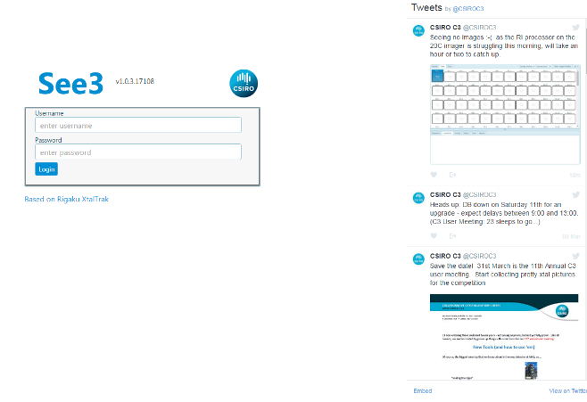

This will open the “Plates” tab, which is dominated by a grid on the left-hand side of the page. The grid can take several seconds to load. The bar to the right of the grid may be moved by dragging the middle of the bar (circled in red, below) with the left mouse button depressed. Many of the panes can be resized the same way.

Always, the name of the person logged in, the Logout and Help button are found in the upper right-hand corner of the site (circled in green, below).

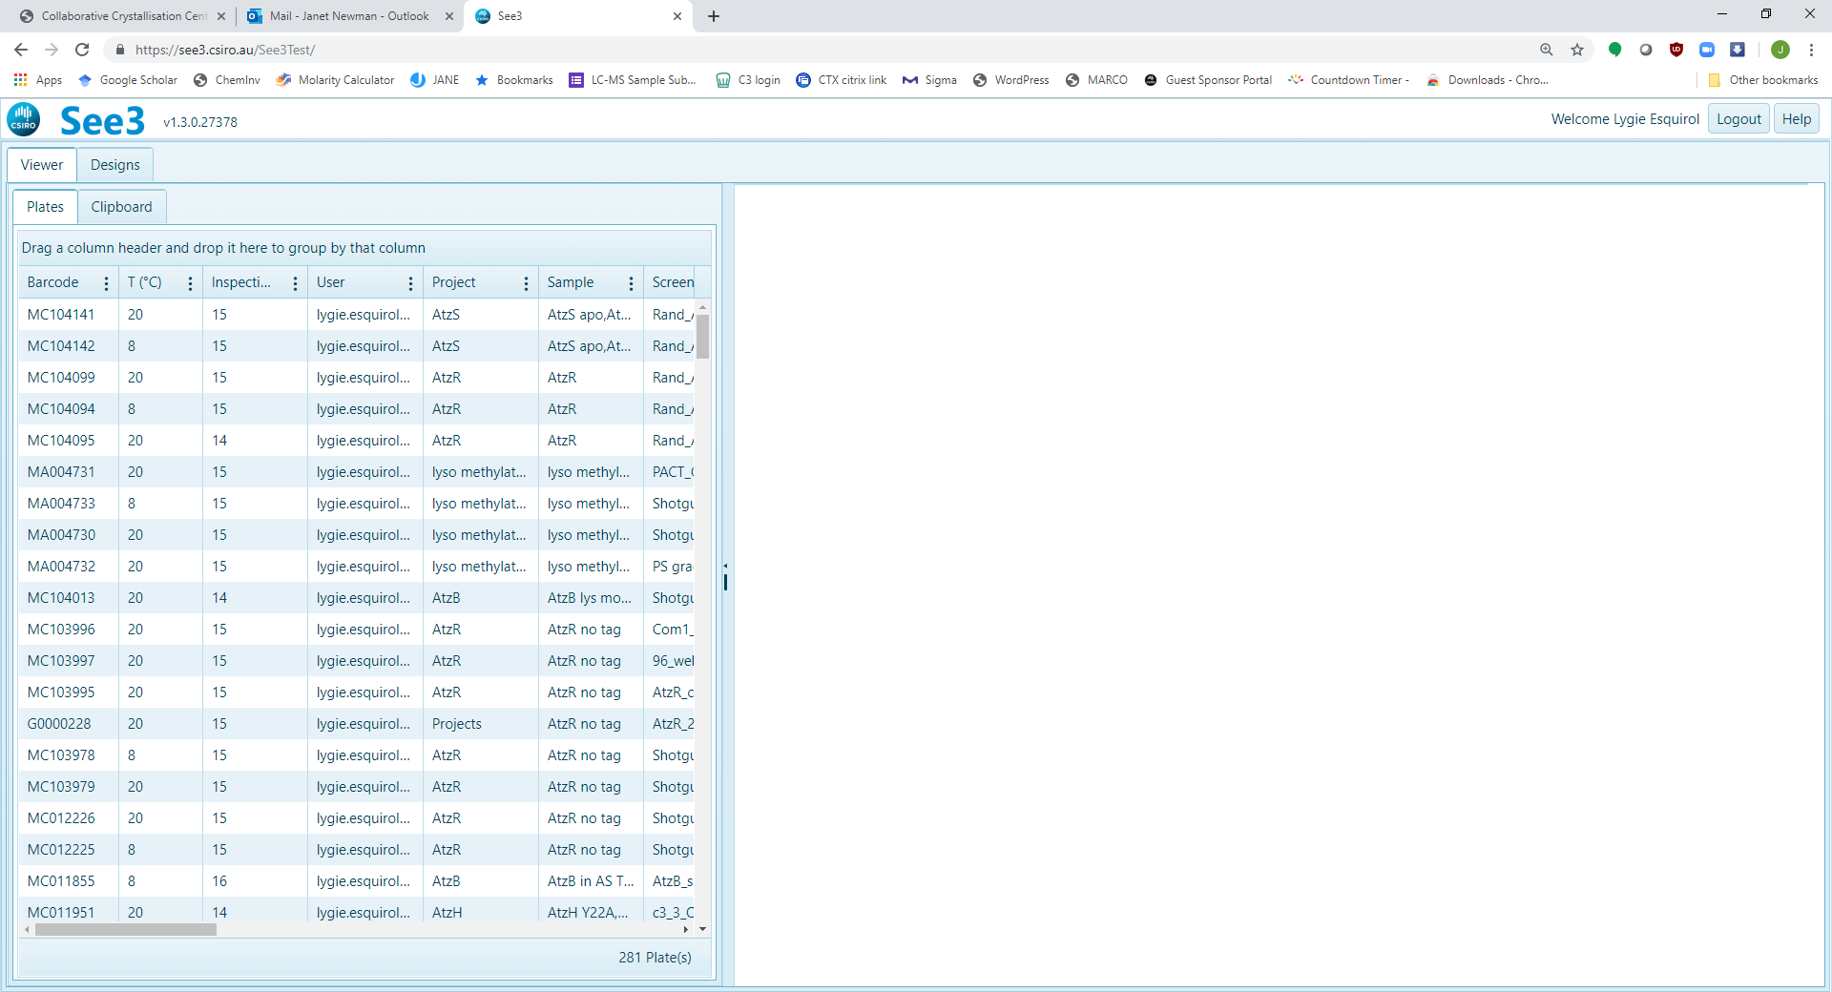

|  |  |
| --- | --- |
| Column Header | Information |
| Barcode | *Plate barcode (8 digit code)* |
| User | *Owner of the plate* |
| T(°C) | *Temperature of incubation (8 or 20)* |
| Project | *Project* |
| Sample | *Sample name* |
| Screen | *Name of the screen in the reservoir of plate* |
| Last Inspected | *Most recent inspection date (default sort)* |
| Date Created | *Date plate was set up* |
| Inspections | *How many times plate has been inspected* |
| Date Collected | *Date plate was removed from C3* |
| Device | *Incubator where plate is stored* |
| Name | *Plate name* |
| Comment | *Any comments for the plate* |

The grid can be modified as you wish, although, depending on the browser the order may change back to the default on your next login. You can resize the columns, change the order of the columns, sort by a column, group by a column, chose which columns to display or filter one or more column(s) Currently there are 13 columns shown by default, shown in the table above. ***Sort*** on a column by clicking on the column header (first click will sort ascending, second click will sort descending, an arrow will show the sort direction). Drag a column header to where you want it to ***reorder***. Click on the ***Group*** by a column by dragging the column header into the space above the column headers. ***Ungroup*** by clicking on the ‘x’ next to the grouped column (circled red, below).

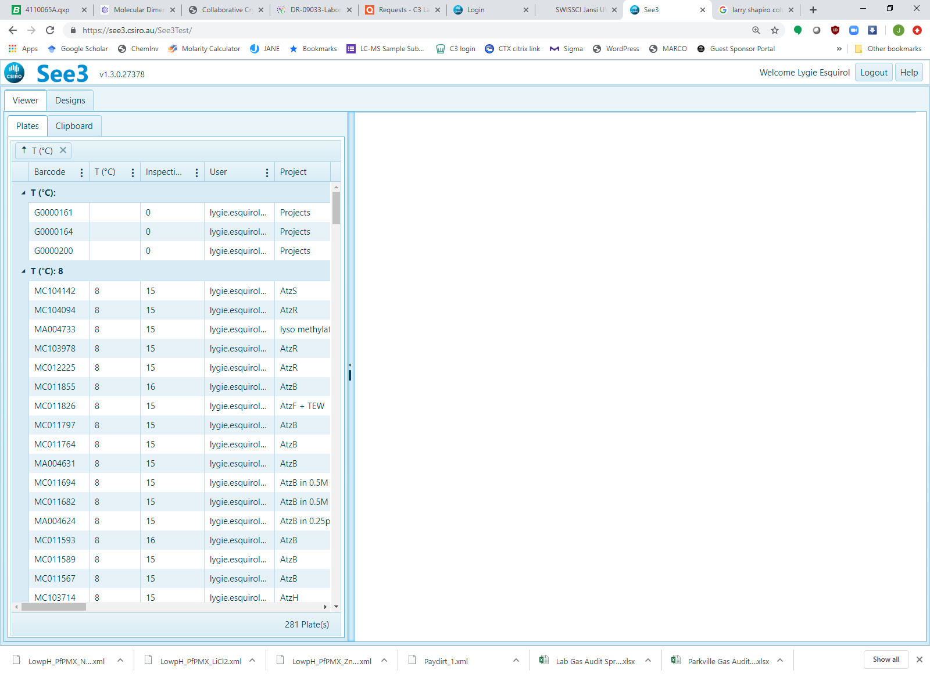

***Filter*** on a column by clicking the three vertical dots on the right side of the column header, and mousing down to the filter option. When a filter is set, the column(s) with an active filter are marked (blue dots, circled in red below), and the number of plates returned is shown in the bottom right hand corner of the screen

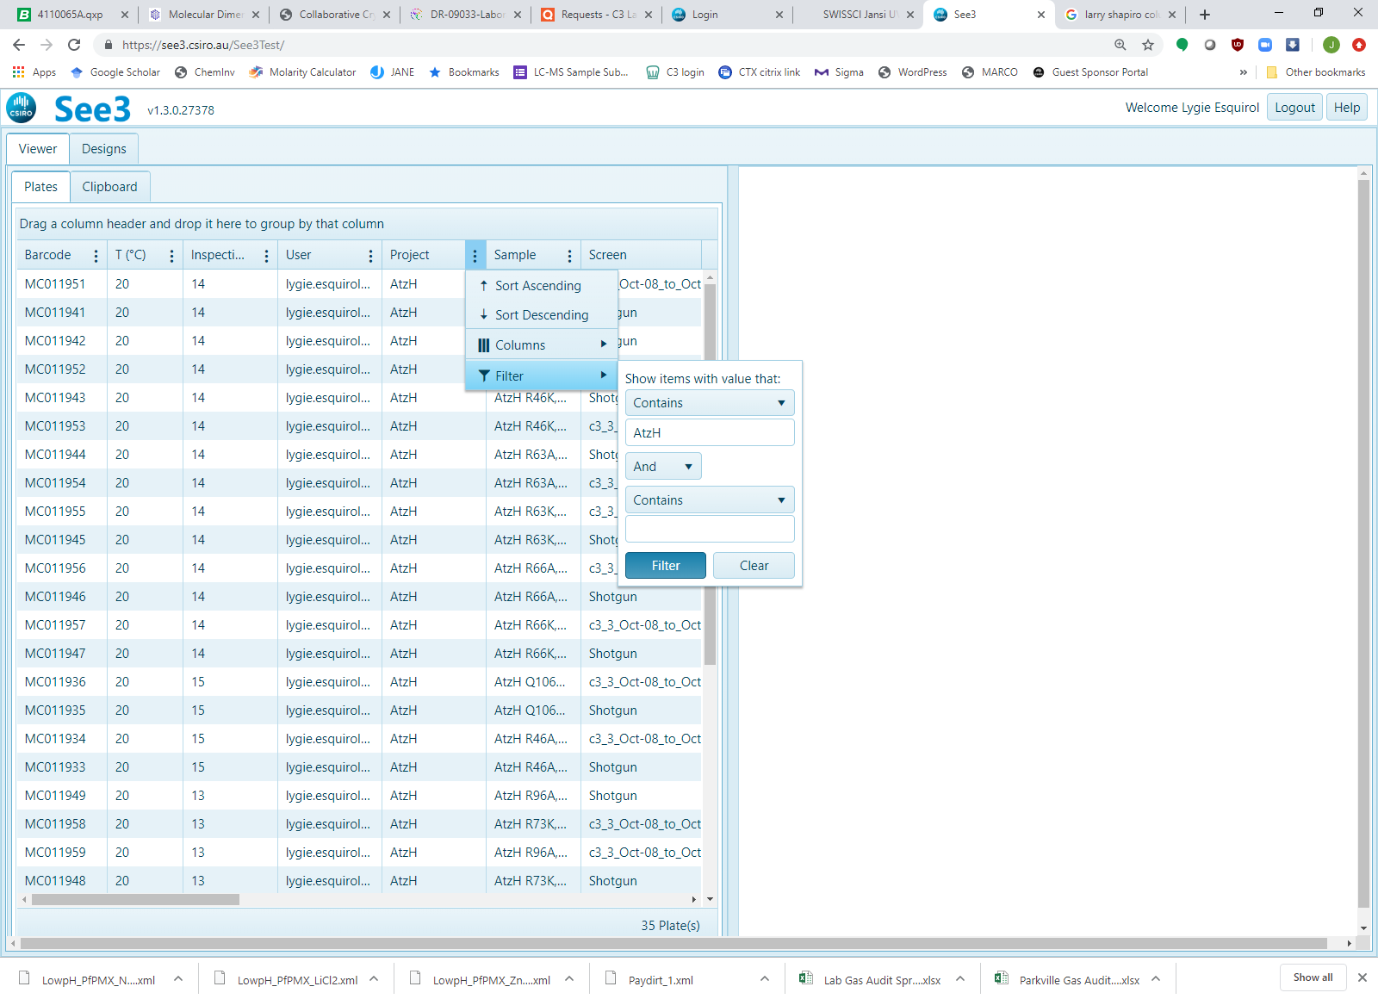

***Hide or unhide*** columns by clicking on the three vertical dots on the right side of any column, and mousing down to the Columns option. Checked columns will be included in the grid

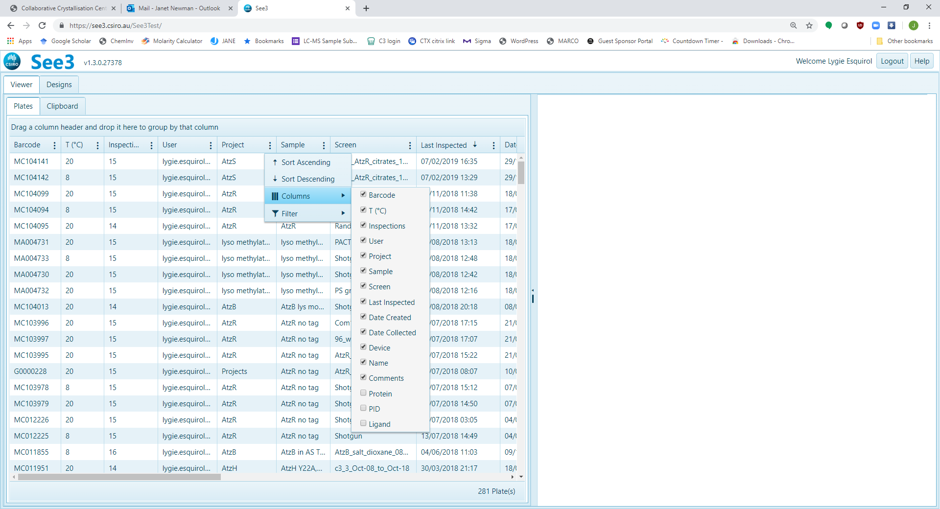

Clicking on a row in the grid will open the latest inspection for that plate. There are many options on this view:

There are two tabs on the upper, left hand side (circled in red, below) – ‘Viewer’ and ‘Designs’. We call these ‘VIEWS’. Each of the two VIEWS has two SUB-VIEWS – the VIEW ‘Viewer’ has SUB-VIEWS ‘Plates’ and ‘Clipboard’. The VIEW ‘Designs’ has SUB-VIEWS ‘Create’ and ‘Browse’

There are three tabs in the upper, middle screen (circled in green) ‘General’, ‘Plate’ (open by default), ‘Drop’. We call these *TABS*

There are four pulldown menus on the upper, right hand side (circled in purple) ‘Sort by’, ‘Score’, ‘Type’ and ‘Subwells’.

There are 6 tabs in the middle of the screen, below the drops (circled in navy blue) ‘Inspections’ (open by default), ’Conditions’, ’Scoring’, ‘History’, ’Tools’ and ‘Reports’. We call these *OPTIONS.*

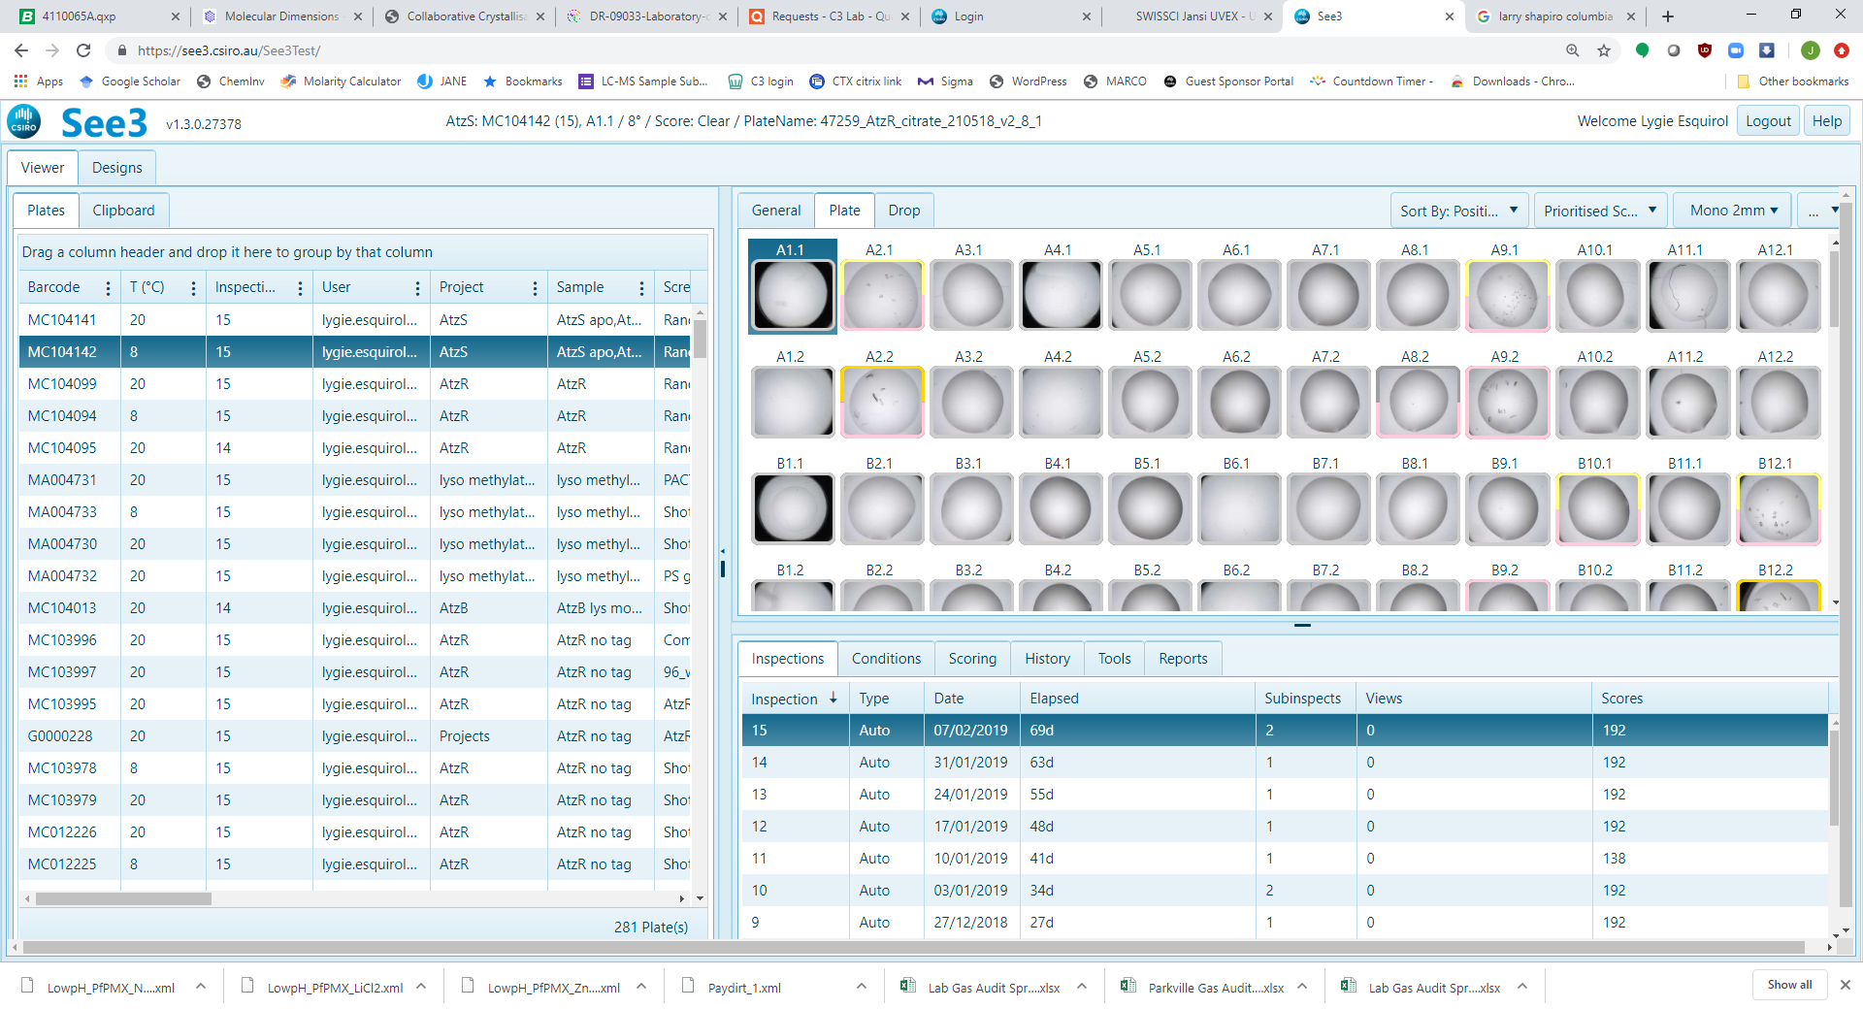

### Plates *SUB-VIEW*, General *TAB*:

The ‘General’ TAB (circled red below) gives general information about the plate selected in the left-hand grid. The information found on the plate can’t be edited, except for the comments field. The “Close Date” (circled green) is the date that the plate is taken out of C3 (either collected, or thrown out)

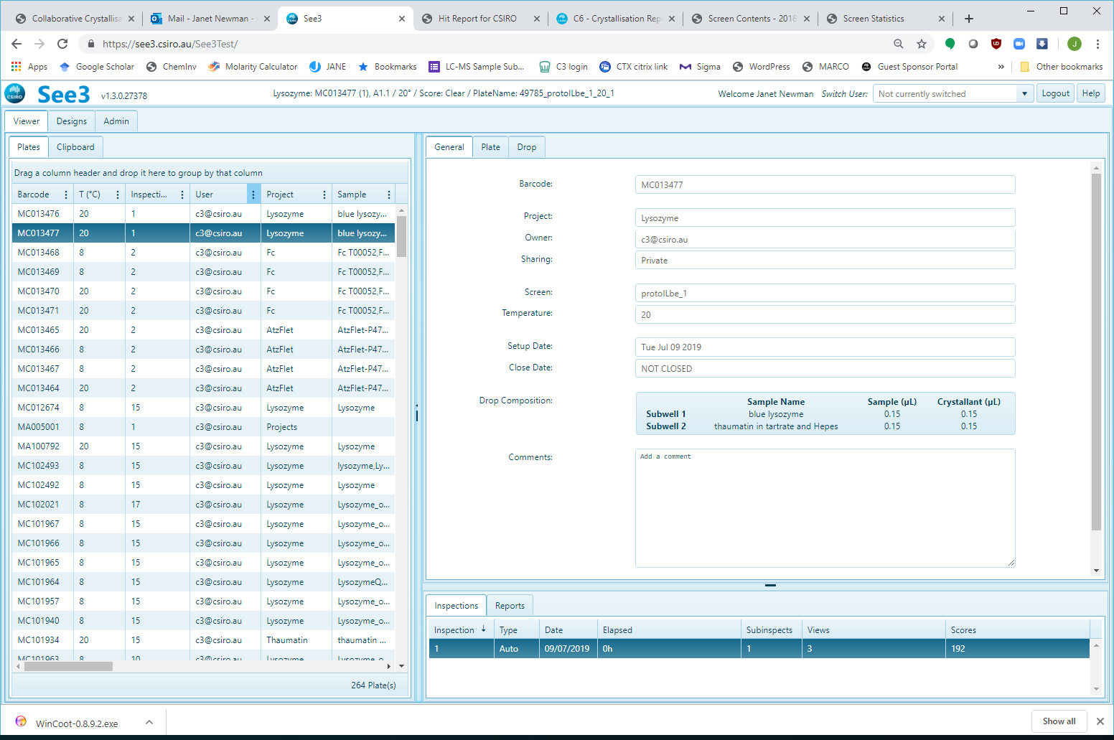

### Plates *SUB-VIEW*, Plate *TAB*:

The ‘Plate’ TAB (circled red below) opens as the default in the ‘Plates’ SUB-VIEW and shows an array of images that come from the most recently collected inspection for the plate selected in the grid. By default, each image is rimmed with a border that might be coloured. The colour indicates that one or more scores has been associated with the image.

#### Sort by

‘Sort by’ pulldown allows you to arrange the images either by position in the plate, or by an assigned score. By default, human scores are shown first, and better scores are shown first (this is the ‘Prioritised Score’). Below is the same plate as above, but with the ‘Sort by Score’ option selected:

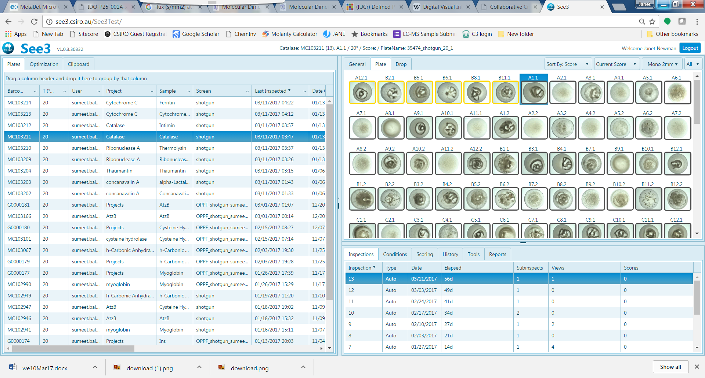

#### Score

In the C3 database, inspections rather than drops are scored. This gives us the ability in See3 to choose different scores to display. Human scores are either those assigned by a user in See3, or through the CINDER Application.

|  |  |
| --- | --- |
| Score name | Score logic (always per drop) |
| Prioritised Score | Most recent human score, otherwise most recent auto generated score |
| Latest Score | Most recent score |
| Latest User Score | Most recent human score only; no auto generated scores displayed |
| Inspection Score | Only scores for the current inspection are displayed |
| No Score | No scores shown |
| Drop Score | The set of discrete scores which have ever been assigned to the drop |

#### Type

In C3 we generally collect zoomed colour images collected with visible light. Our imaging schedules include other types of images – for example, images collected with UV light, or with polarising filters in place. If there is more than one type of image collected at the same time (i.e. in the same inspection), they can be accessed by choosing the appropriate image type from the ‘Type’ pulldown. The example below shows that there were both visible and UV images for a given inspection, and the visible option has been selected.

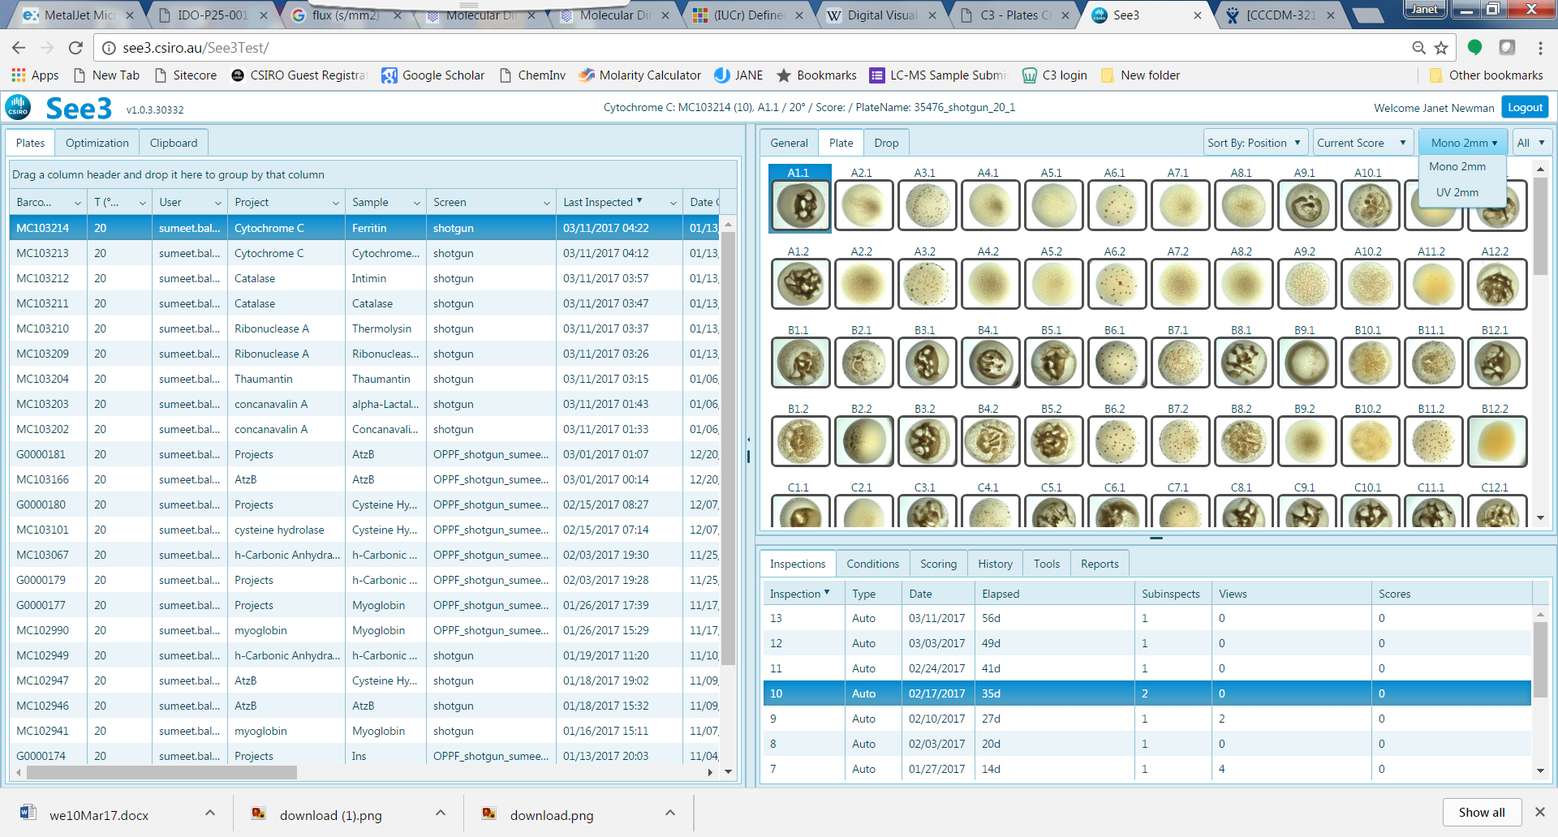

The first inspection of a plate will show both an overview inspection and the zoomed inspection.

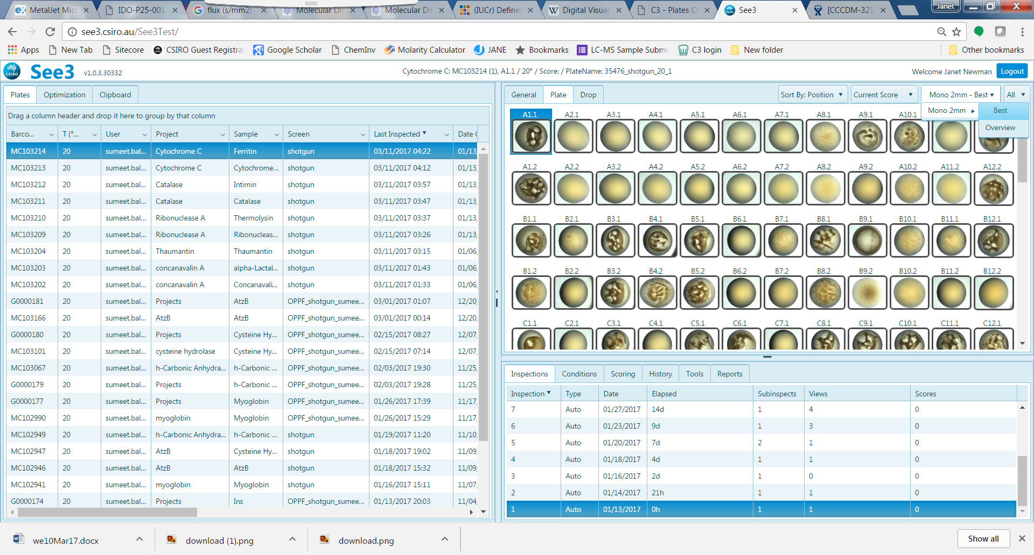 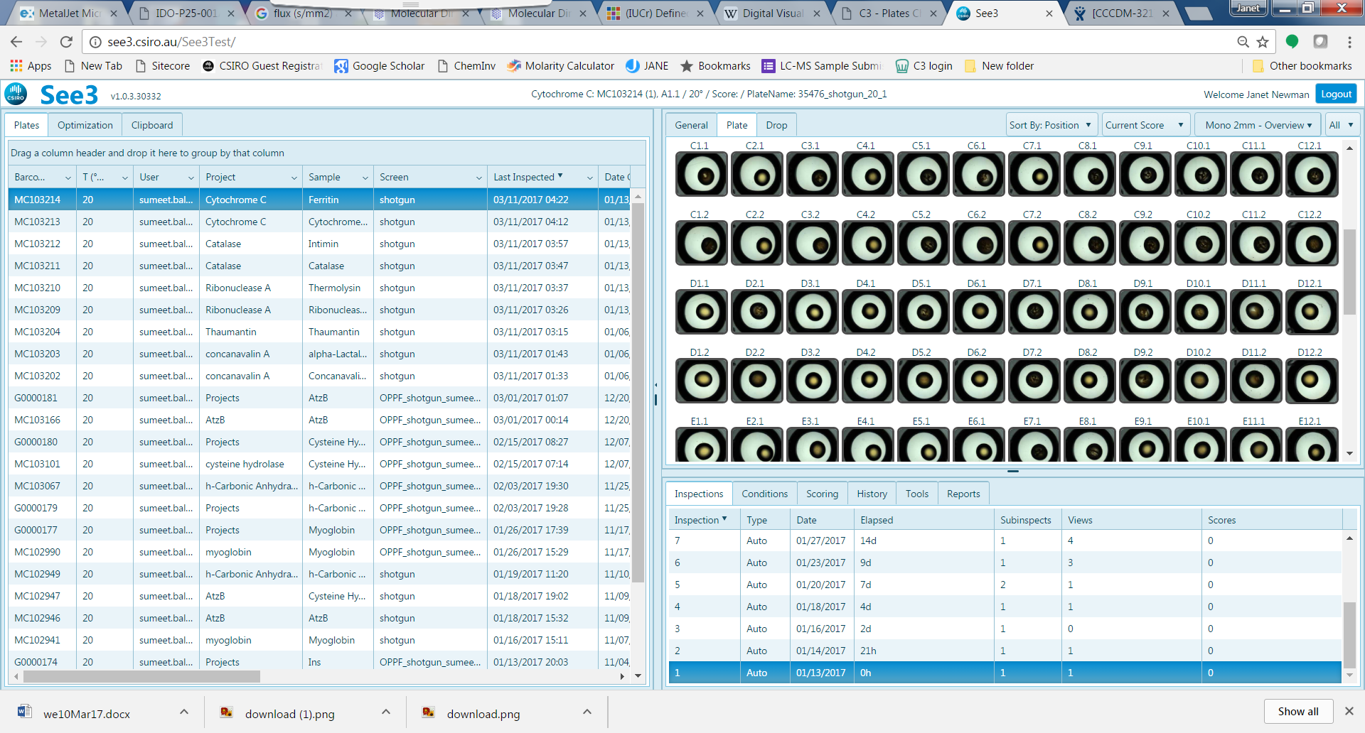

#### Subwells

C3 uses two subwell plates (SwissSci SD-2 plates, aka ‘MRC plates’); by default all drops are shown. If you want to only view the drops in the top (or the bottom) subwell then choose the appropriate subwell set from this pulldown

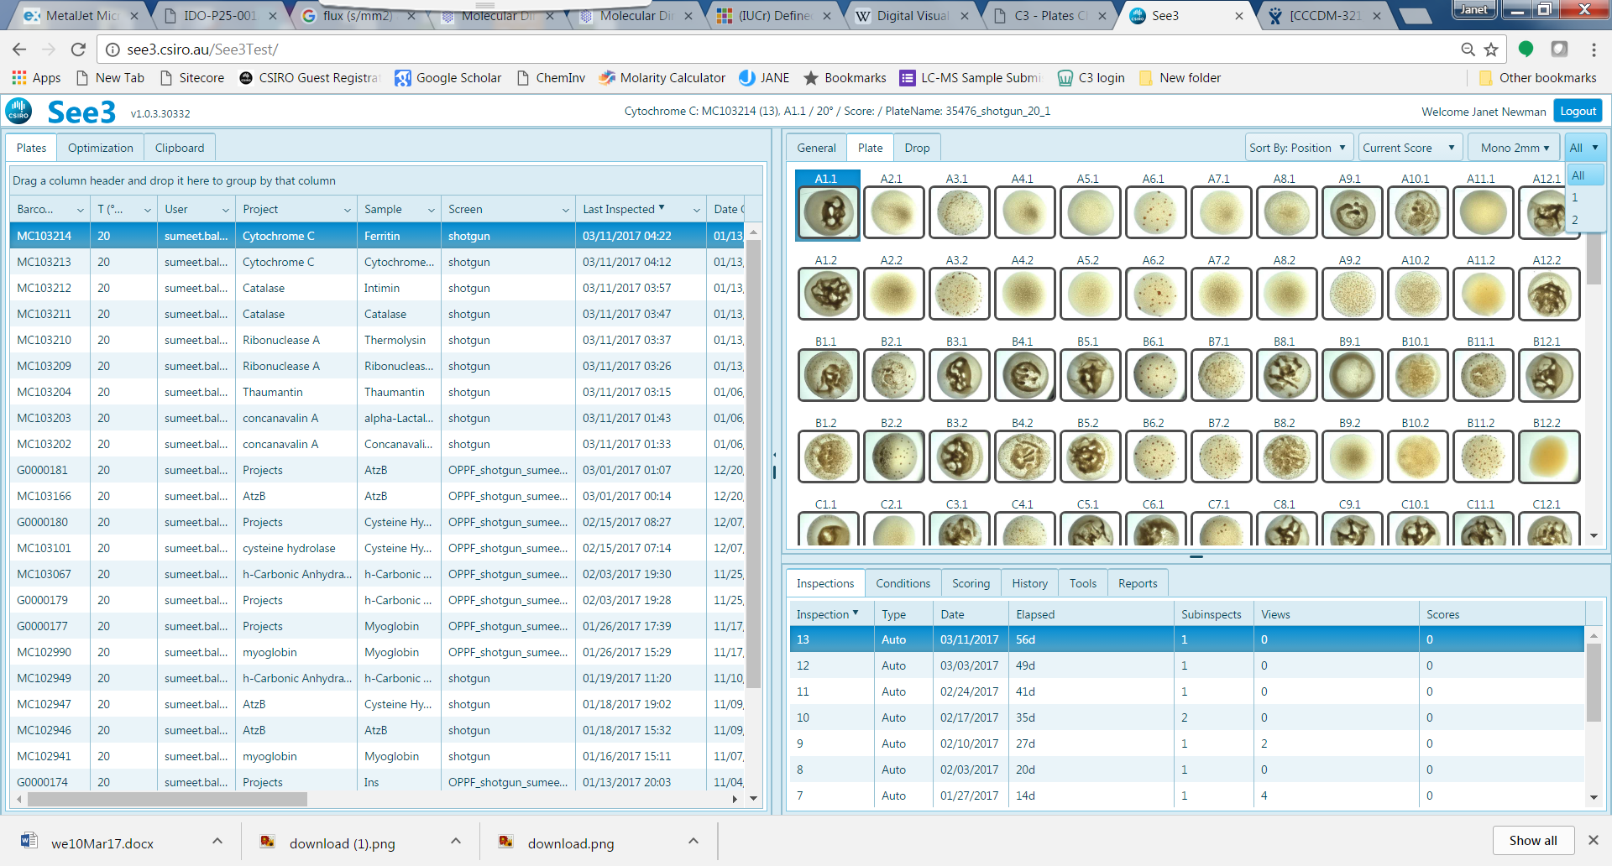 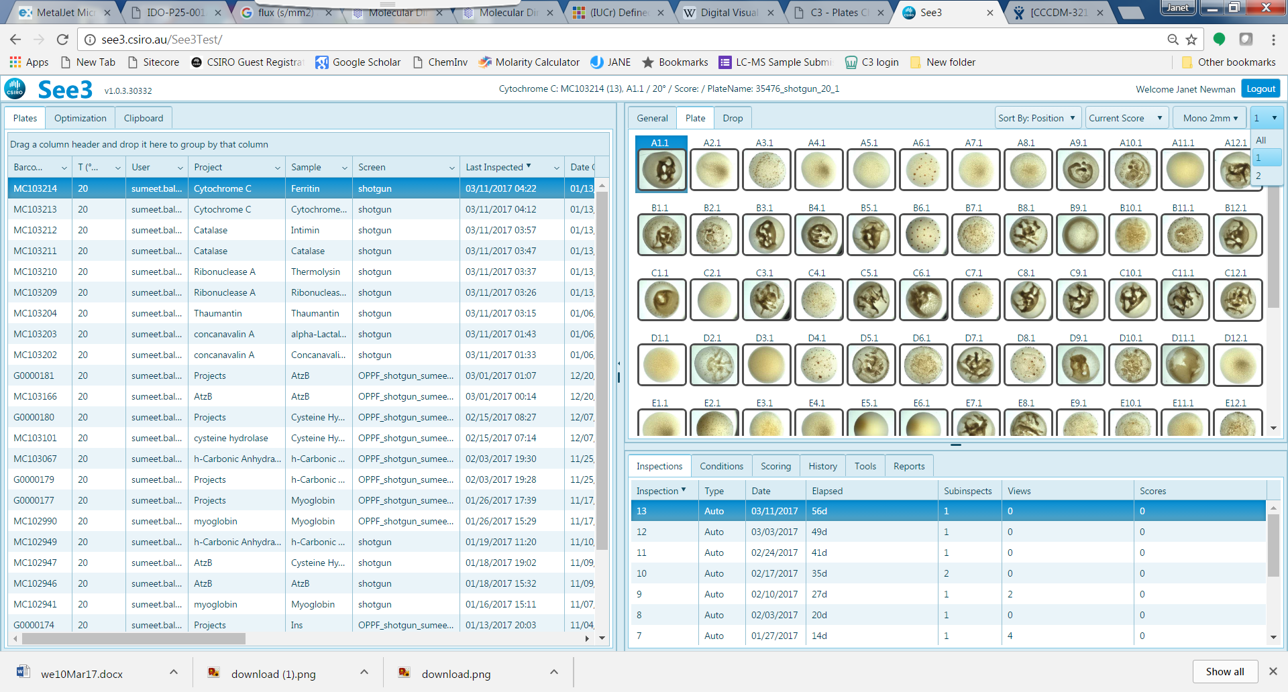

### Plates *SUB*-*VIEW*, Drop *TAB*:

In this arrangement, the ‘Sort’ menu changes to ‘Split’, which allows the user to see two images from the same inspection (for example, Visible and UV images) side by side.

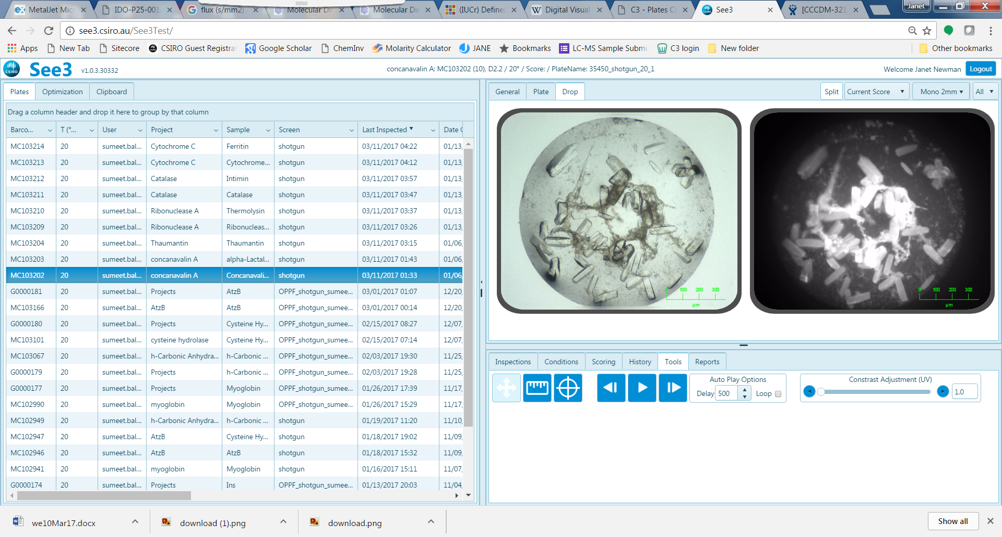

Most of the six *OPTIONS* give information or functions the Drop *TAB*. In the Drop *TAB*, the image can be zoomed in using the mouse wheel, and the green scale bar will adjust according to the zoom level. Once zoomed, holding down the left mouse button allows you to drag the drop around. The zooming and re-centring on the image persist until another plate is loaded from the plate grid.

### Plates *SUB*-*VIEW*, Drop *TAB,*

#### Inspections OPTION

Shows the list of inspections for a selected plate, and gives the Inspection Number, the Date of Inspection, the time since the plate was set up, the number of sub-inspections, how many times an inspection has been viewed, and if any scores were associated with an inspection. This is the default *OPTION.* If there are more than one sub-inspections (for example, see the highlighted row of the inspection grid in the figure below) then there are different types of inspections collected at the same time – most commonly this means that both an visual light and a UV light inspection were collected at that time.

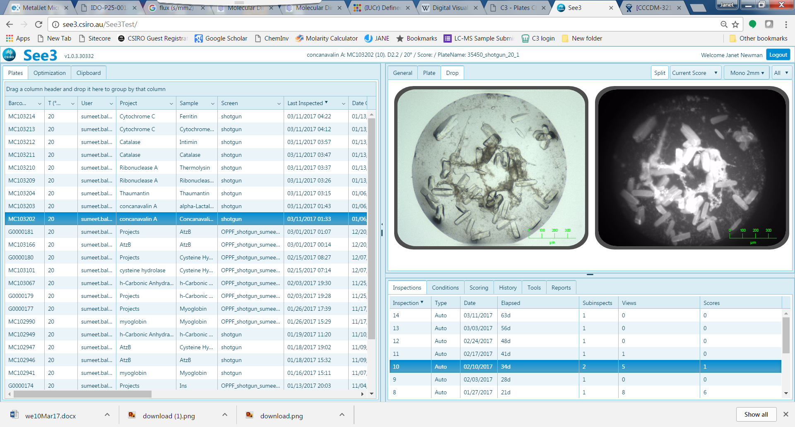

#### Conditions OPTION

Shows details about the chemistry of the droplet (what is in the reservoir), information about the sample (concentration, sample_ID), the ratio of the sample to the reservoir and information about additives, if appropriate. By default, the treeview for the reservoir contents is open, to see more information about the sample, click on the small arrow to the left of the sample (circled in red, below)

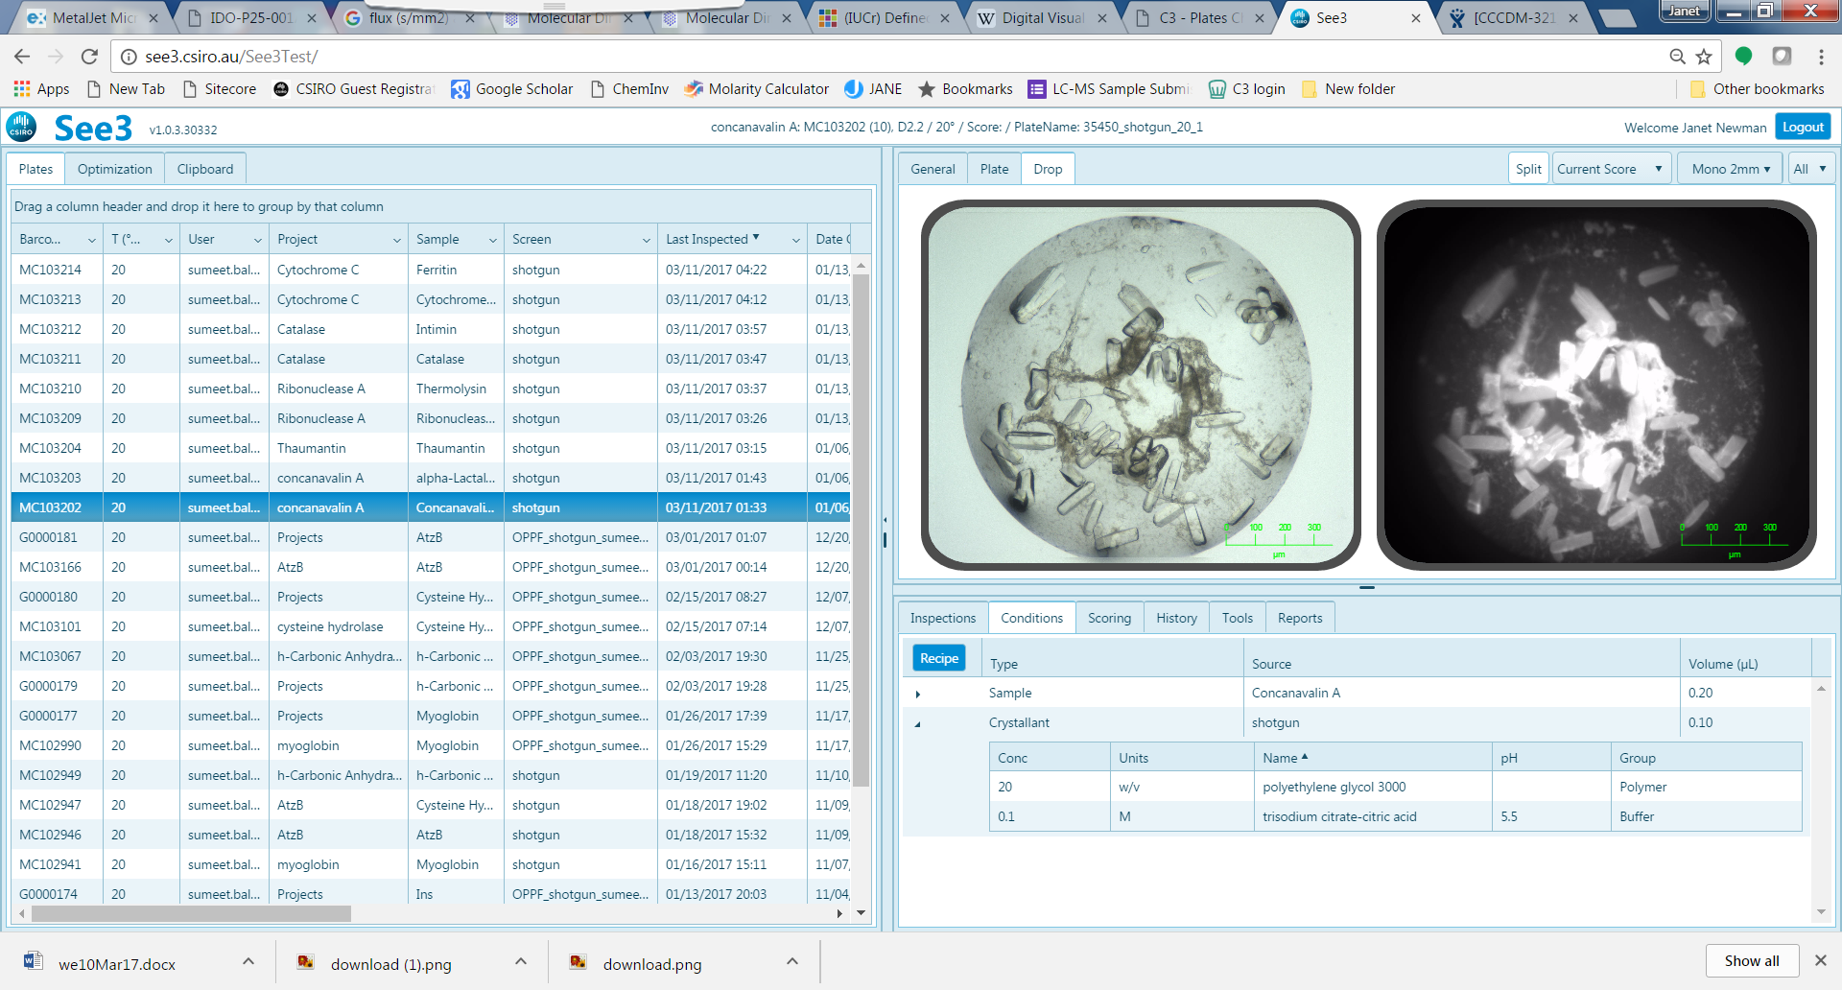 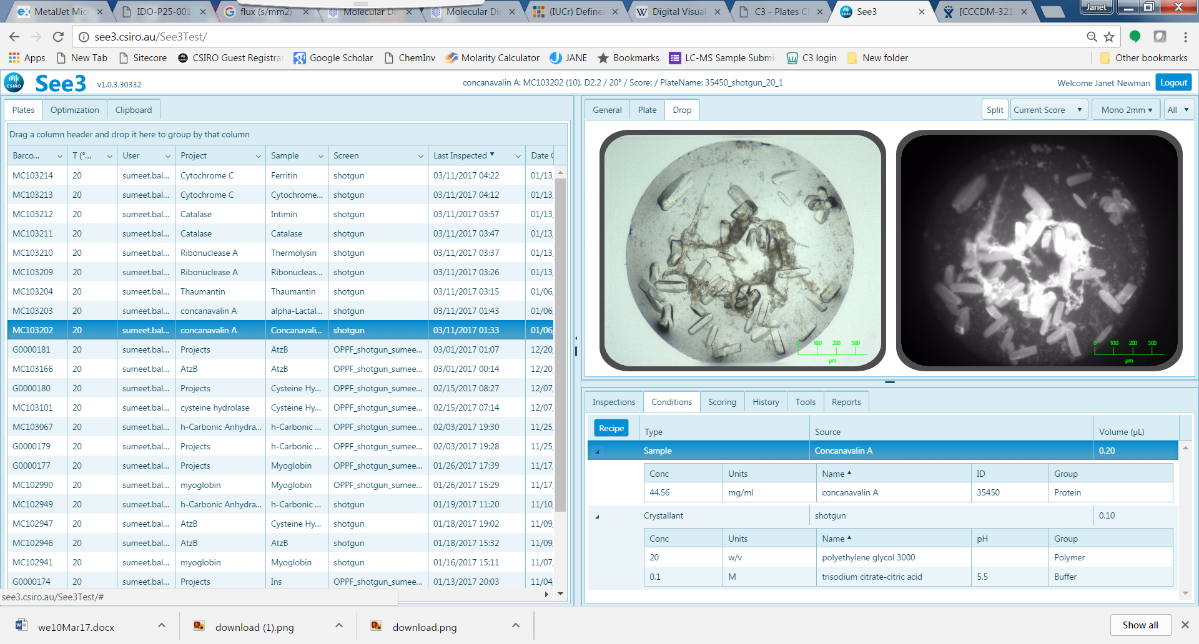

Click the Recipe button (circled green, above) to find out how to make up 1 mL of reservoir solution using C3 stocks. Use this recipe when booking a ‘One Tube’ request on the TECAN

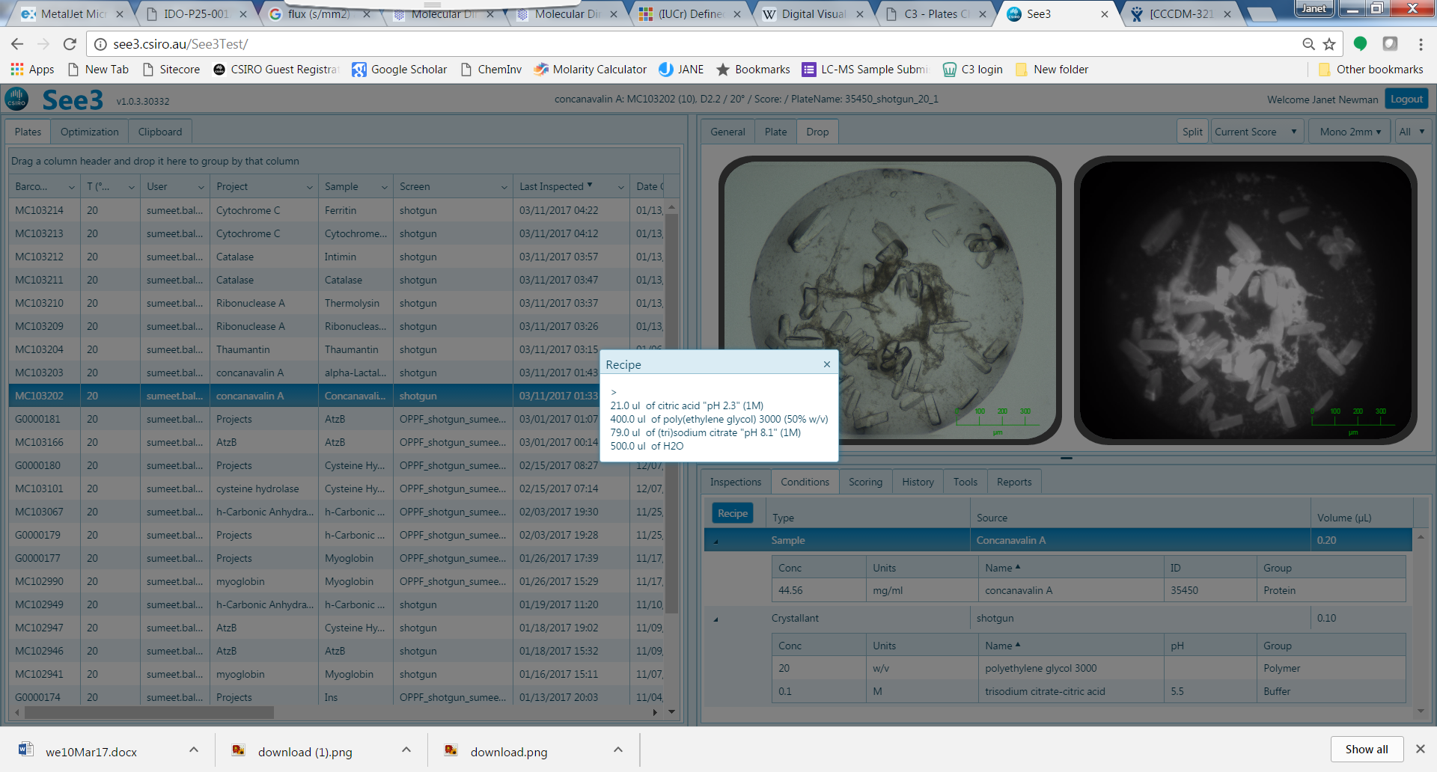

#### Scoring OPTION

There are several possible scores one can associate with a droplet – see the table below. The order of the scores in the table below shows the ordering of scores when the ‘Sort by Score’ menu option is chosen – drops with scores at the top of the table will be shown first. There are different types of scores: ‘**Manual**’ scores are ones that a user associates with a drop through the See3 interface. ‘**Mobile**’ scores are associated with a drop through the CINDER mobile application. ‘**Auto**’ scores are scores associated with a drop automatically, though AI tool.

The process of scoring is somewhat arbitrary, as one project’s ‘Crystals***’ might be another project’s ‘Crystal*’, but the idea is that the more stars there are, the better. When a score is associated with a droplet, a coloured rim is drawn around the crystal image. The colours are grouped – yellow/red colours are associated with crystals, blue colours with precipitate, green colours for other results.

|  |  |  |  |  |
| --- | --- | --- | --- | --- |
| **TYPE** | **NAME** | **COLOR** | **DESCRIPTION** | **KEYSTROKE** |
| **Manual** | Shoot me |  | In plate screening marker | g |
| **Manual** | Crystals *** |  | Worth harvesting | 6 |
| **Manual** | Crystals ** |  | Needs some work, but very promising | 5 |
| **Manual** | Crystals * |  | Needs some optimising | 4 |
| **Manual** | Crystalline |  | Needs lots of optimisation | c |
| **Mobile** | Crystal |  | Cinder crystal |  |
| **Auto** | Crystal |  | autoscore crystal |  |
| **Manual** | Degraded |  | Dissolving or degrading | ? |
| **Manual** | Harvested |  | drop left after harvesting | h |
| **Manual** | Spherulites |  | meteors | 8 |
| **Manual** | Other |  | unknown | 9 |
| **Auto** | Other |  | Autoscore other |  |
| **Mobile** | Other |  | Cinder other |  |
| **Manual** | Salt? |  | Putative salt crystals | s |
| **Manual** | Ligand? |  | Compound or ligand [detergent] crystal | l |
| **Manual** | Yep, Salt |  | Truly Salt | z |
| **Manual** | Good precipitate |  | grainy, shiny, birefringent | 1 |
| **Manual** | Precipitate |  | All other precipitates | 3 |
| **Manual** | C3PO |  | For optimisation | = |
| **Manual** | Ppt and stuff |  | Lumpy precipitate, not crystals | p |
| **Mobile** | Precipitate |  | Cinder precipitate |  |
| **Manual** | Bad precipitate |  | Brown, smoky, denatured | 2 |
| **Manual** | Phase separation |  | oily, immiscible | 7 |
| **Manual** | Clear |  |  | 0 |
| **Manual** | Clear + stuff |  | Clear with non-crystalline matter | j |
| **Mobile** | Clear |  | Cinder clear |  |
| **Manual** | Skin |  | Skin - wrinkles | w |
| **Manual** | Bubbles |  | Bubbles | b |
| **Manual** | Dried |  | Drop dried out | d |
| **Manual** | Null experiment |  | this experiment is a bust | n |
| **Auto** | Changed |  | Changed since the last inspection |  |
| **Auto** | Precipitate |  |  |  |
| **Auto** | Clear |  |  |  |
| **Manual** | UV Clear |  | uniform fluorescence | ( |
| **Manual** | UV Precipitate |  | glowing precipitate | # |
| **Manual** | UV Crystal |  | Crystal that glows under UV | * |
| **Manual** | UV Other |  | Phase separation or glowing dust etc | ) |
| **Auto** | Image Not Found |  |  |  |

One can assign a score to a droplet in either through the See3 interface or through the CINDER application. Scores assigned in CINDER will appear as a coloured border in See3. Score in See3 by clicking on one of the coloured boxes in the *Scoring OPTIONS* (circled red below), or by using the keyboard shortcut given in the table. When a score is associated with a drop, the viewing software will advance to the next image, and the scorer and score date will show up in the Scoring *OPTION*. One can delete a (human) score from an inspection by clicking on the ‘Remove’ button next to the score you wish to delete (circled green, below).

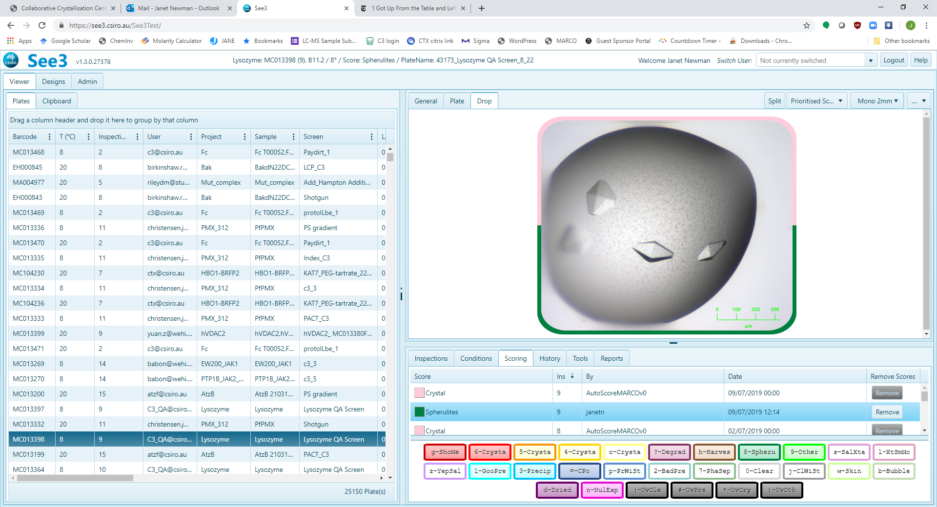

An image may have more than one score associated with it – there may be one or more user scores, and there may also be one or more auto-generated scores. All user scores are considered valid; this is a way of generating granularity about the results of an experiment – for example, a user may score the same inspection of the same droplet three times, to describe a drop that shows precipitate, crystals and a skin. Multiple scores are shown as a multi-coloured band around the image, which scores are used in the colouring will depend on the option chosen in the Score pulldown menu. The origin of the coloured rim is at 9 o’clock, and score colours are shown in order of importance (i.e. the order of the scores in the scores table shown above) in a clockwise direction around the rim. In the example below both the human assigned score of ‘Crystal **’ and ‘Precipitate’ and the auto-generated score of ‘Crystal’ are shown; the human crystal score is weighted more highly than auto-generated crystal, which in turn is rated more highly than ‘Precipitate’, and thus the two crystal scores are shown first.

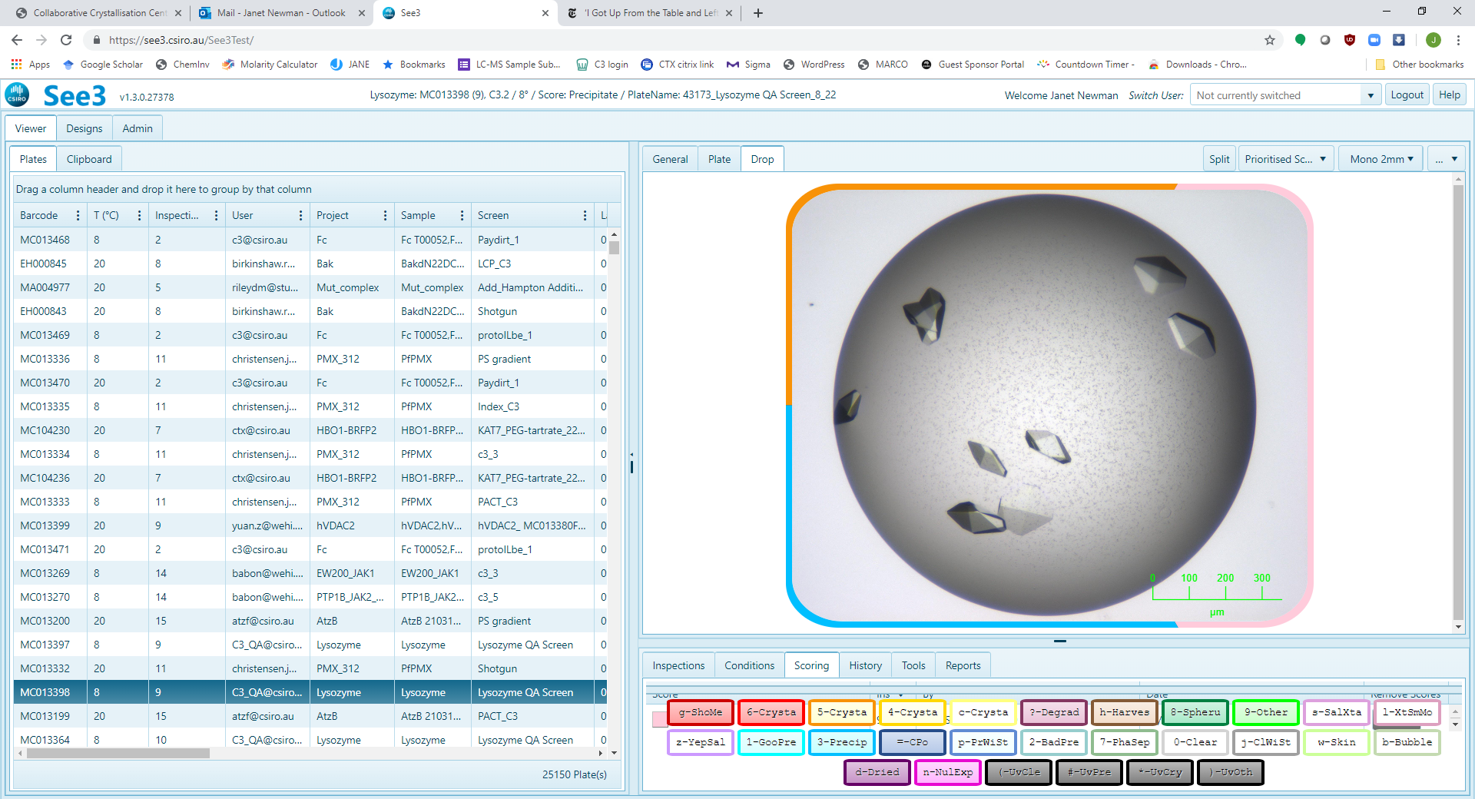

#### History OPTION

Shows the time-course of the droplet, that is, all the images associated with the droplet to date. Clicking on one of the thumbnails in the History OPTION will move it to the main viewing pane. The scores associated with each inspection in the history of a plate are shown as the coloured border around the thumbnail images. One can add all the images associated with a droplet to the clipboard (for printing out as a report) by pressing the button “Add all to clipboard” – highlighted

#### 

#### Tools OPTION

Many of the Tools have associated text which are displayed in the area below the icons.

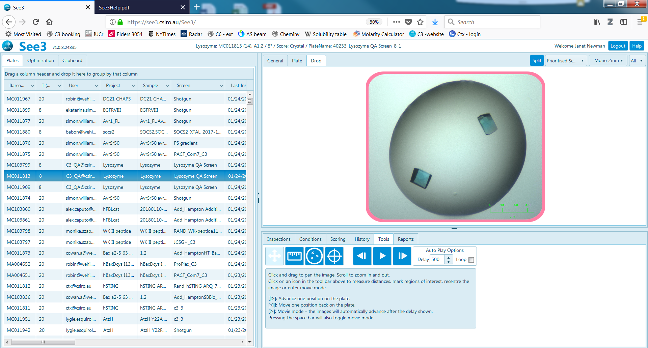

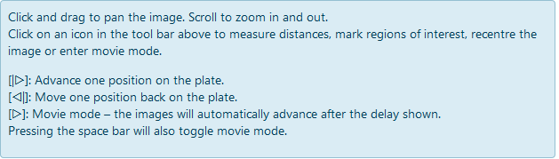

The text in the figure describes what each of the icons under this option does.

The measure tool is selected by clicking on the ruler icon (circled red, below left), and is de-selected by clicking on the four-arrow icon (circled green, below right). This option allows one to measure an object in a drop. The green ruler lines on the image persist until another plate is loaded from the plate grid.

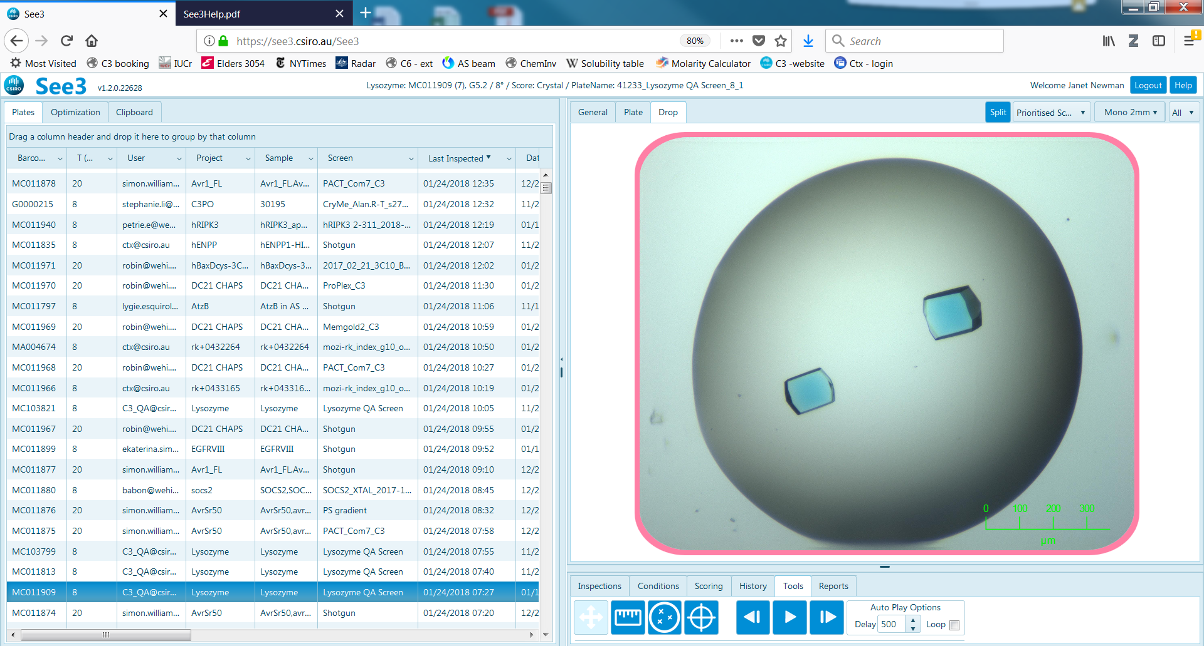 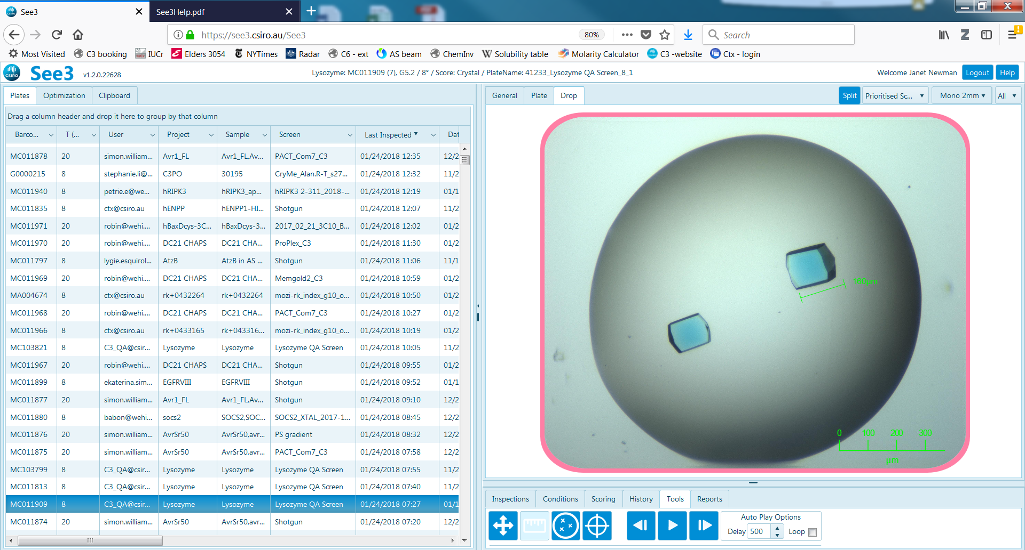

The re-centre/re-size tool is selected by clicking on the crosshair icon (circled in purple, below)

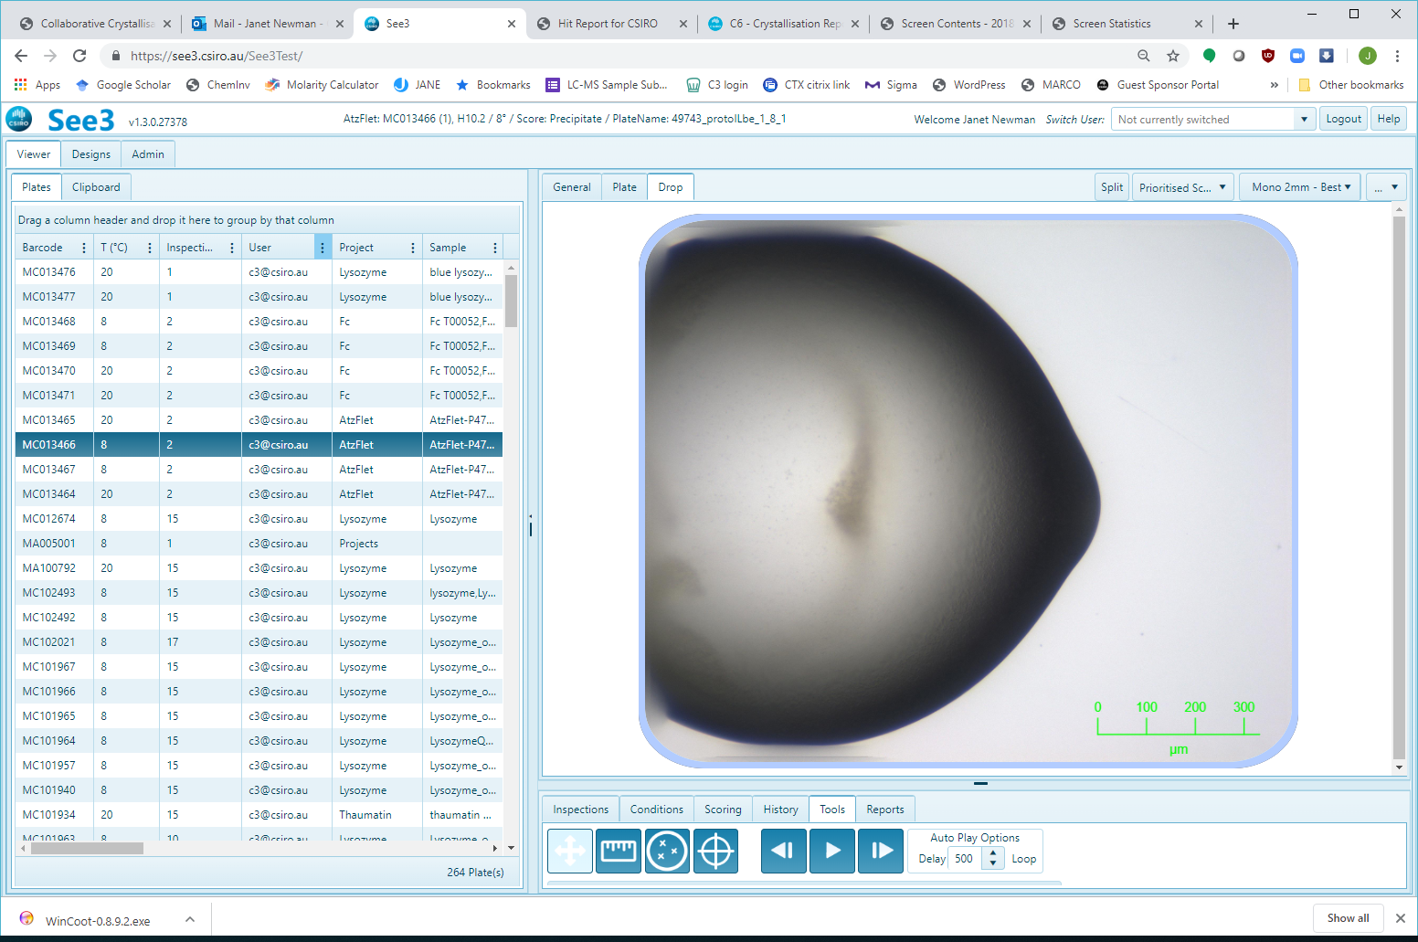

Once clicked, use the mouse to re-centre/re-zoom the droplet (some guesswork might be involved) - one can both zoom in and zoom out the image.

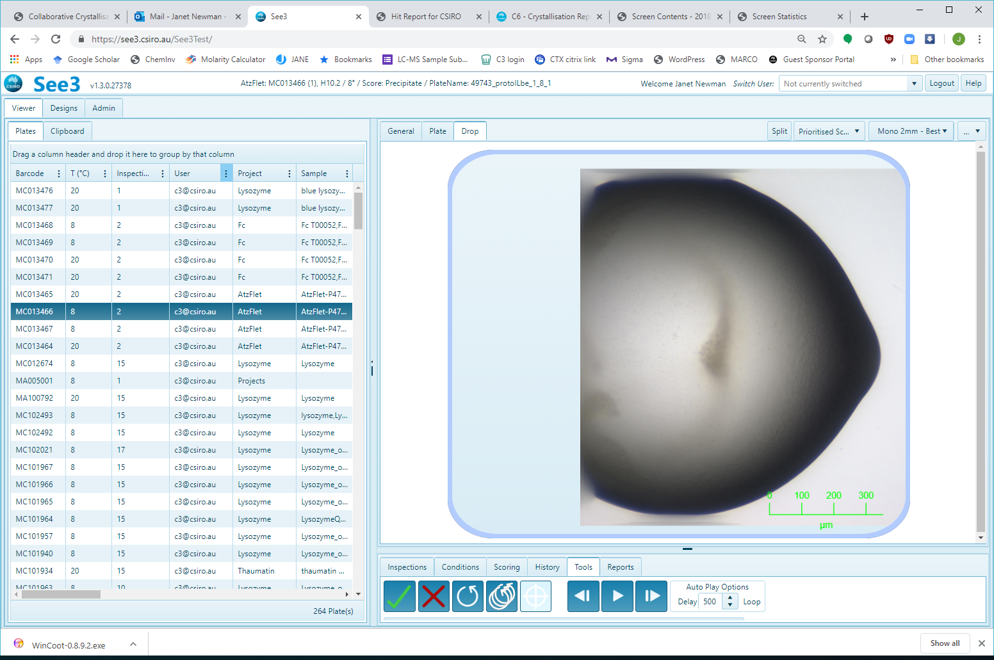 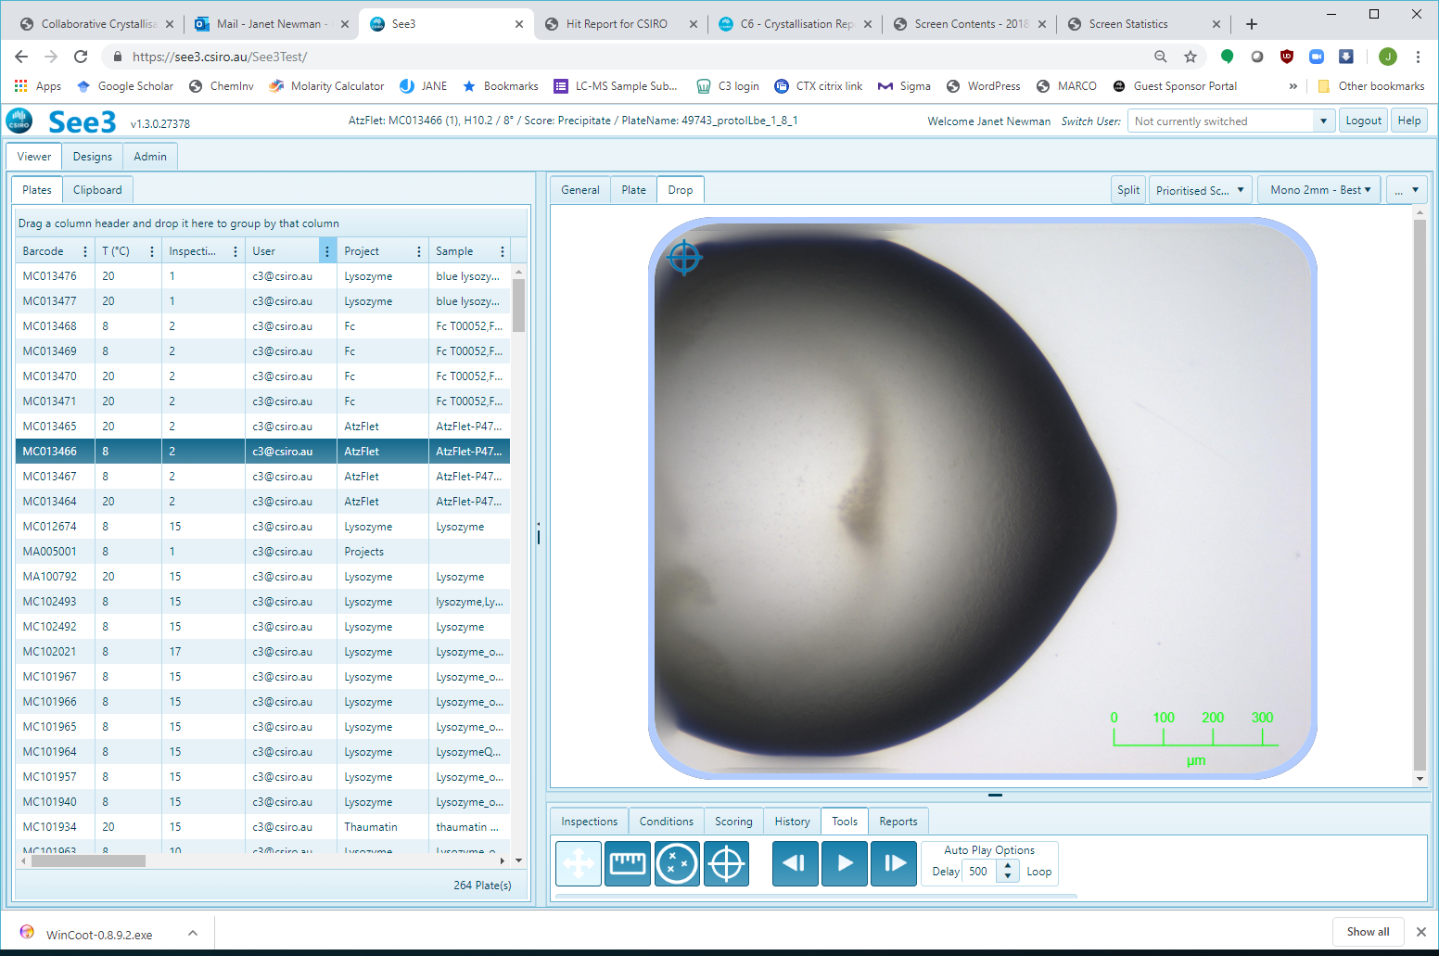 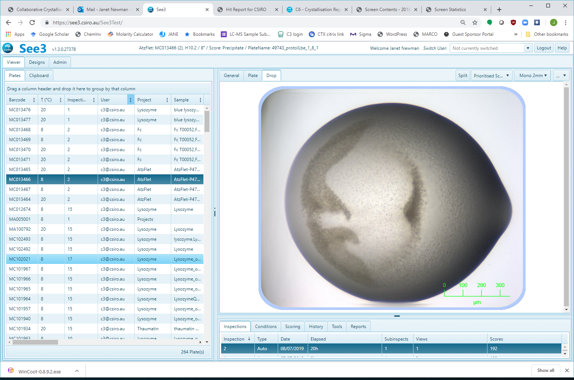

Click the green tick or the red cross to exit the re-centre tool. If you selected the tick the new centre and extent will be used for the next inspection of that drop, and the icon (marked with purple arrow) will appear in the drop image to confirm that the drop has been re-centred. After the next inspection (right hand image), the drop centre and zoom will reflect the change.

When the re-centre tool is selected two more icons become visible, circled in purple:

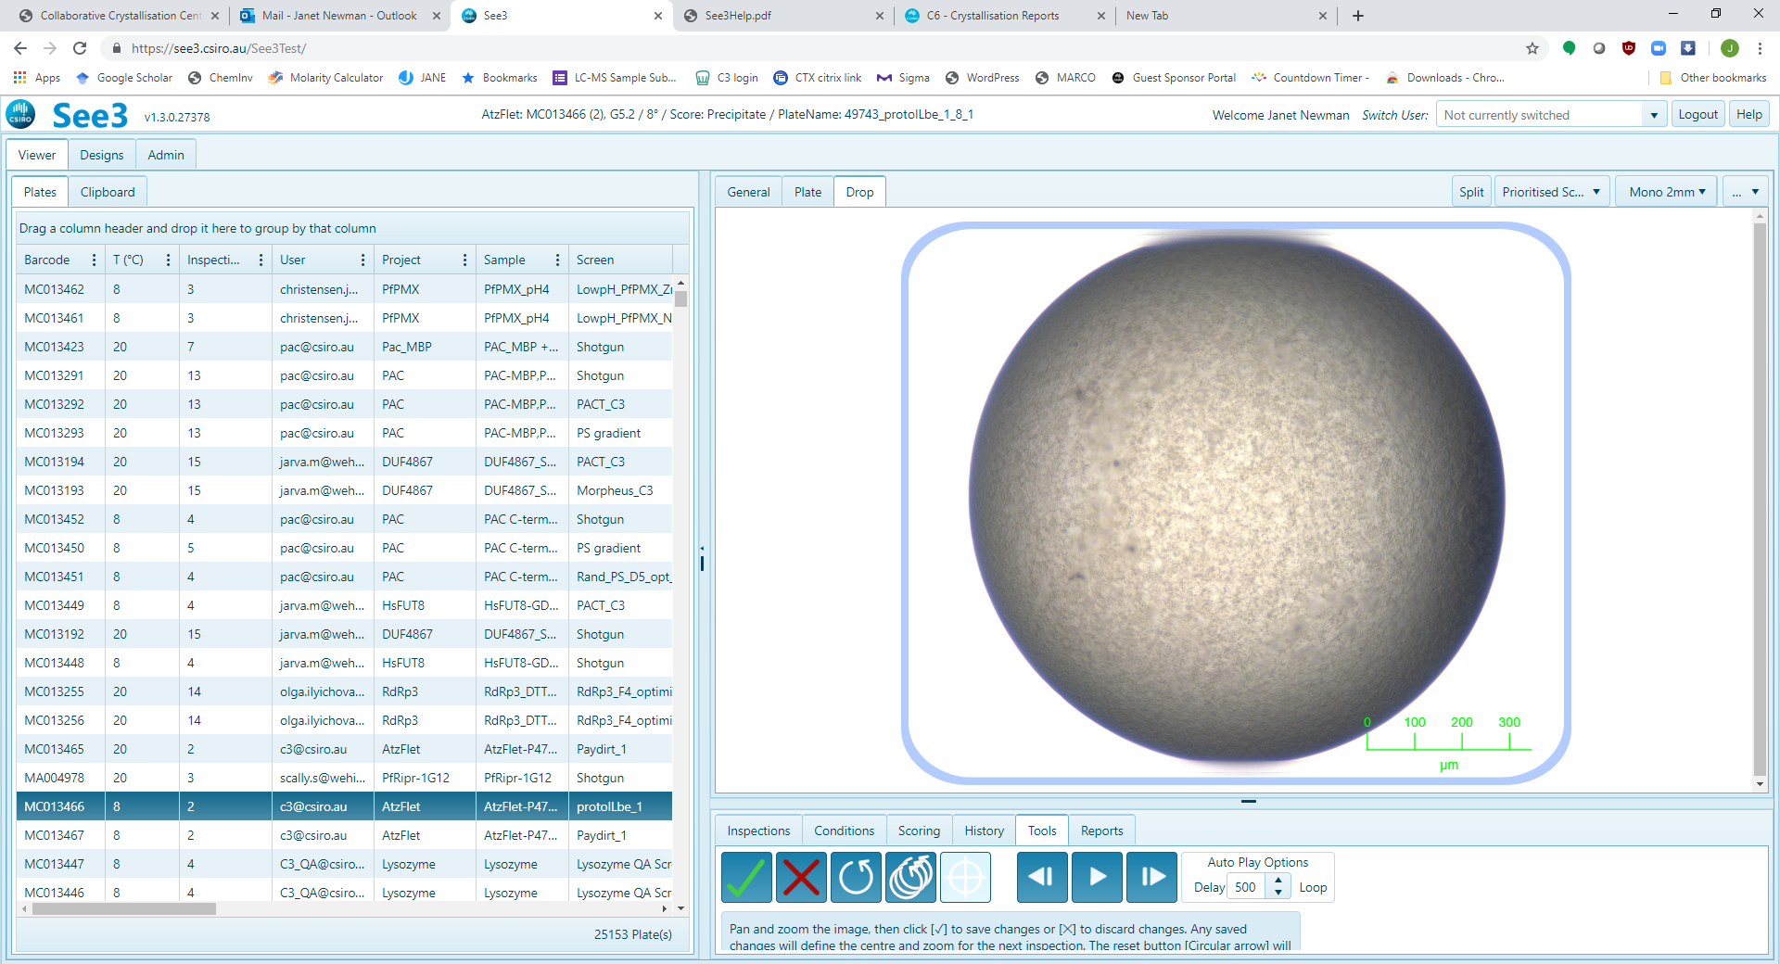

The icon with the single circle will remove any information about the location of the currently selected single drop from the database, forcing the Imager to re-find that drop on the next inspection. The multiple circle icon will remove all location information about all drops on the current plate from the database, forcing the imager to re-find all drops on the plate in the next inspection.

The forward, back and play buttons (circled below) move you through the images – the delay between the images can be set here as well.

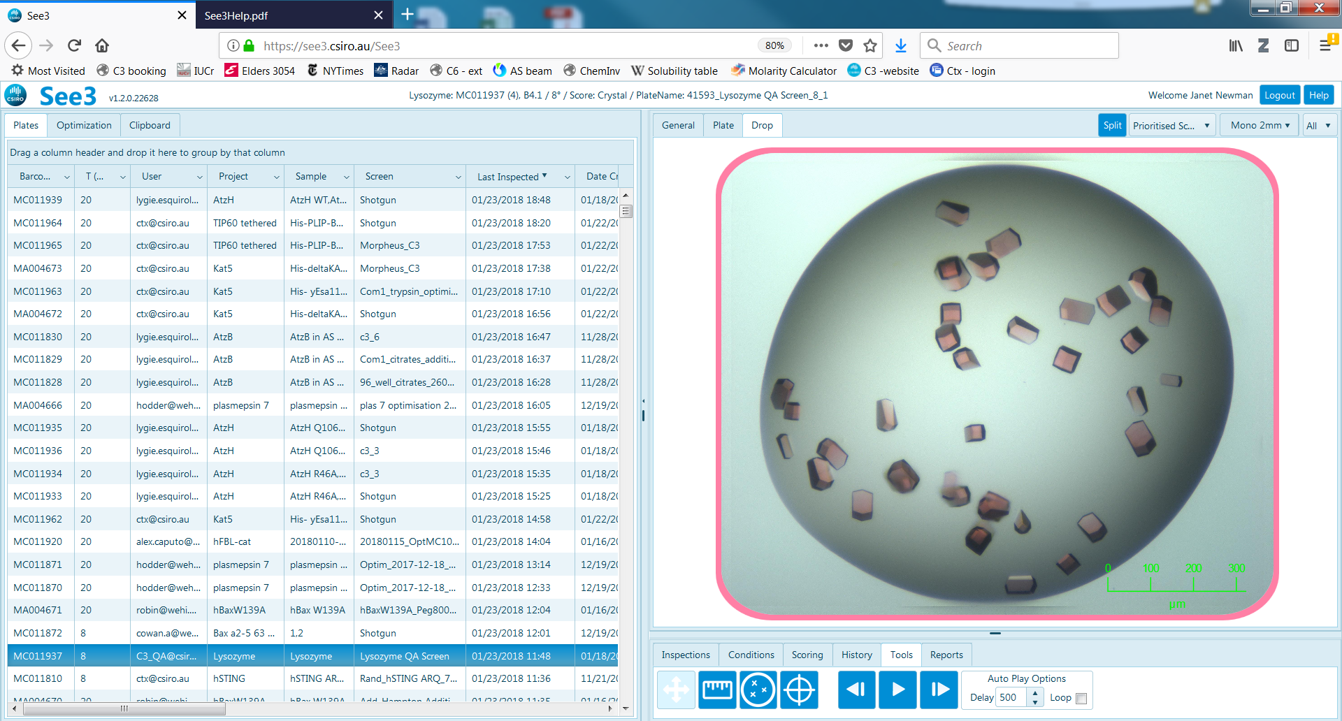

The autoplay function can also be toggled on and off with the space bar, and the keyboard arrow keys will also move you between images.

Regions of Interest (ROIs) can be selected using the ROI icon (highlighted in green, below). *This feature is in beta testing, so please give us feedback about it.*

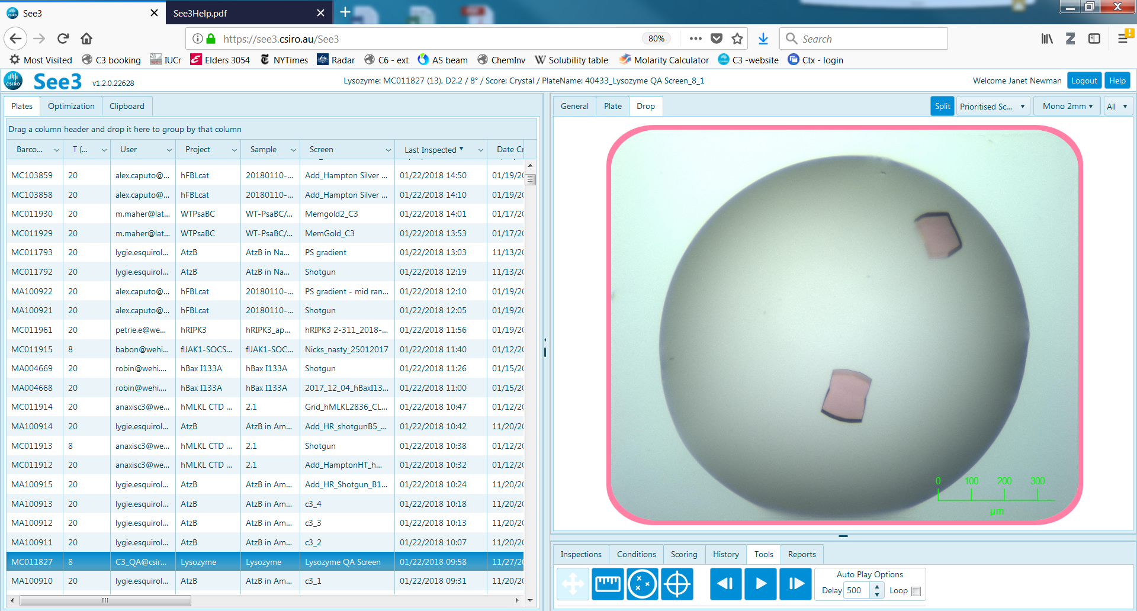 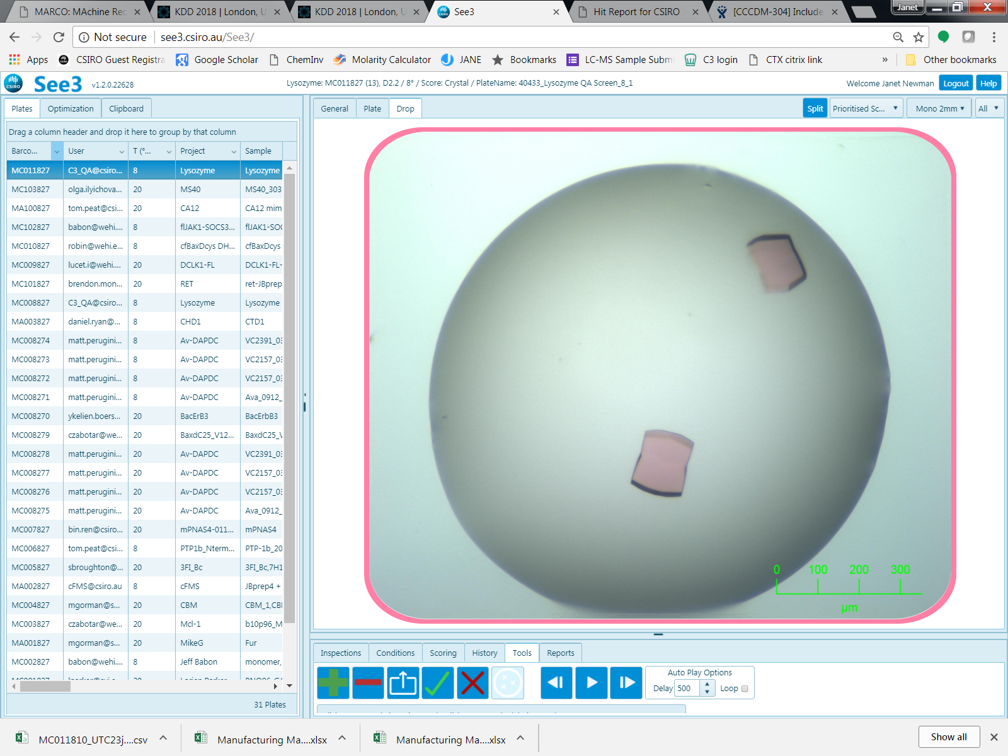

Once selected, click on the ‘+’ icon to activate ROI addition. Once the ‘+’ icon is active (it will lighten when active), select ROIs (up to 20) by left-clicking on the image. ROIs can be removed by selecting the ‘-‘ icon, and clicking on a ROI.

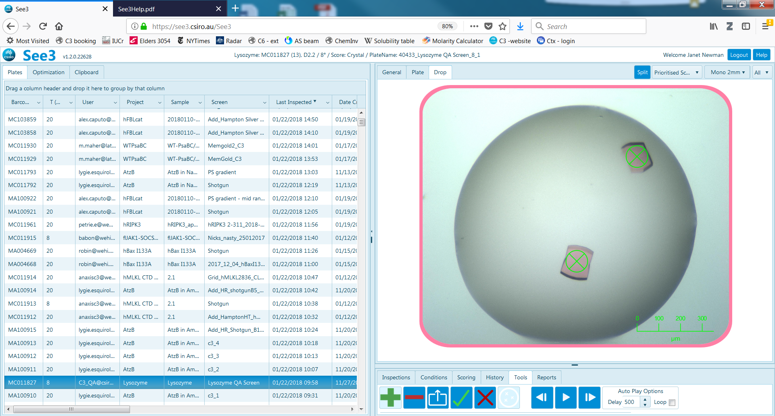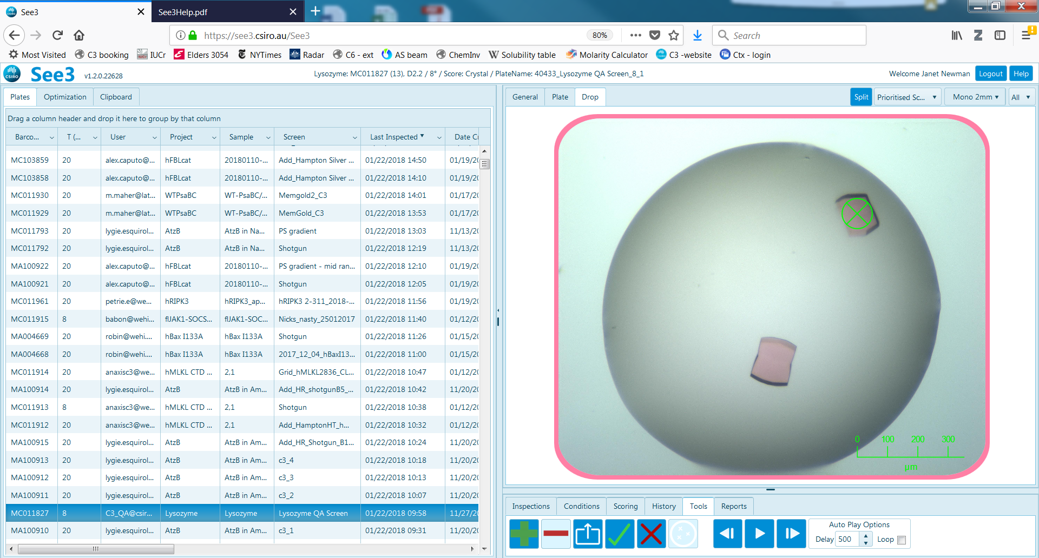

Select the ‘✓’ icon to save the currently selected ROIs. Select the ‘🗶’ icon to exit the ROI option without saving the current ROIs. Click the light ROI icon (outlined purple, above) to exit the ROI picking tool – a prompt appears alerting the user about unsaved changed. ROIs will remain selected until deselected. A Hit Report created with images with (saved) ROIs, (‘Reports’ OPTION, page 14 of this guide) will show the regions of interest on the image associated with each hit.



The export button will generate a formatted (.csv) file containing all the ROIs for the current plate, these are x and y coordinates from the centre of the plate subwell, and an estimation of the Z-offset, based on the curvature of the SD-2 plate.

+x

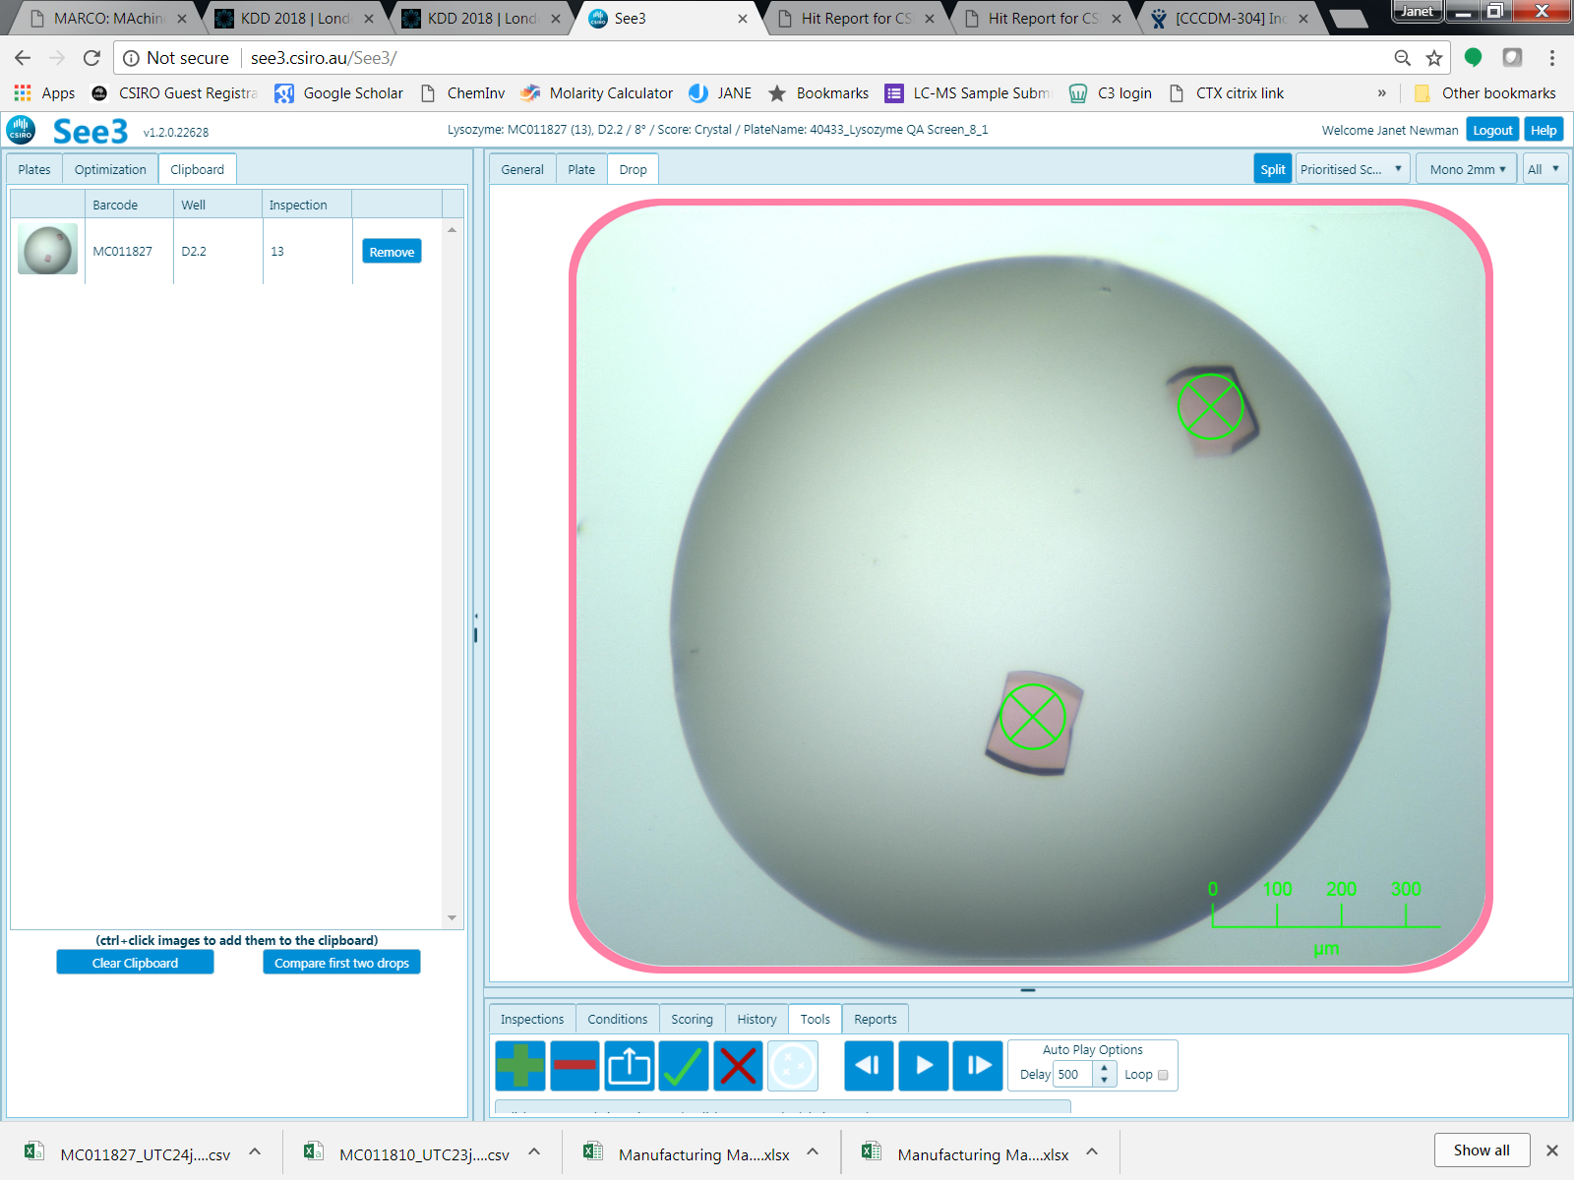

+y

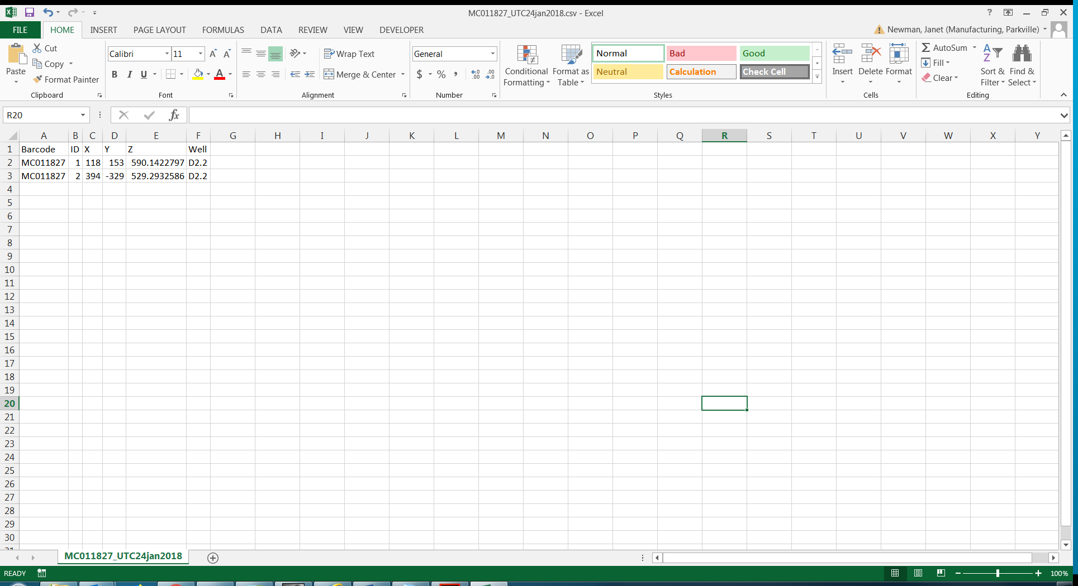

#### Tools OPTION when UV image is showing

When a UV inspection is shown, either as a split screen or as a full inspection, the tools OPTION bar will have one more function, which is a slider bar for adjusting the contrast of the UV image.

By default, the contrast adjustment slider bar is set all the way to the left (least contrast on the UV image).

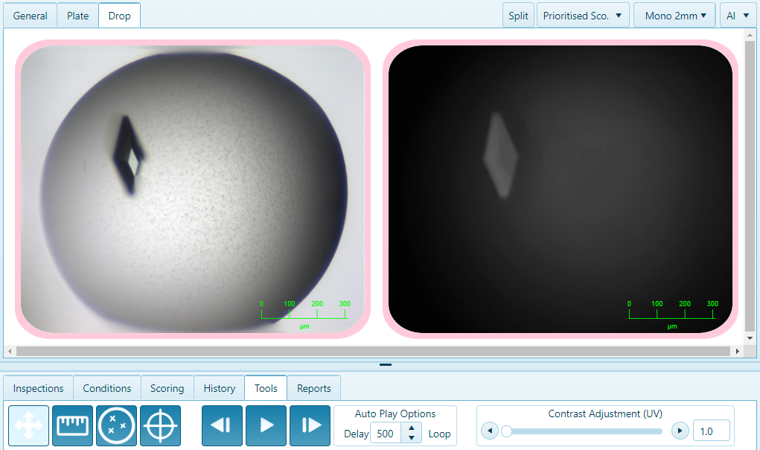

Moving the slider bar across (or typing a number between 1 and 5 into the box on the right side of the slider bar) increases the contrast. The slider bar will stay at the new position until either another manual adjustment is made, or a new plate or inspection is loaded.

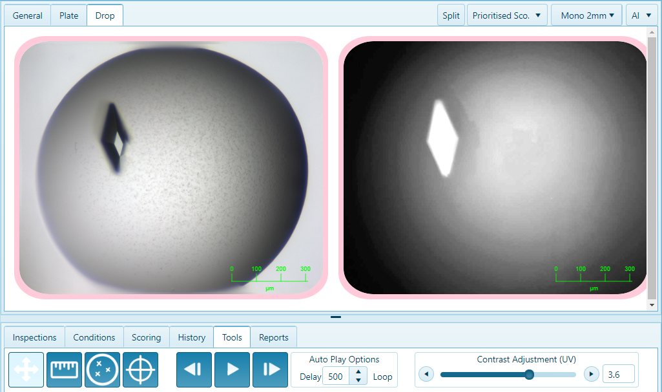

#### Reports OPTION

There are two reports, one which gives an overview of the selected plates, and one which gives a more detailed report of images that have been placed on the clipboard. Click on the “Generate” button opposite the report that you desire.

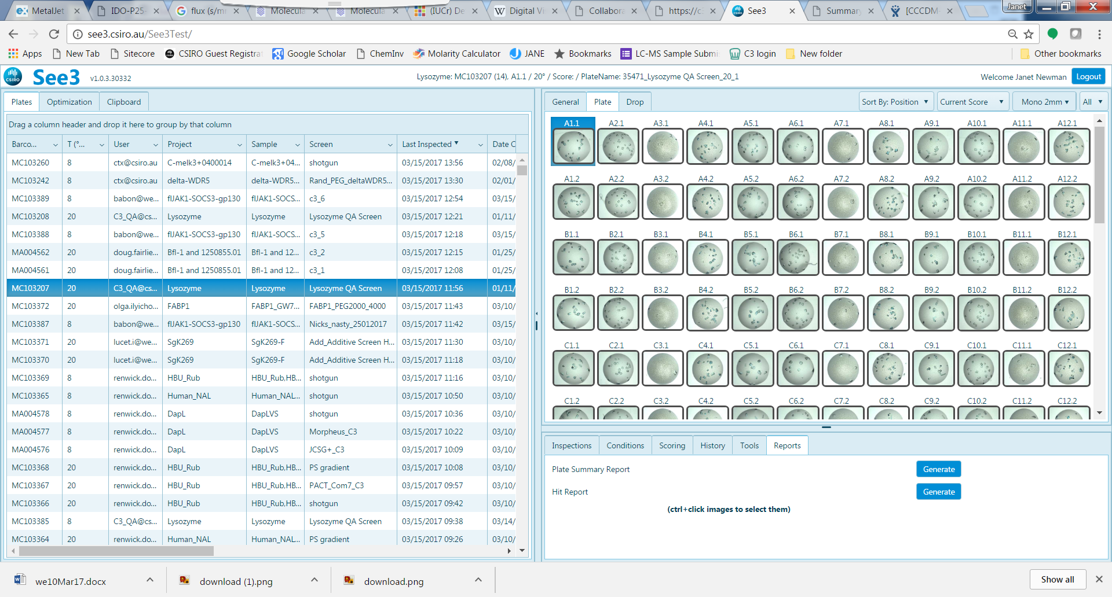

The Overview Report gives a .pdf report of the plate as it is laid out

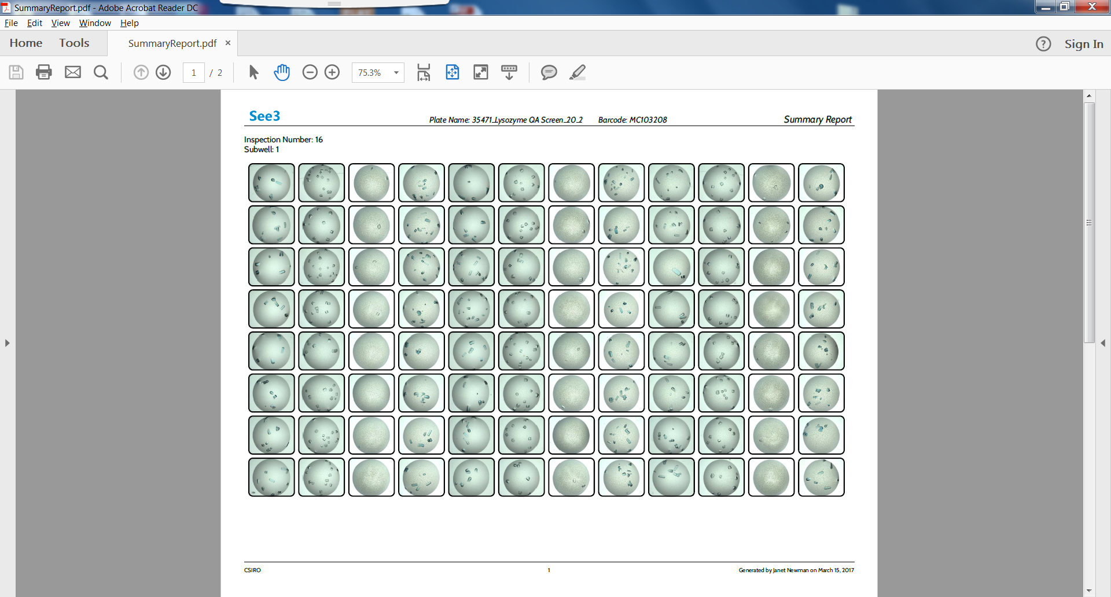

The Hit Report gives details about individual droplets that have been selected. At the end of the Hit Report, a summary of the chemistry found in the drops selected for the report is given (‘Chemistry Range Table’ - circled red below), and all the comments associated with the plates in the report will be written out (circled green, below).

 

### Clipboard *SUB*-*VIEW*

The clipboard allows the user to assemble a set of images (droplets) that are interesting – these can be from one or more plates. The clipboard is cleared each time a user logs out of the system. A drop is added to the clipboard by holding down the CTRL key whilst clicking the appropriate image. This works both from the Plate or the Drop VIEW.

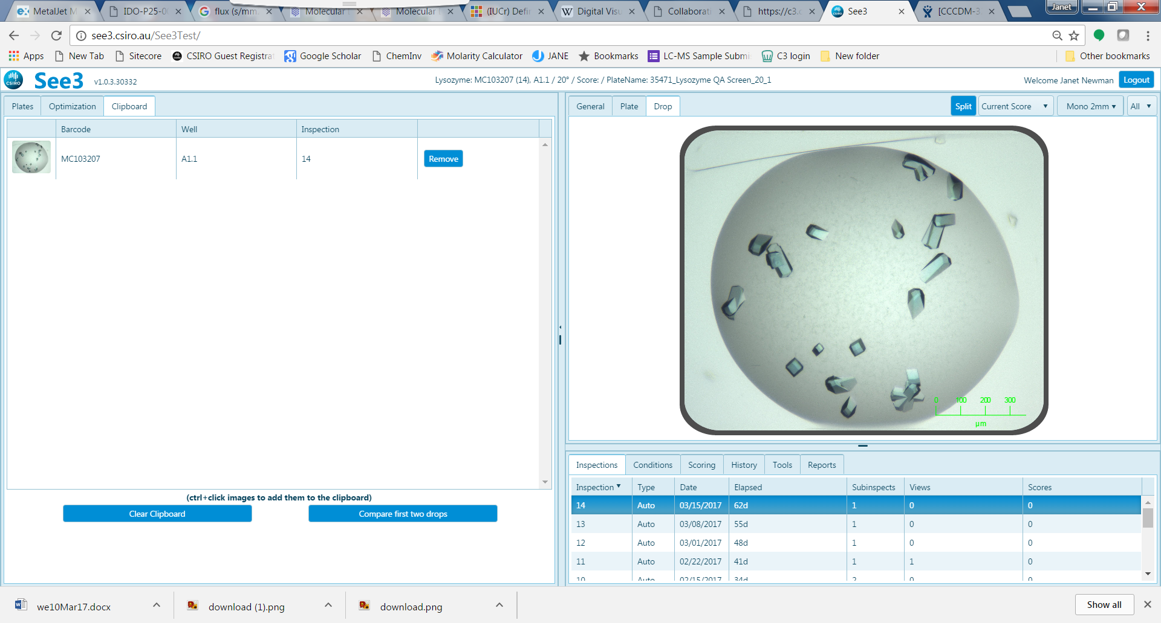

Once the appropriate set of drops has been assembled, these can be used in either optimisation or to generate a Hit report. One can add all the images from the History *OPTION* to the clipboard, then use the Hit Report to get a record of the time course of a droplet

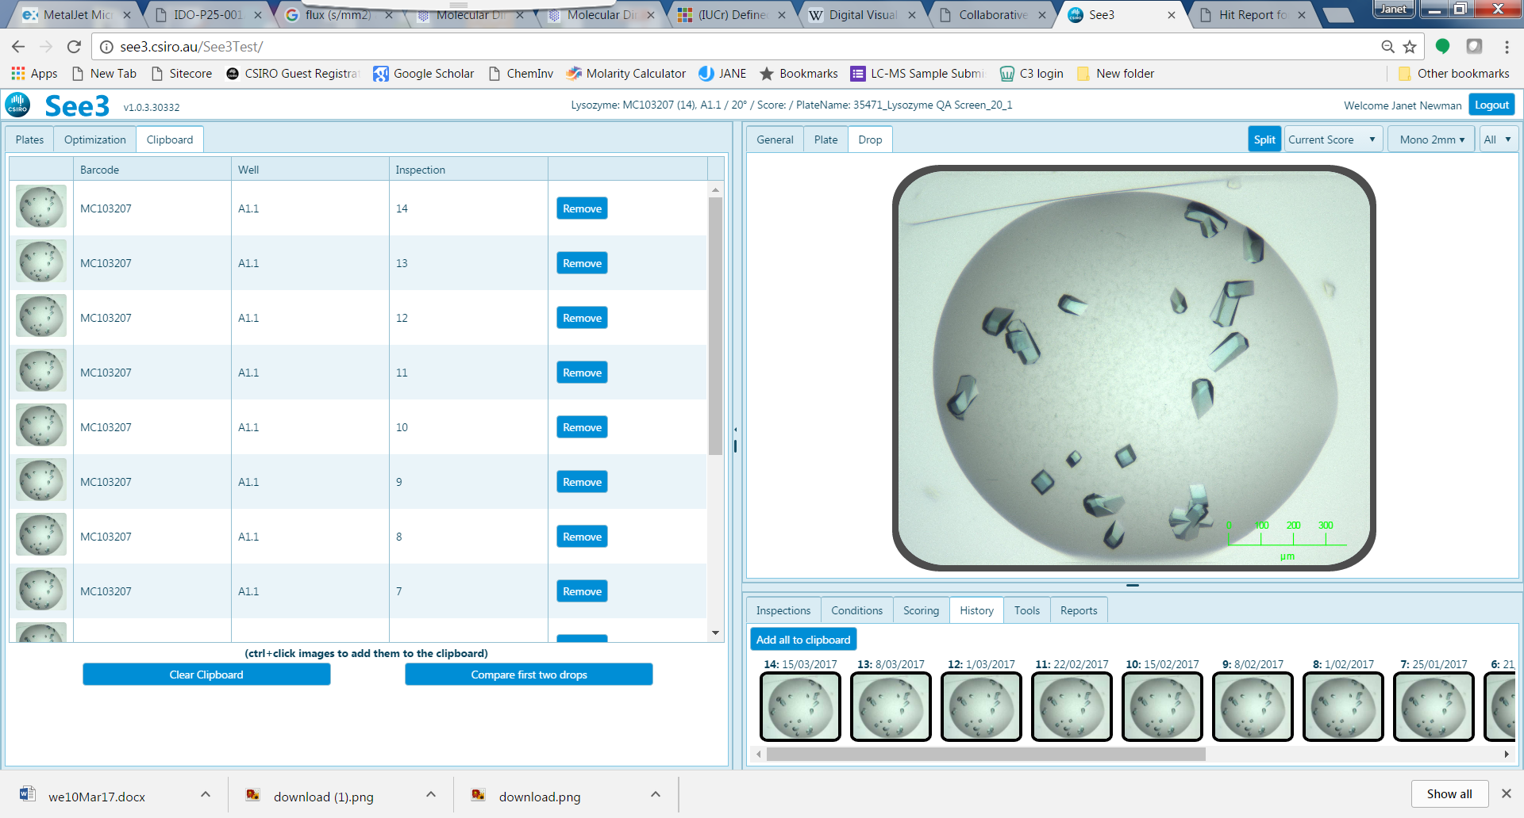

### Designs *VIEW*

The designs view has two SUB-VIEWS, ‘Create’ and ‘Browse’

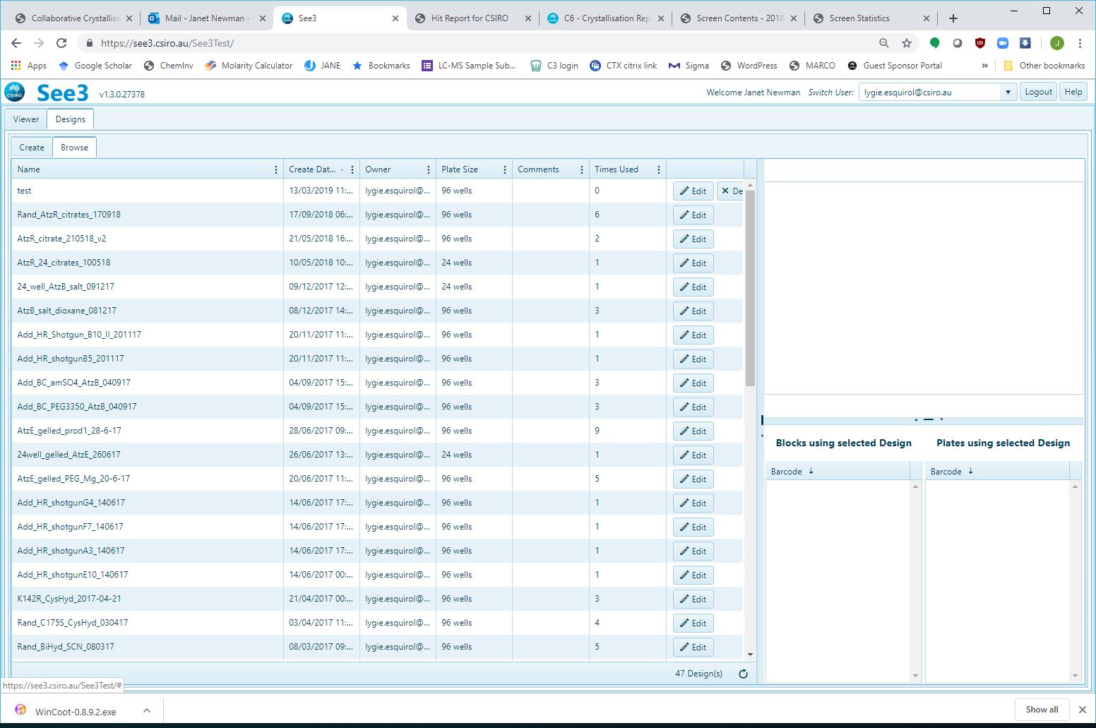

#### Browse SUB-VIEW

The ‘Browse’ sub-view opens to show a grid on the left, and two panels on the right, see image below. The grid contains a listing of all the designs (i.e., description of crystallisation screens) owned by the user currently logged in. This design grid can be modified in a similar manner to the ‘Plate’ grid described above. The design grid can be customised by filtering, sorting, grouping, re-ordering and selecting which columns are to be displayed. The upper of the two panels shows a graphic of the screen design, when one is selected from the design grid. The lower panels shows the usage of the design selected in the grid.

By default, the ‘Browse’ design grid shows all the designs ordered such that the most recently created design is at the top of the grid. The right-most column allows one to Edit or Delete a design – a design may only be deleted if it has not been used in either a crystallisation plate or a deepwell block.

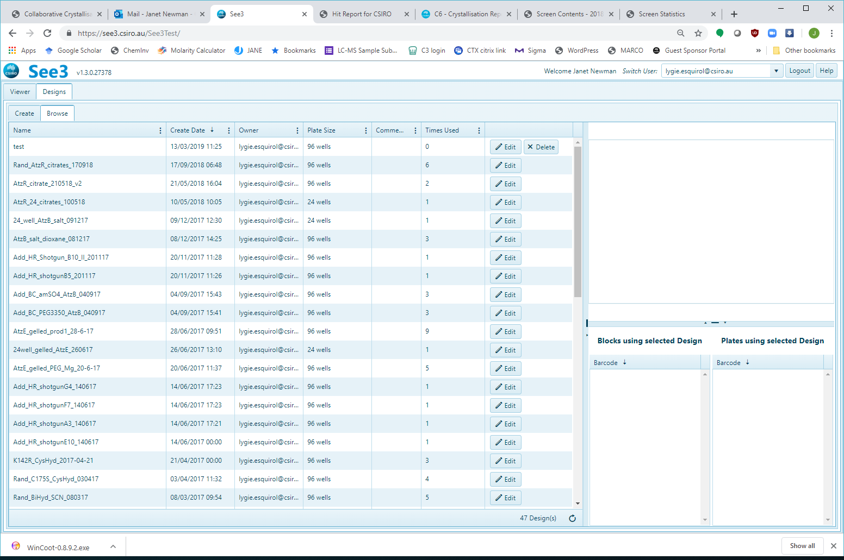

**Design Use**

**Design Graphic**

**Design Grid**

Clicking on a row in the design grid selects that design, and populates the panels on the right-hand side of the sub-view. The design graphic panel will show a cartoon of the contents of each well, where the colours of the bars represent the type (or class) of chemical factors, for example, all PEGs will be in the same colour. The length of the bar shows the concentration (or pH) of the different chemical factors. Hovering the cursor over a well in the design graphic will pop up a dialogue containing a description of that well. The lower, design use panel shows a list of all the barcodes ever associated with the selected design. There are two lists – one for deepwell blocks and one for experimental plates. In the example below, the design has been made up into one deepwell block and has been used in five crystallisation plates.

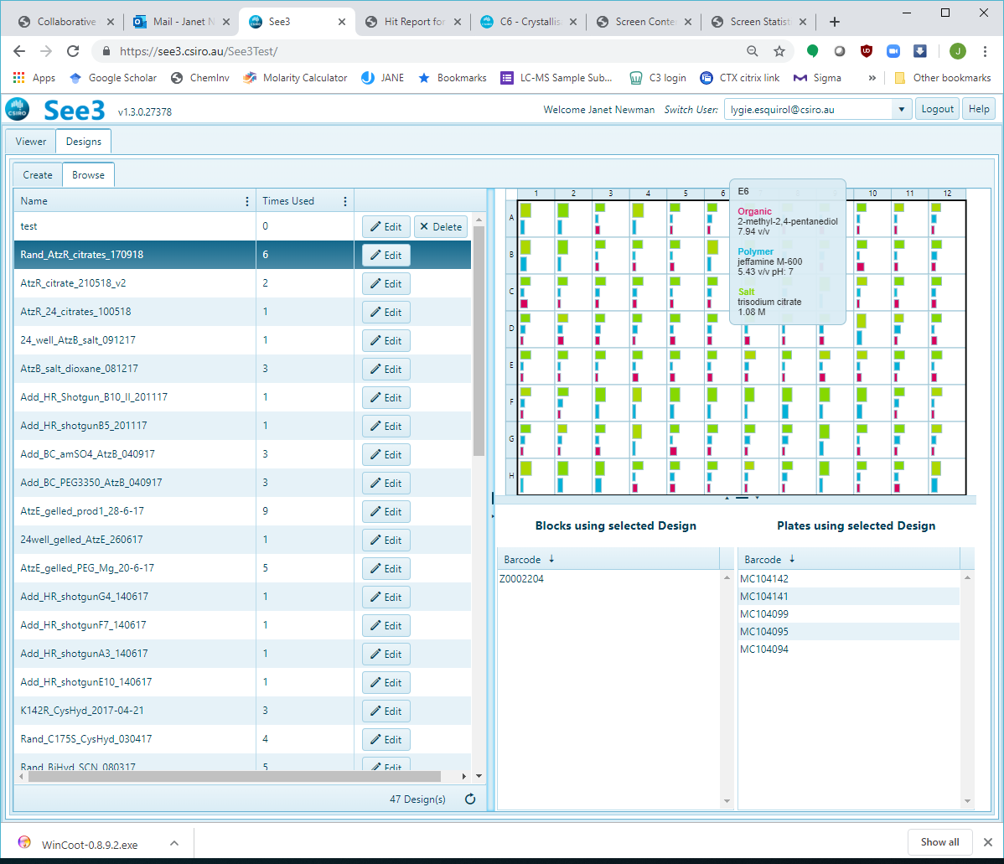

Clicking the ‘Edit’ button brings up a window which shows the information from the grid, but only allows one make changes to any comments associated with the design:

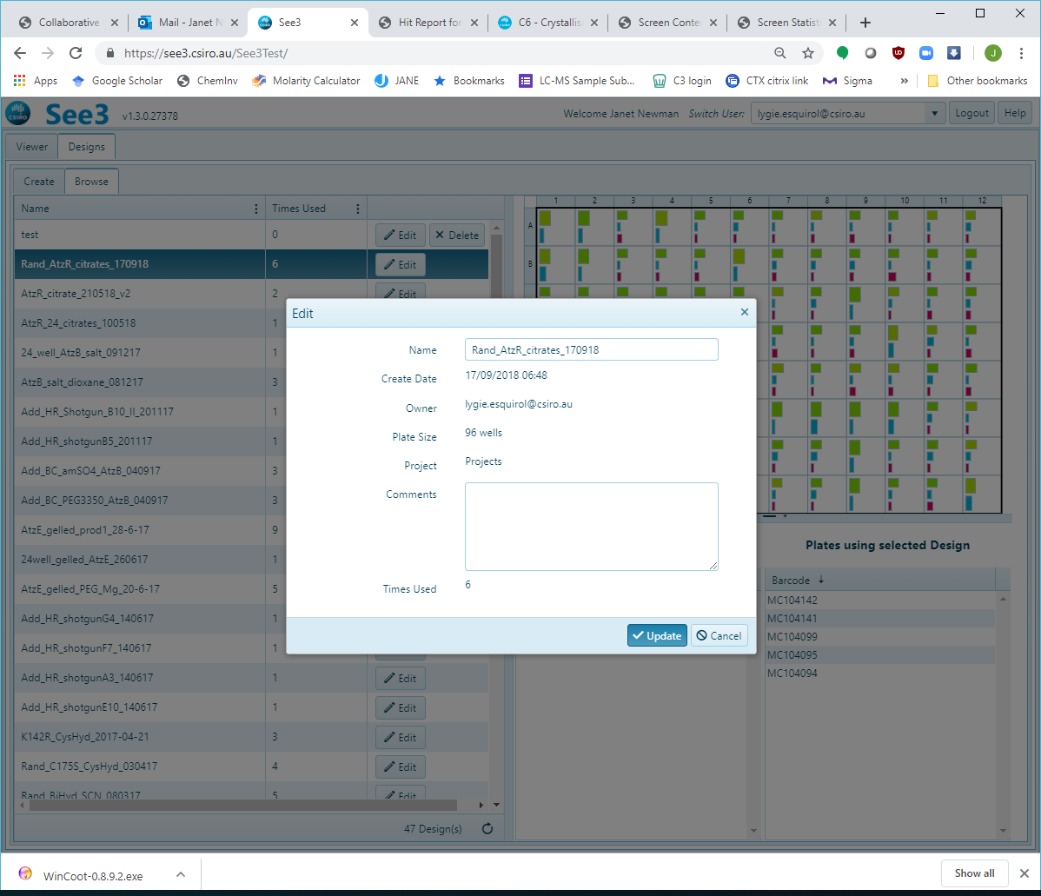

#### Create SUB-VIEW

The Create sub-view has four panels, the **Design Details** panel, found on the upper left-hand side of the screen, the **Generation** panel, found on the lower left-hand side of the screen, the **Factor Grid**, on the upper right-hand side of the screen and the **Plate Graphic**, on the lower right side of the screen. When you first click on the ‘Create’ tab only the **Design Details** panel will be populated:

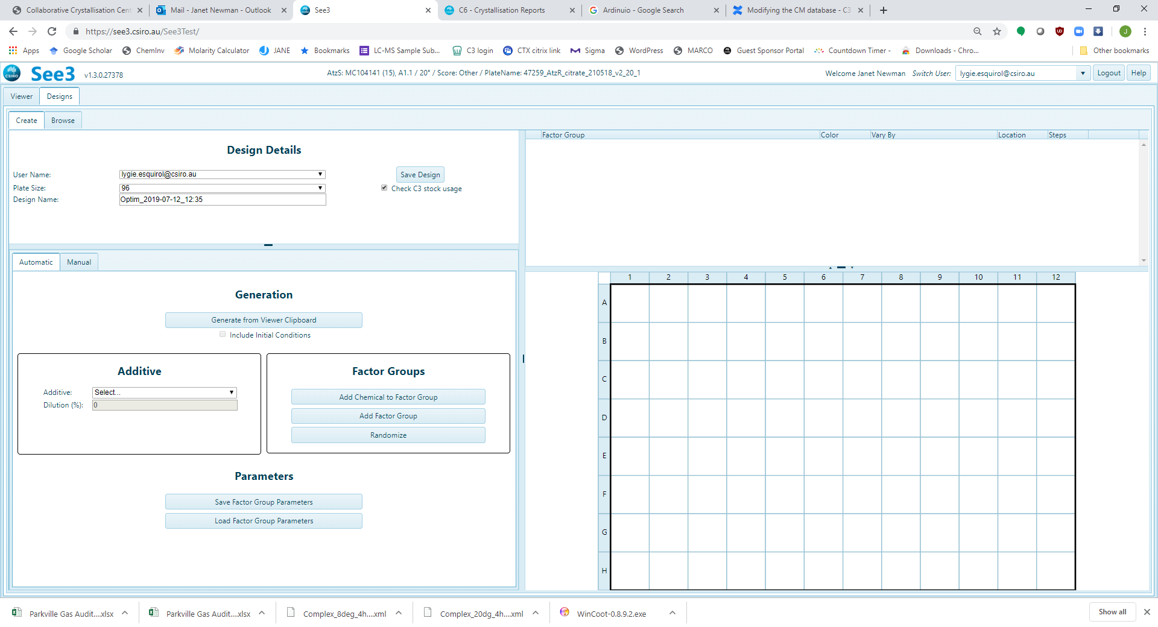

**Plate Graphic**

**Factor Grid**

**Generation**

**Design Details**

The **Design Details** panel sets the defaults for ownership, size and name of any screen designed in the ‘Create’ tool. By default the *User Name* is set to the user currently logged in (any other registered user may be selected), the *Plate Size* is set to 96 (other options are 24 or 48) and the *Design Name* is set to a “Optim_*date*”.

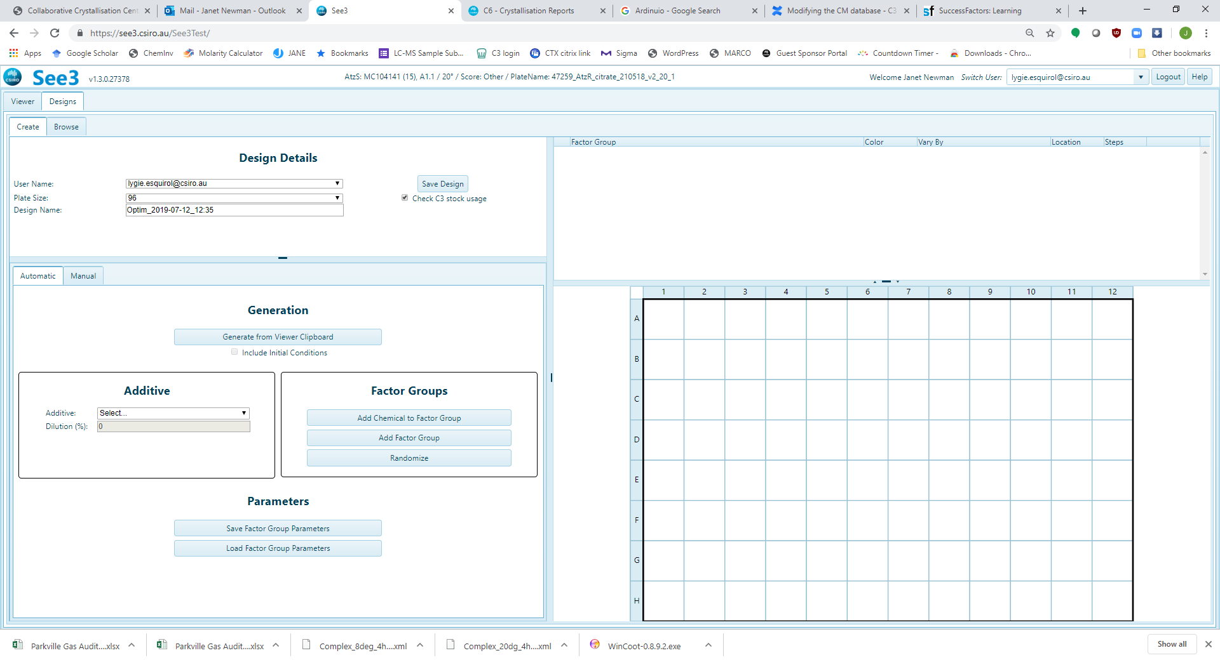

The Generation panel has two options – ‘Automatic’ and ‘Manual’ (circled red)– by default the Automatic Tab is active.

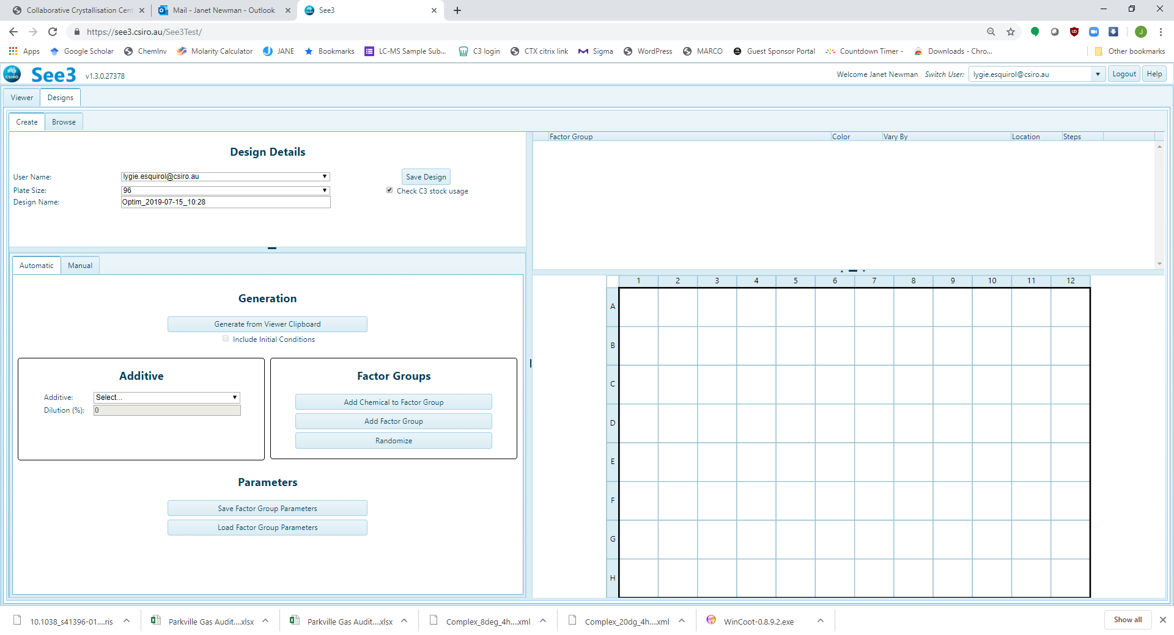

In this mode, whole-plate optimisations are generated automatically. The default optimisation generated is a random optimisation – in a random optimisation upper and lower limits are set for either the concentration or pH of a chemical, and a value between the limits is selected each time that chemical is used.

There are three ways of initiating an automatic optimisation – adding chemical factors one by one, or by using all the chemical factors defined by the current selection on the clipboard. The most common way to start an optimisation is to load to clipboard with any hits from a project, then use the button ‘Generate from Viewer Clipboard’, circled red below.

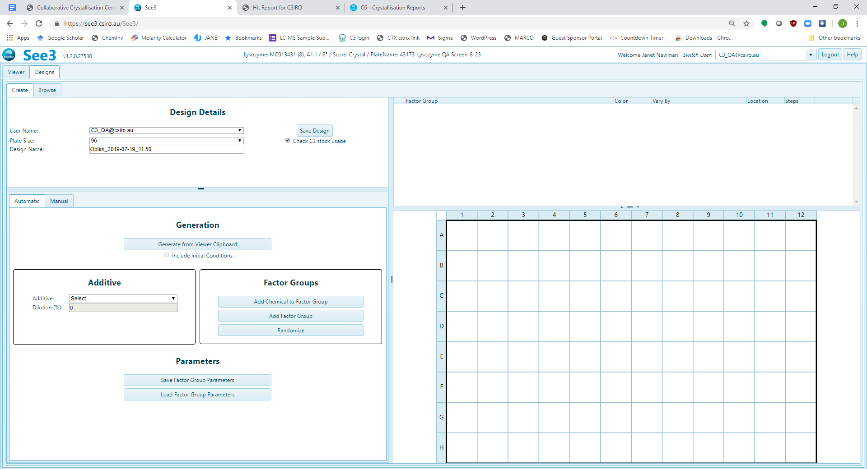

When this button is pressed, the information in the Chemistry Range Table is used to populate the factor grid, and in turn to populate the plate grid. Taking as an example, the Chemistry Range Table below:



On pressing the ‘Generate from Viewer Clipboard button’, the **Factor Grid** is populated:

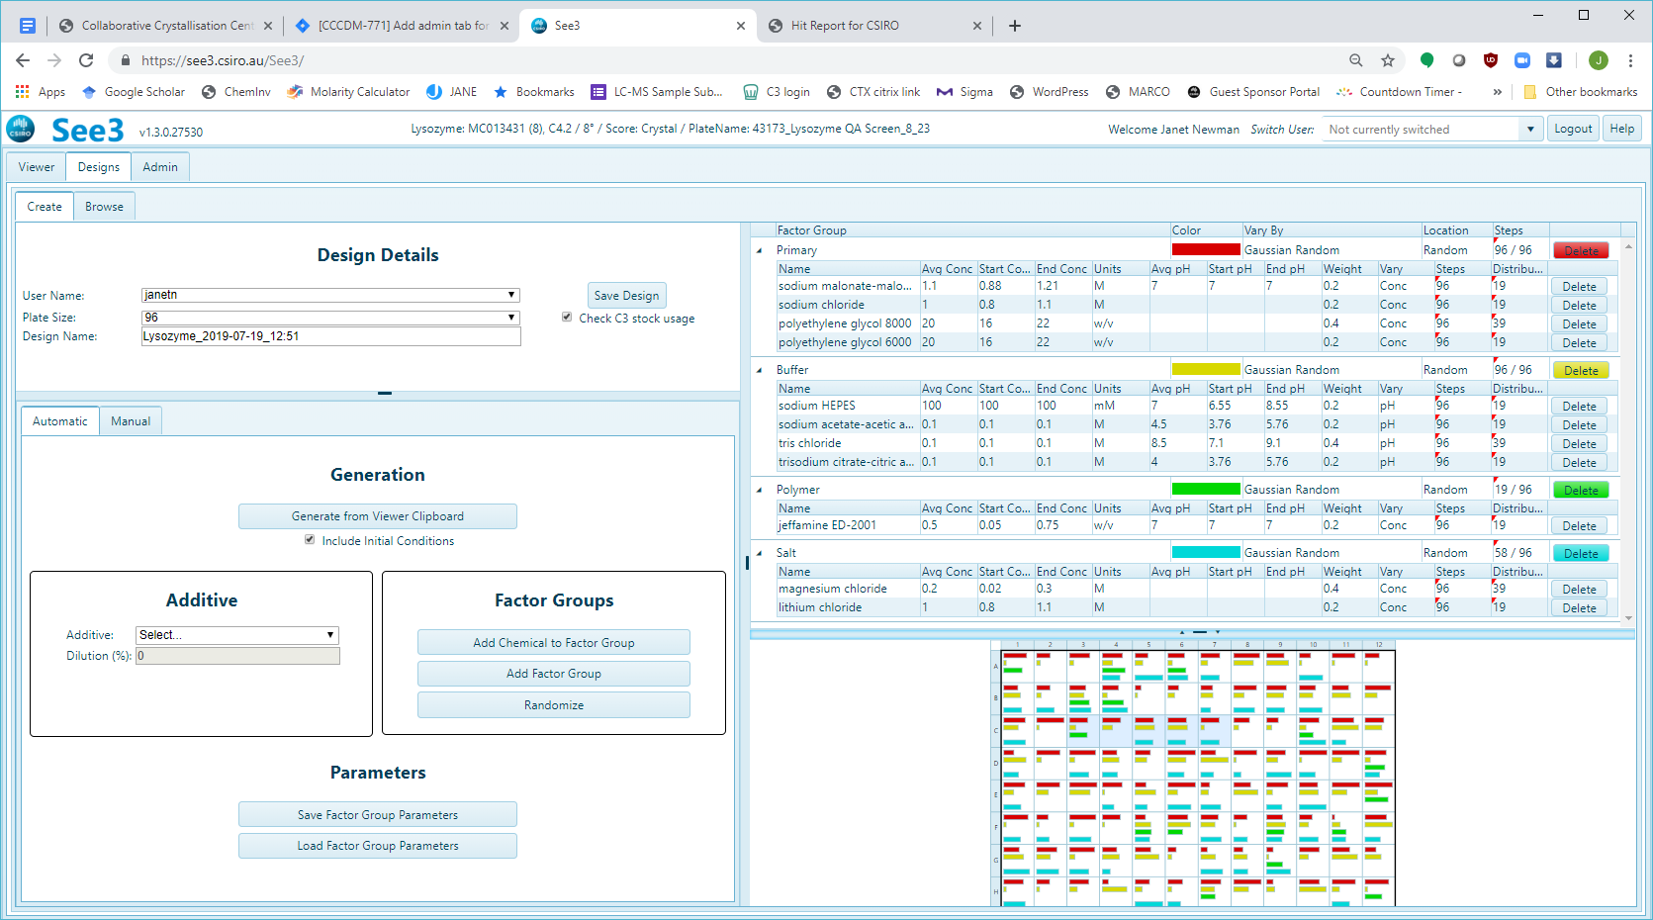

Using the defaults, this will generate the following **Plate Graphic** – hovering the cursor over a well will display the contents of that well.

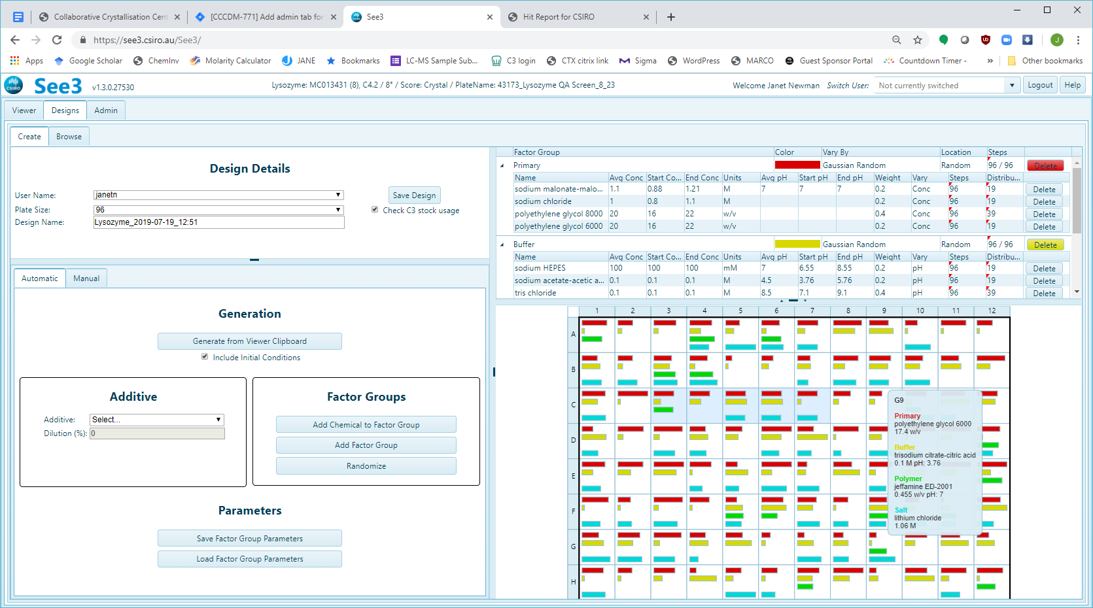

Notice that the same eleven chemical factors (in this case) appear on both the Chemical Range Table from the Hit Report and in the **Factor Grid**, with the same average concentrations. However, the grouping of the chemical factors has changed - these are now sorted into chemical **Factor Groups**. The optimisation logic selects a single chemical factor from each **Factor Group** and selects a value for the concentration (or pH) for that factor; these are combined to create a new condition in the resulting optimisation. Normally, a **Factor Group** will contain chemical factors of the same class (salts, for example, are found in the ‘Salt’ **Factor Group**). However, the chemicals which are found at the highest concentration in each of the Initial conditions (the primary factor) are combined into their own ‘Primary Factor’ **Factor Group**.

A second way to start an optimisation is from a saved Factor Group



This will bring up a list of saved Factor Sets

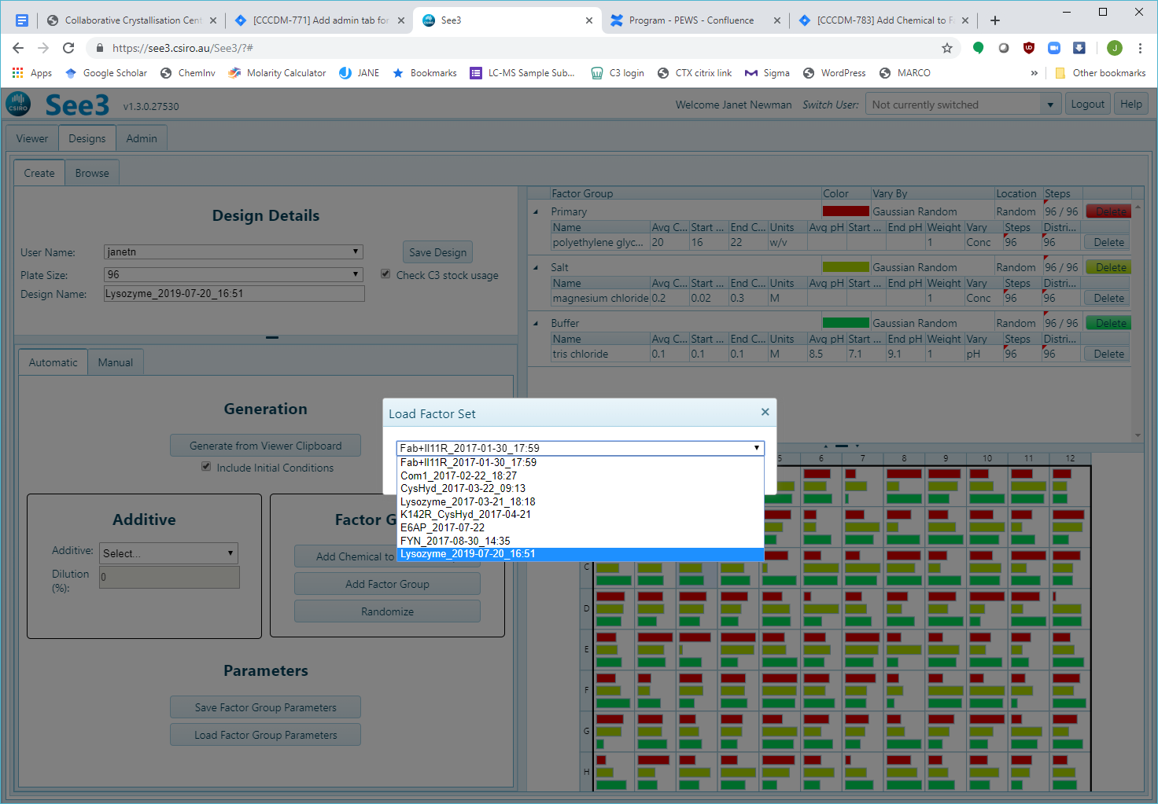

Choosing one will populate both the **Factor Grid** and the **Plate Graphic.**

The **Factor Grid** encapsulates the concepts of the optimisation, whereas the **Plate Grid** shows the current instantiation generated by the **Factor Grid**. The same **Factor Grid** will generate different **Plate Grids** if the ‘Randomize’ button on the **Generation** tab is clicked. If the ‘Save Design’ button on the **Design Details** panel is pressed, the conditions currently shown in the **Plate Grid** will be saved. A previously saved **Factor Grid** can be reloaded by clicking the ‘Load Factors’ button – this will display a list of previously saved grids, any of which can be selected.

The **Plate Grid** gives a visual representation of the current instance of the **Factor Grid**, where the colour of the bar indicates from which Factor Group it comes, and the length of the bar gives an indication of the concentration or the pH (the distance from the lower limit). Mousing over a well will display the contents of the well. By default, the conditions on the clipboard (the **Initial Conditions**) used to define the optimisation will be transferred unchanged to the optimisation and will be found in the wells starting at position C3. These wells have a pale blue background, and the starting condition is included in the information provided in the mouse over. Uncheck the ‘Include Initial Conditions’ checkbox in the **Information Pane** to turn off this feature (Red Arrow, below)

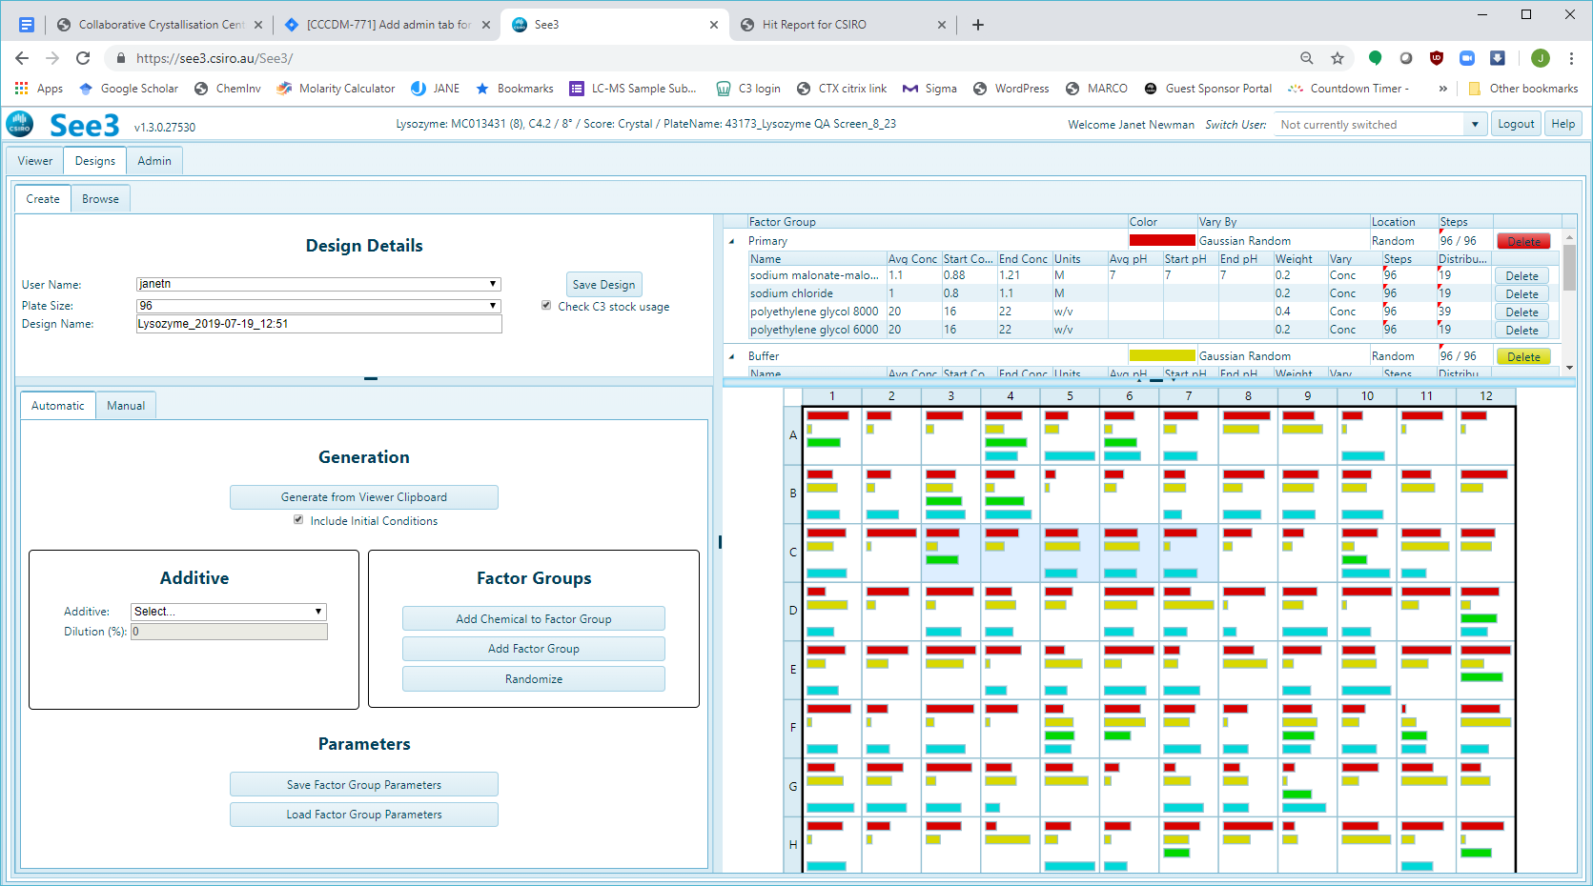

Mousing over a coloured bar will highlight the other wells which contain that same chemical (black dashed border) and will highlight where that chemical is found in the Factor Grid. Conversely, mousing over a chemical in the **Factor Grid** will highlight where that chemical is found in the **Plate Grid** (black arrow, below).

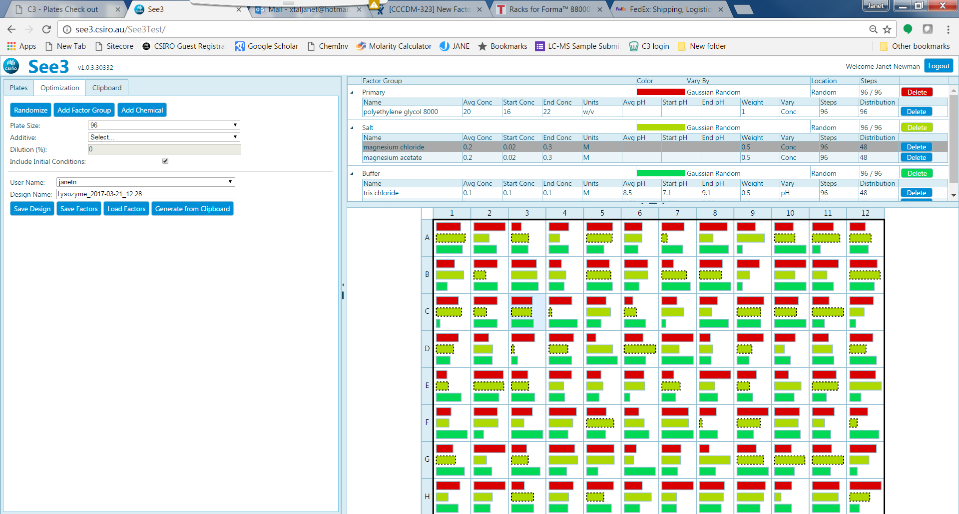

The **Factor Grid** consists of one or more **Factor Groups**. Each **Factor Group** contains one or more **Chemical Factors**. A **Chemical Factor** is a chemical with an associated concentration, unit and (potentially) pH value. Thus ‘ammonium sulfate’ is a chemical, and ‘1 M ammonium sulfate’ is a **Chemical Factor**. The **Factor Grid** has a Header Bar (marked with a red arrow, below) which contains columns relevant to all **Factor Groups**. Each individual **Factor Group** has a secondary Header (green arrows) which contains columns relevant to the **Chemical Factors** within the **Factor Group**. The coloured ‘Delete’ buttons remove the entire **Factor Group**, whereas the blue ‘Delete’ buttons remove individual **Chemical Factors** from within a **Factor Group**. 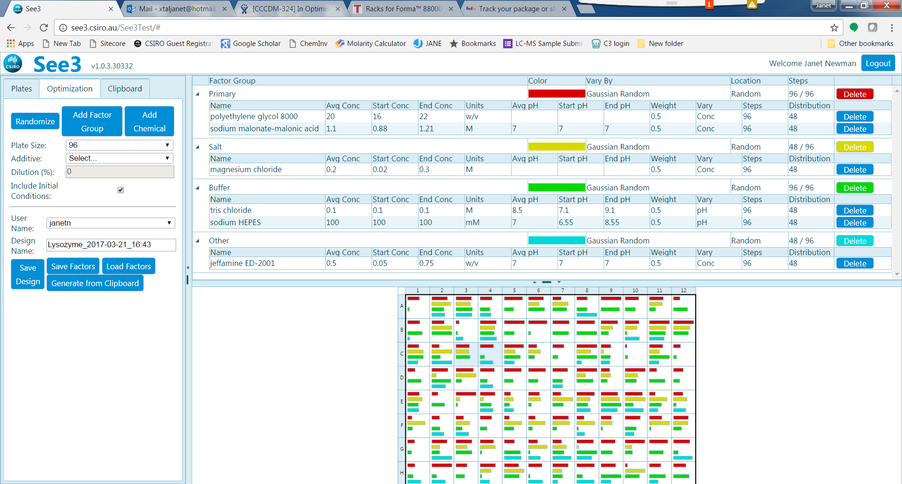

One can drag and drop **Chemical Factors** between **Factor Groups**, and you can drag and drop within a **Factor Group** as well – this allows one to change the order of the **Chemical Factors** and thus potentially their location on a plate.

Within a **Factor Group** one can vary the colour, the way in which concentration varies (‘concentration’ will be used throughout, the same logic would apply to pH values if the pH rather than concentration is being varied) and the way in which the values are arrayed in the **Plate Grid**. All factors in the group will use the same ‘Colour’, ‘Vary By’ and ‘Location’ options.

The ‘Vary By’ pulldown menu shows the different options for changing the concentration of the factors within the group. By default, the concentration is varied randomly between the upper and lower limits, but with a bias towards the starting value. This is called ‘Gaussian Random’. An unbiased random selection of concentration between the upper and lower limits can be chosen with the ‘Vary By’ option ‘Uniform Random’.

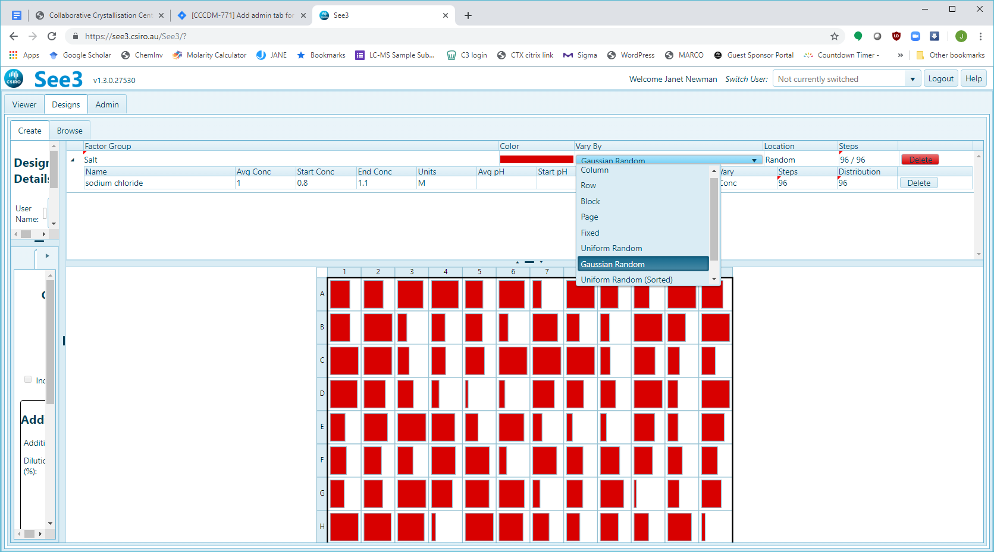

Both the Gaussian and Uniform random selections can be ordered, so that the smallest concentration value is found in the upper right hand corner of the selection, and the largest concentration is found in the lower right. The values don’t change, but the arrangement does.

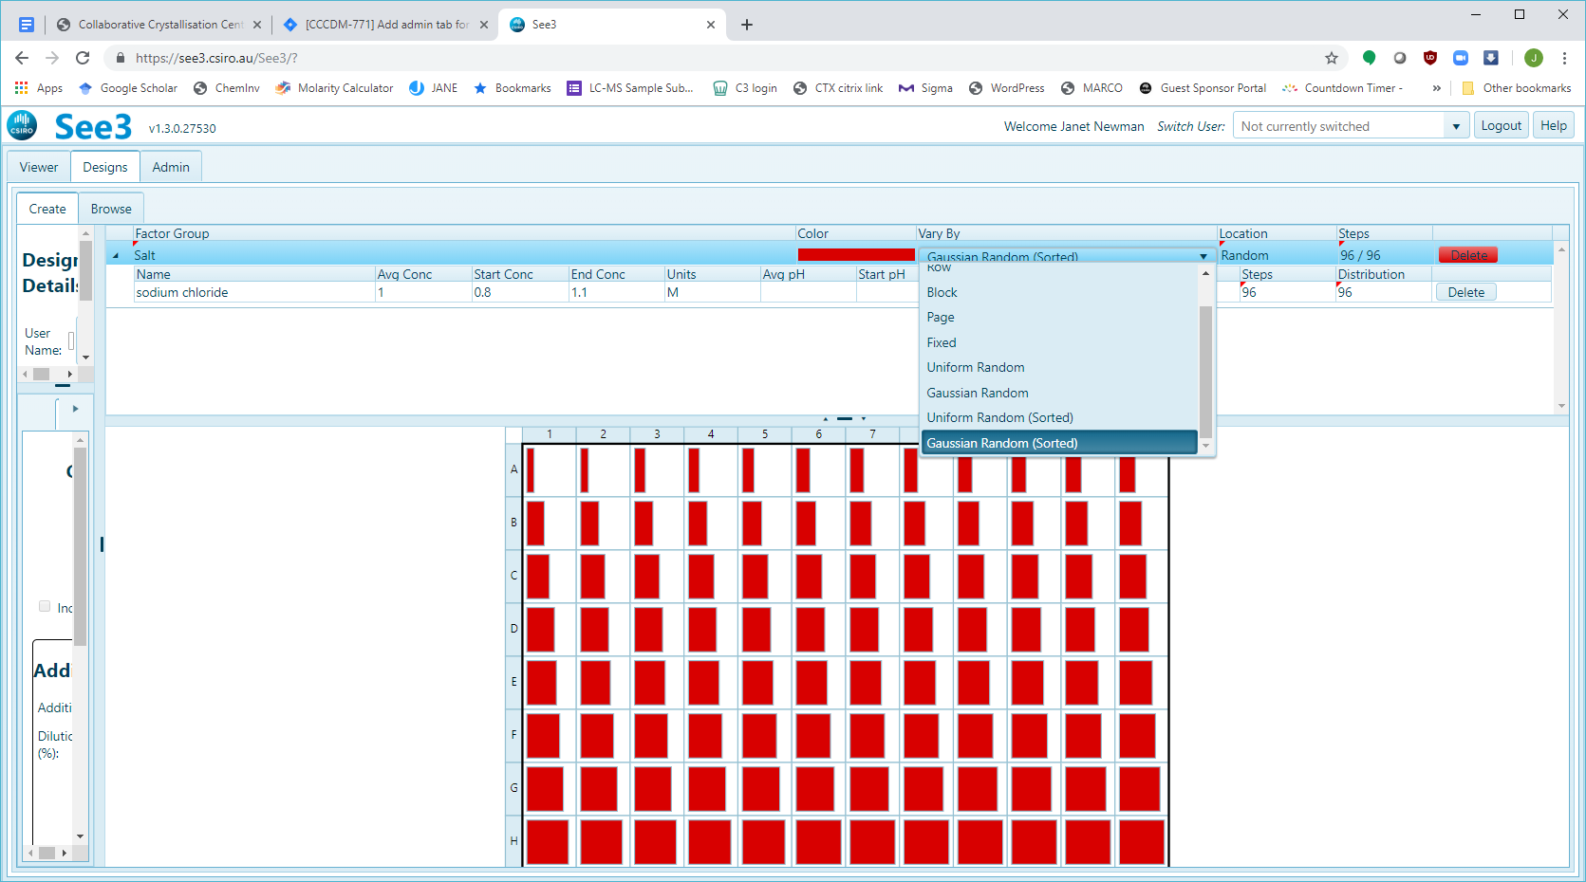

‘Vary By’ column sets up a grid from left to right across the columns of the plate (green, below) and ‘Vary By’ row sets up a grid from top to bottom across the rows of the plate (yellow, below)

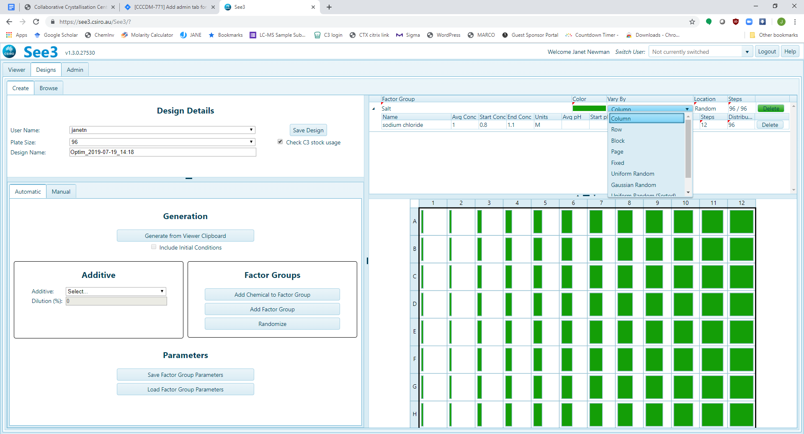 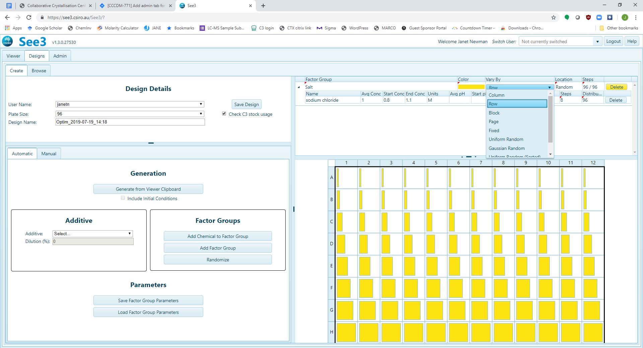

‘Vary By’ block gives four values spread over the quadrants of the plate (cyan, below), and ‘Vary By’ Page gives two values spread over the two halves of the plate (magenta, below)

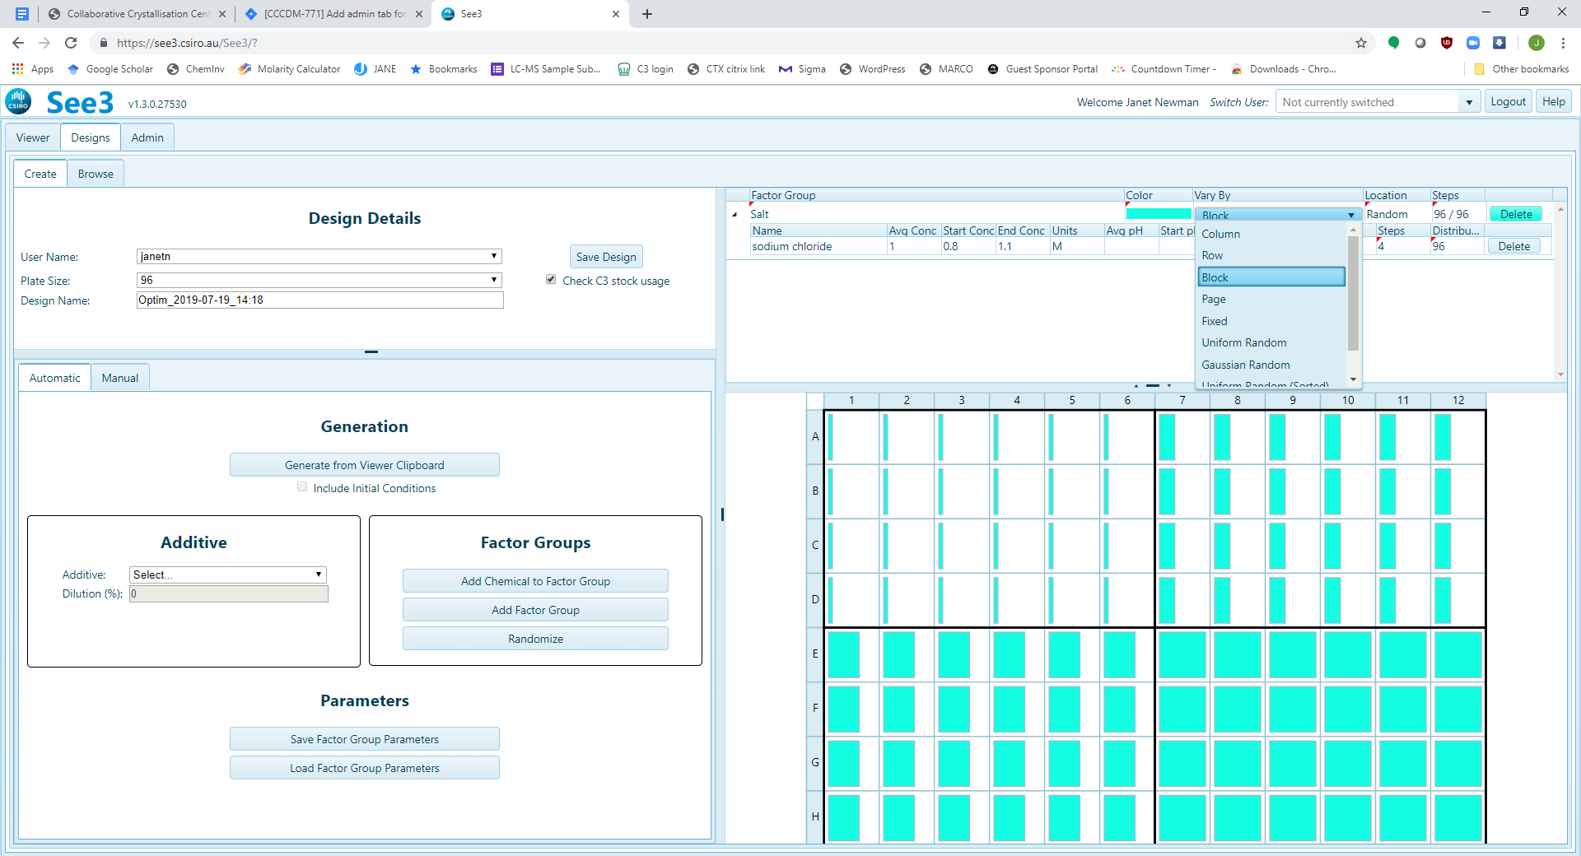 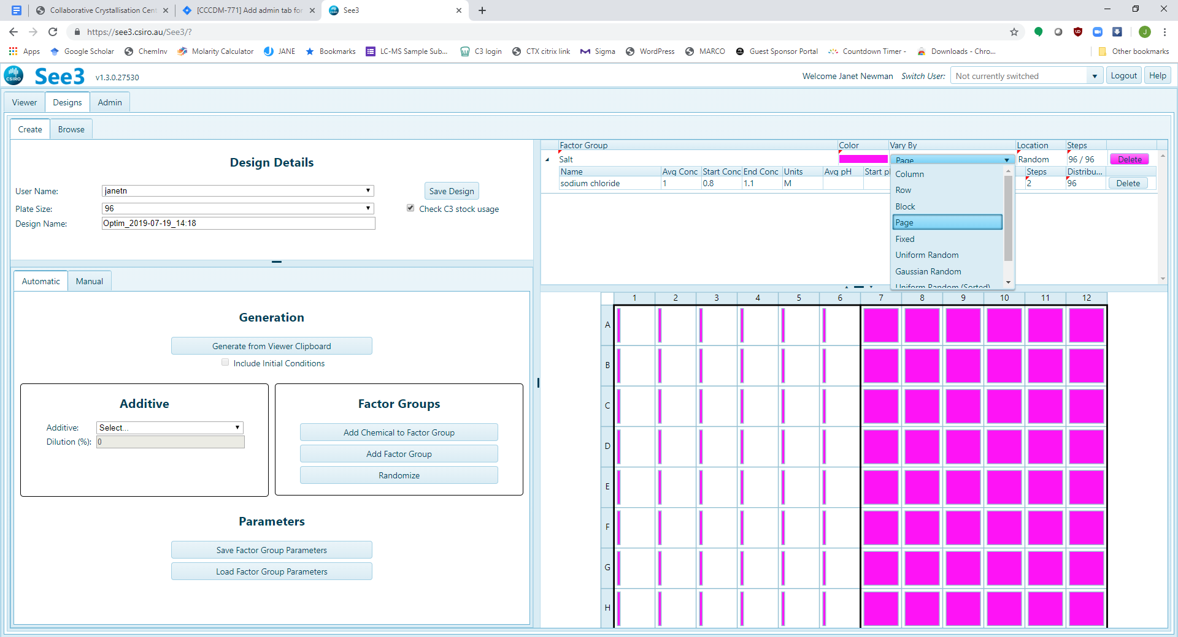

‘Vary By’ fixed keeps the value of the factor constant (brown, below)

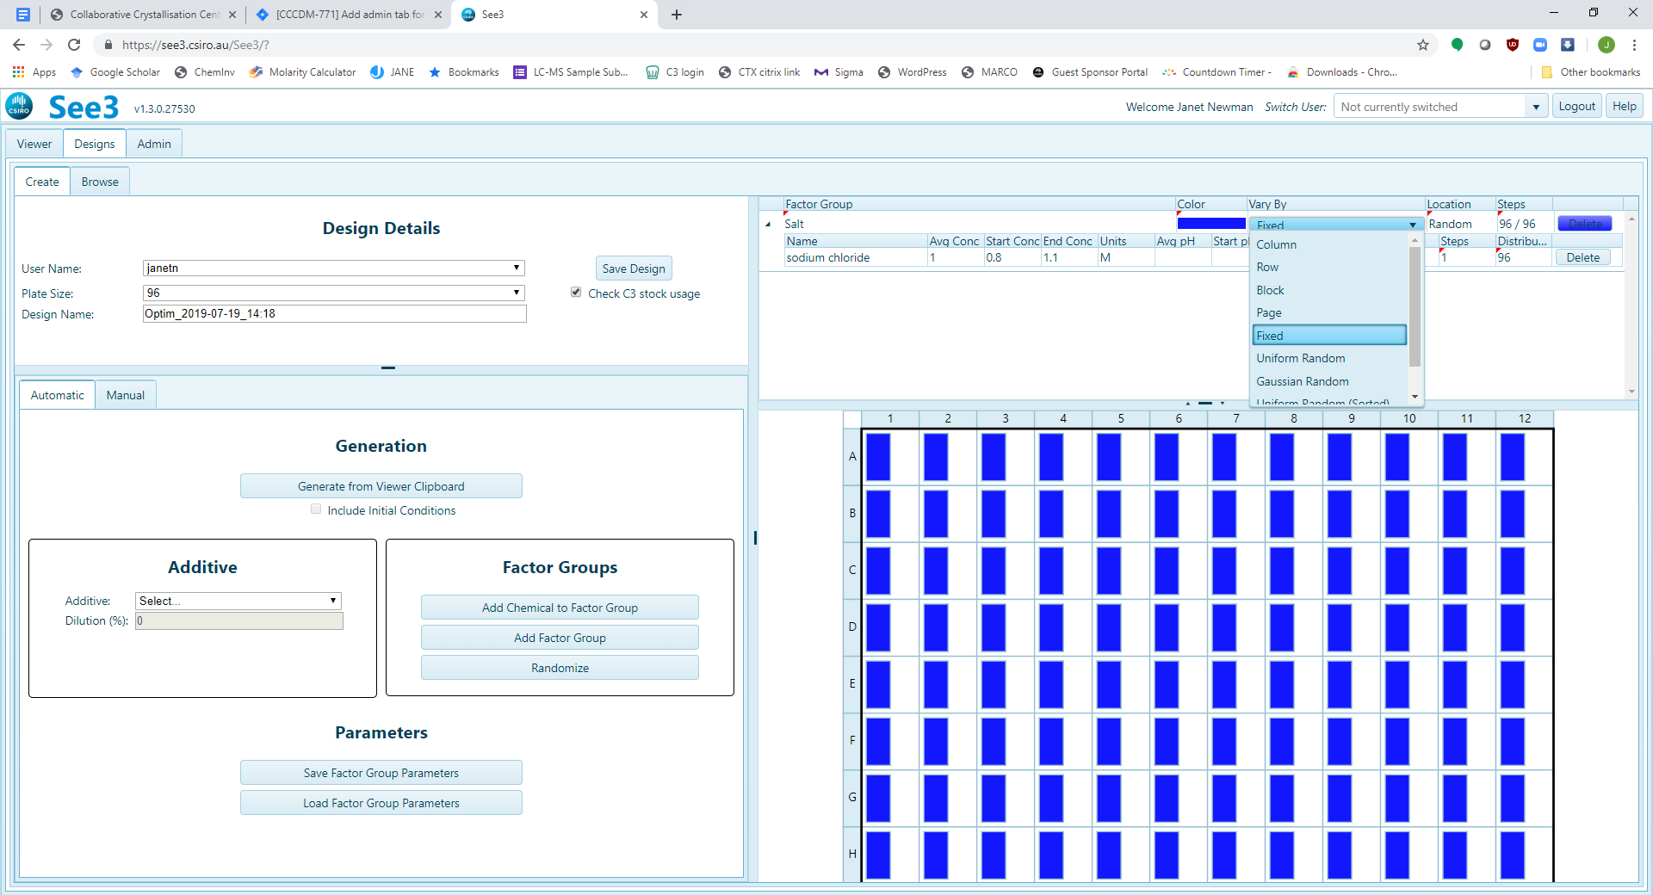

When there is more than one Chemical Factor in the Factor Group then the ‘Location’ option becomes relevant. This allows one to position the Chemical Factors on the plate, irrespective of how the concentration is being varied. By default, the distribution of the Chemical Factors on the plate is ‘Random’ (see below).

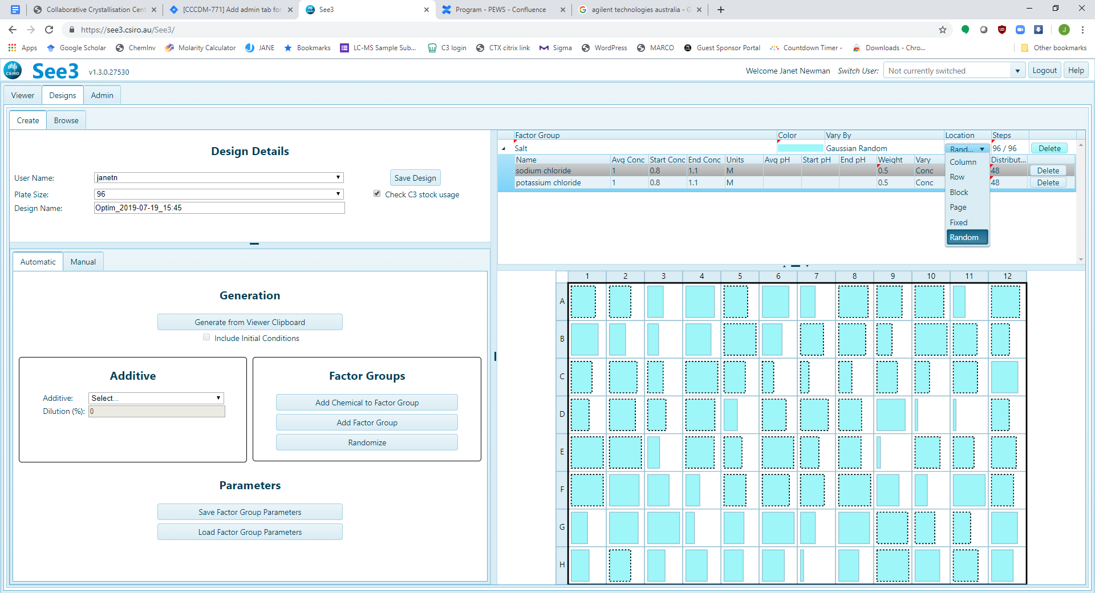

By selecting ‘Column’ under ‘Location’, the plate is sorted so that all the wells containing a particular Chemical Factor are co-located (blue, below – look to see which wells have the black dotted border).

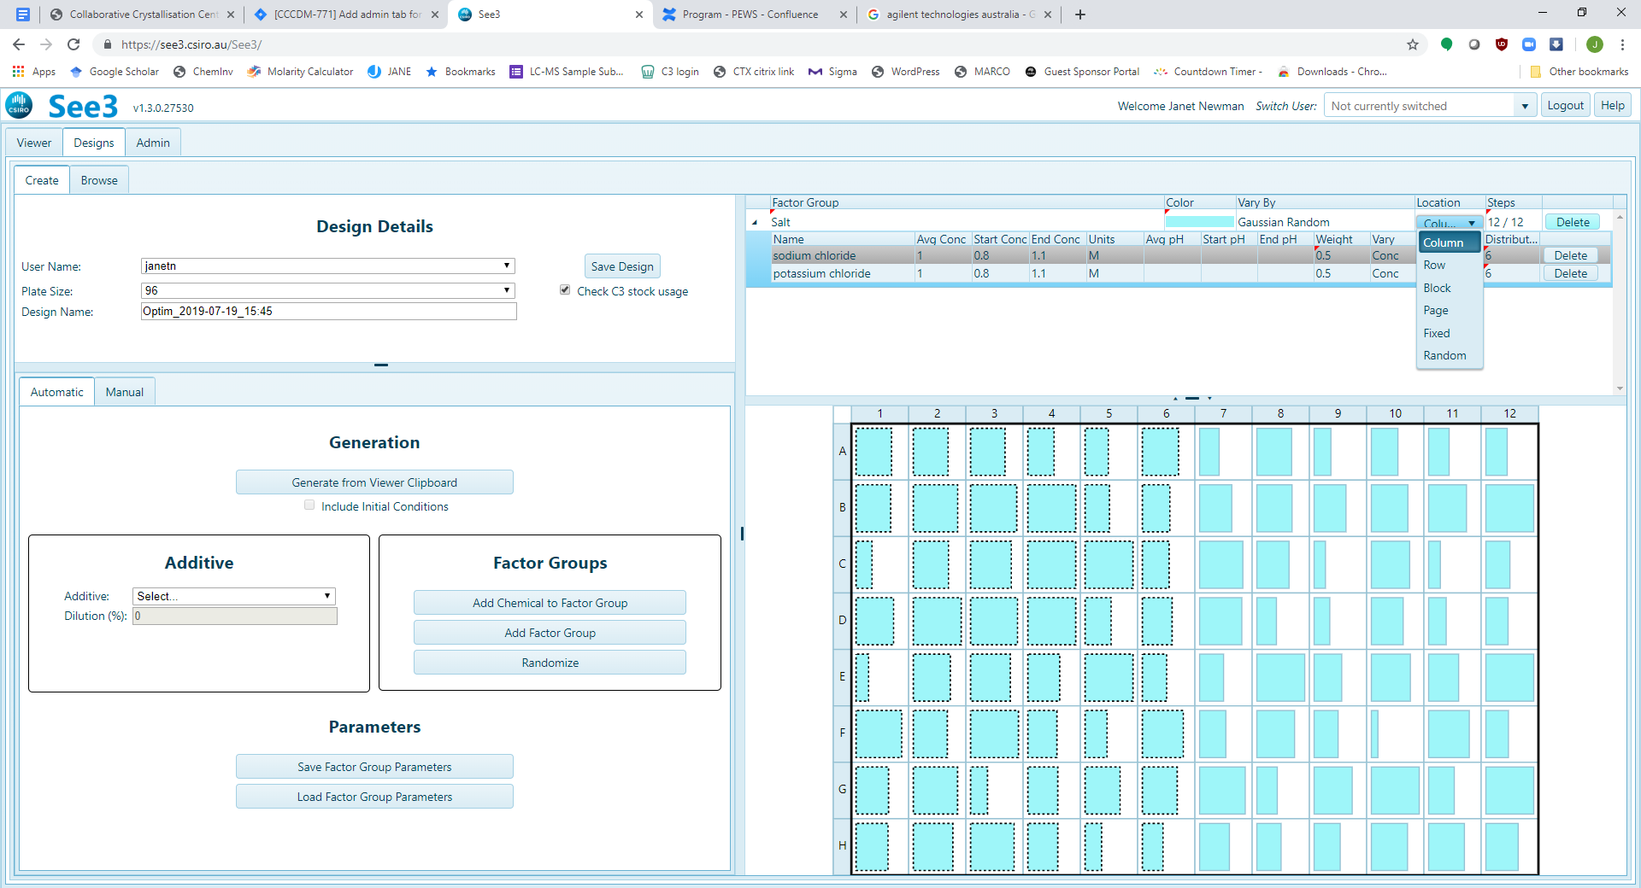

The distribution of the Chemical Factor across the plate is determined by the weight associated with the Chemical Factor. In the following example, each of the two Chemical Factors within the Factor group have an equal weighting of 0.5, so so each gets half the number of available columns. The order of the Chemical Factors within the group dictates where on the plate the clustering occurs – the first Chemical Factor in the Factor Group will be to the left (Location = Column or Plate) to the top (Location = Row), to the upper left (Location = Block). One can drag and drop Chemical Factors within a Factor Group to fine tune the location on the plate.

If the number of Chemical Factors or weighting of the Chemical Factors in a Factor Group does not divide evenly into the location (for example, below – three Chemical Factors of equal weight cannot be spread exactly into a Location = Row), the software will round as best it can to whole columns, rows, blocks or pages – and this will be shown in the ‘Distribution’ column of the Secondary Header – circled in red, below.

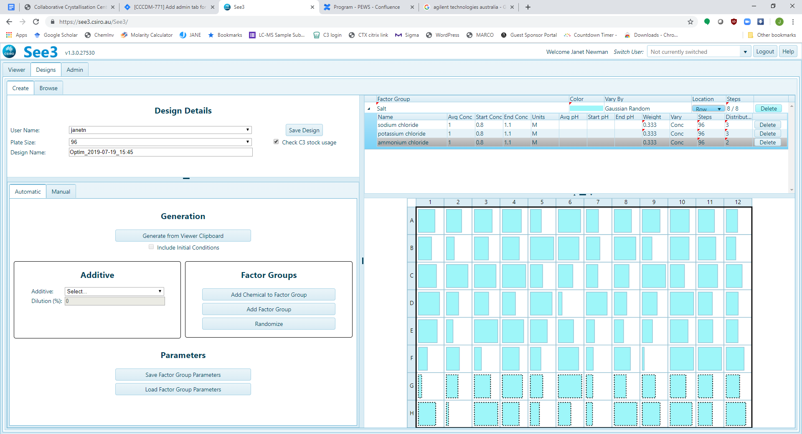

Most of the columns in the secondary header within a **Factor Group** can be edited for each **Chemical Factor** within the **Factor Group**, although ‘Steps’ and ‘Distribution’ are information columns which depend on either the ‘Weight’ or ‘Weight’ and ‘Location’. Use the ‘Vary’ option to determine if the concentration or the pH is to be varied.

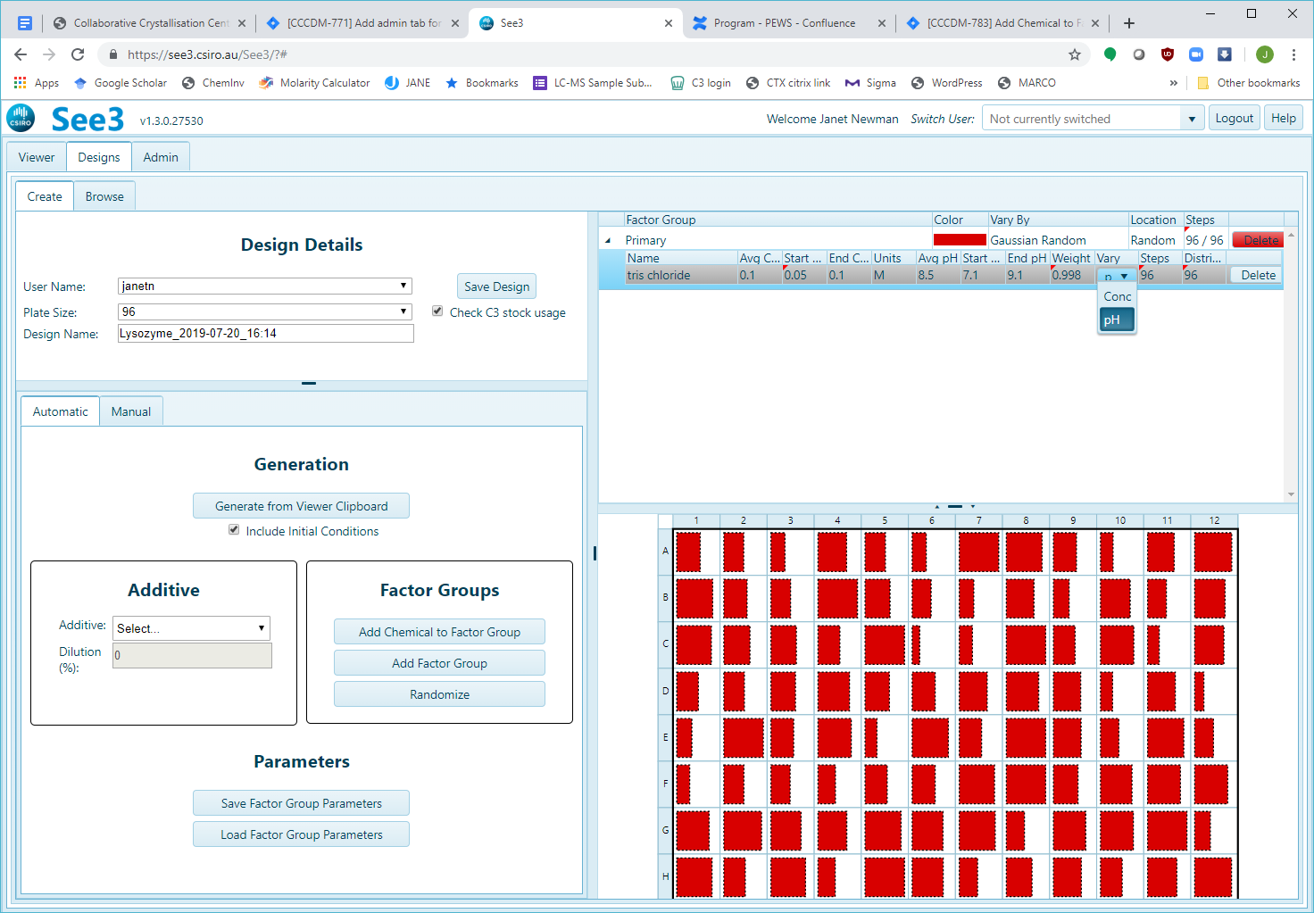

The ‘Start Conc’ and ‘End Conc’ associated with a Chemical Factor are the upper and lower concentration limits for that Chemical Factor in the optimisation.

The average concentration (Avg Conc) of a Chemical Factors defines the default upper and lower concentration limits. For Chemical Factors where the Avg Conc is > 0.2 M or > 2%

Start Conc: 0.8 × (Avg Conc)

End Conc: 1.1 × (Avg Conc)

Chemical Factors where the Avg Conc ≤ 0.2 M or ≤ 2%

Start Conc: 0.1 × (Avg Conc)

End Conc: 1.5 × (Avg Conc)

The three values Start Conc, End Conc and Avg Conc can all be edited by the user.

For Chemical Factors which are simple buffers, the upper and lower pH limits are always set to the pKa of the buffer ± 1 pH unit. For buffers with more than one (independent) pKa (phosphate, for example) the upper and lower pH limits are set to the pKa closest to the ‘Avg pH’, ± 1 pH unit. For complex buffers (mixtures, or ones where the pKas are not independent (citrate, for example) the upper and lower limits are set by taking the ‘Avg pH’ value ± 1 pH unit.

The three values Start pH, End pH and Avg pH can all be edited by the user.

Note that the sum of ‘Weight’ for a Factor Group may never exceed 1, even temporarily – so to change from having two Chemical Factors with equal (0.5) weight to having one at 0.6 and one at 0.4 requires changing the weight 0.5 -> 0.4 first, then changing the weight 0.5 -> 0.6, as shown below.

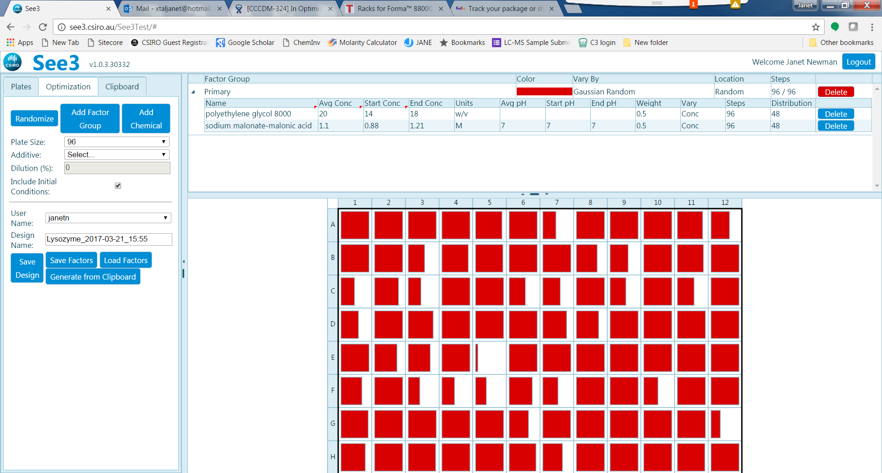

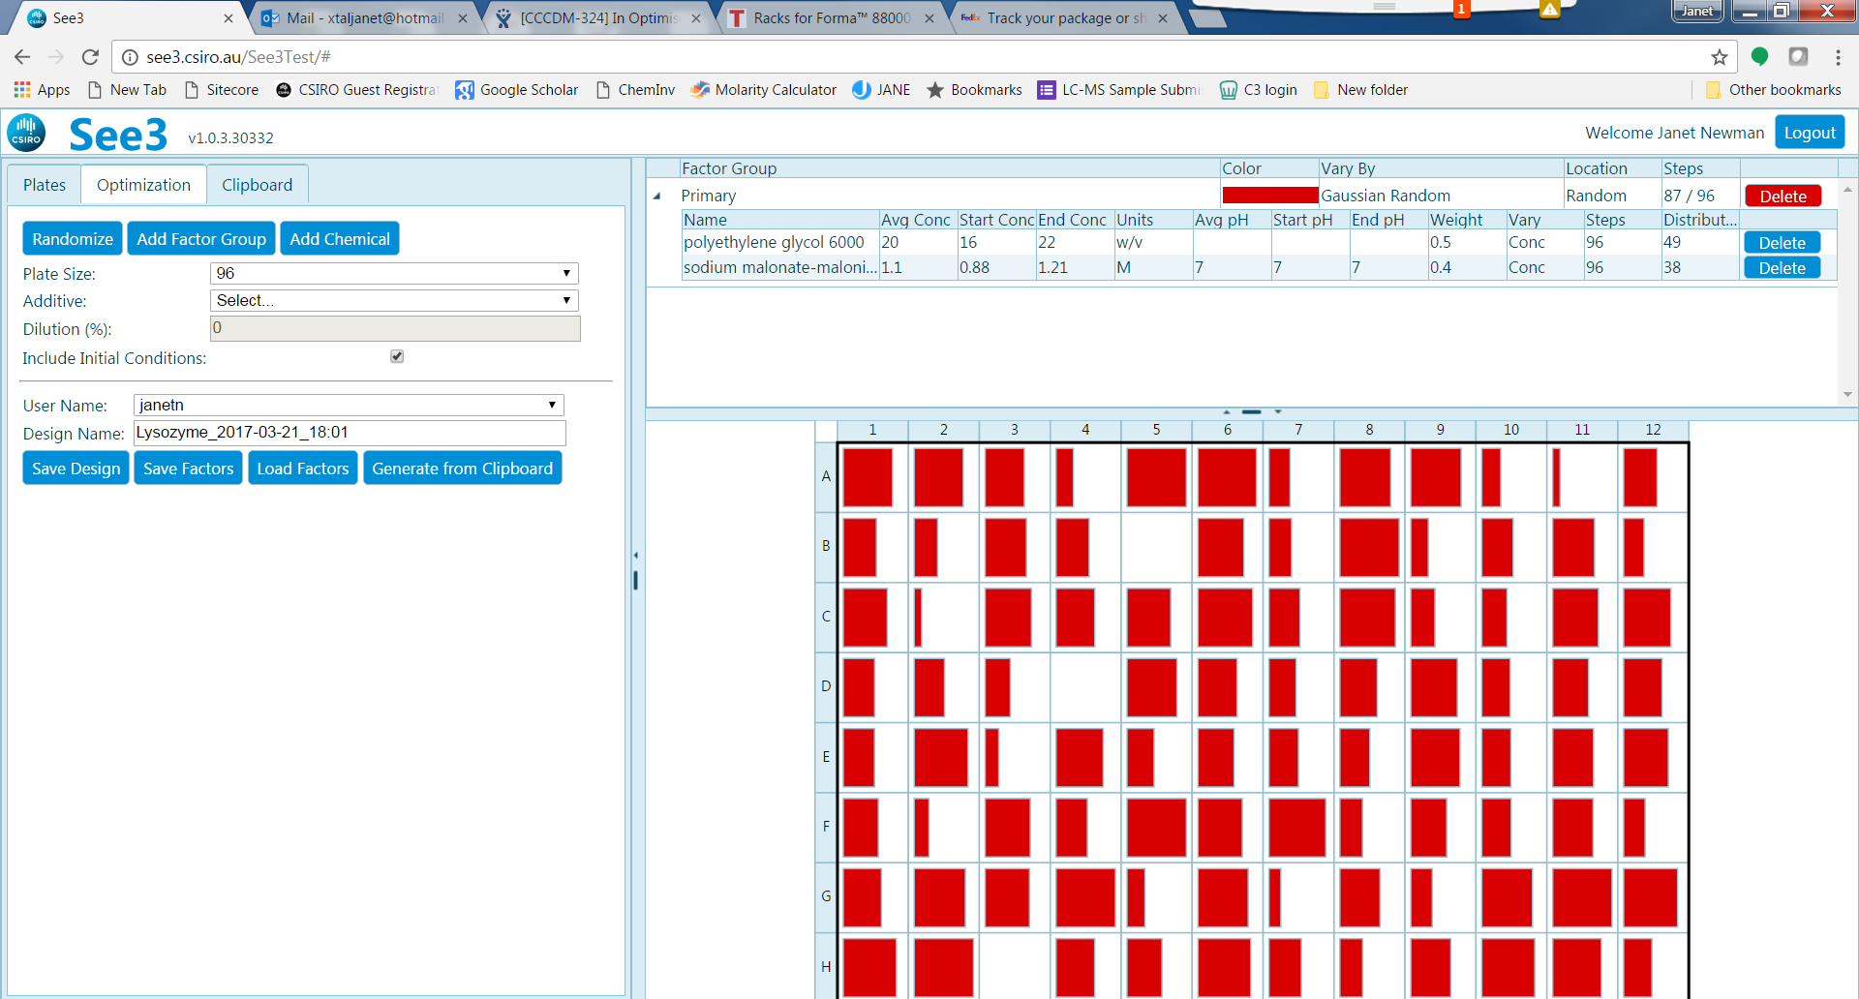

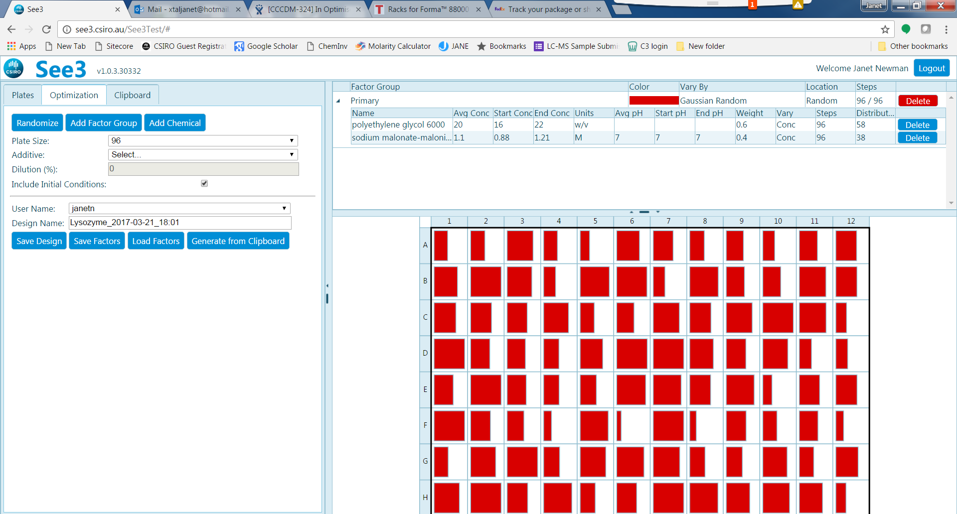

New Chemical Factors can be added to an optimisation manually.

You must make sure that there is a Factor Group defined in the **Factor Grid** BEFORE you try to add a new Chemical Factor. If you have already started an optimisation (from the clipboard, for example), then there will be Factor Groups defined in the Factor Grid, in the example below there are three Factor Groups already defined, ‘Primary’, ‘Salt’ and ‘Buffer’.

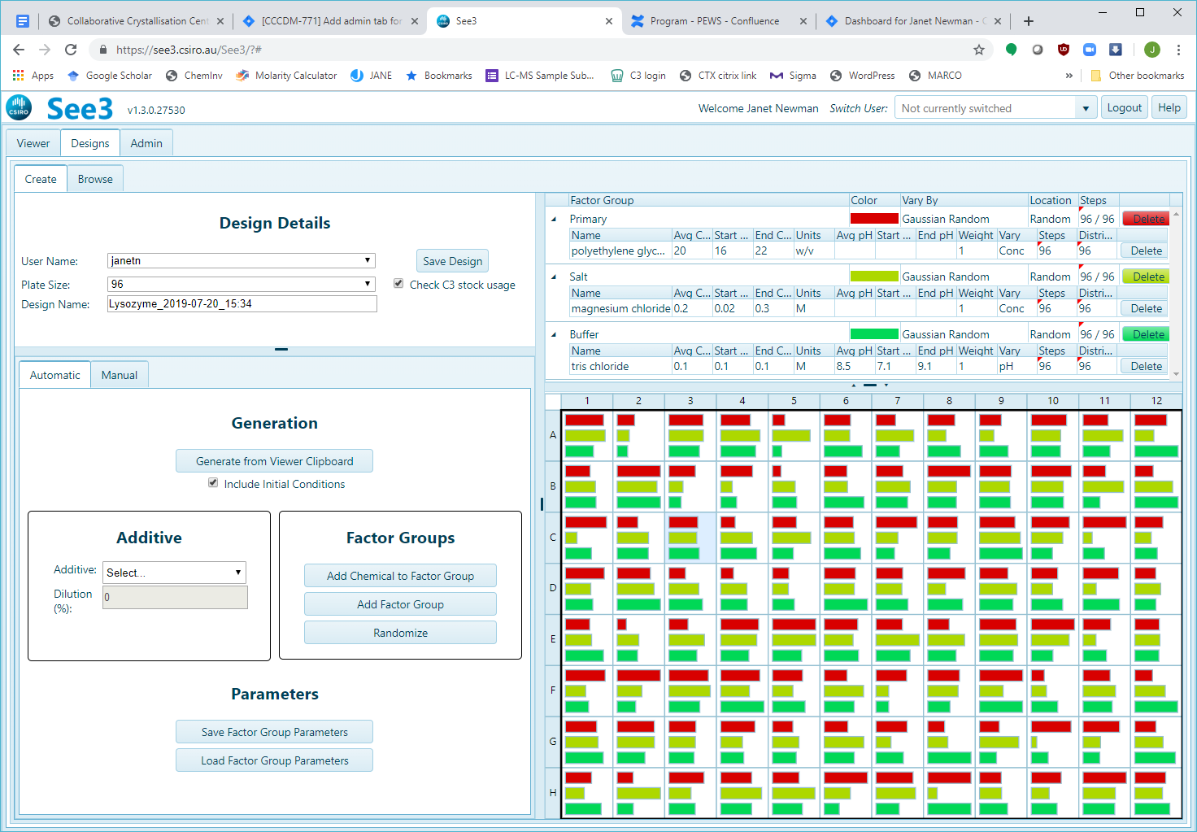

If the Factor Grid is empty, click the ‘Add Factor Group’ button on the Generation Panel, circled below.

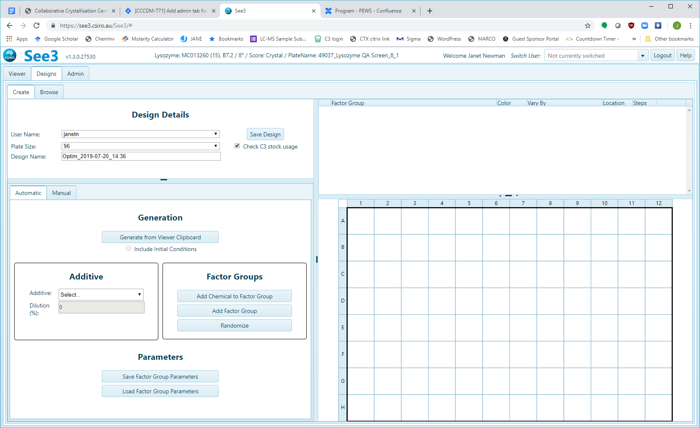

This will add ‘New Group 1’ to the Factor Grid (blue arrow)

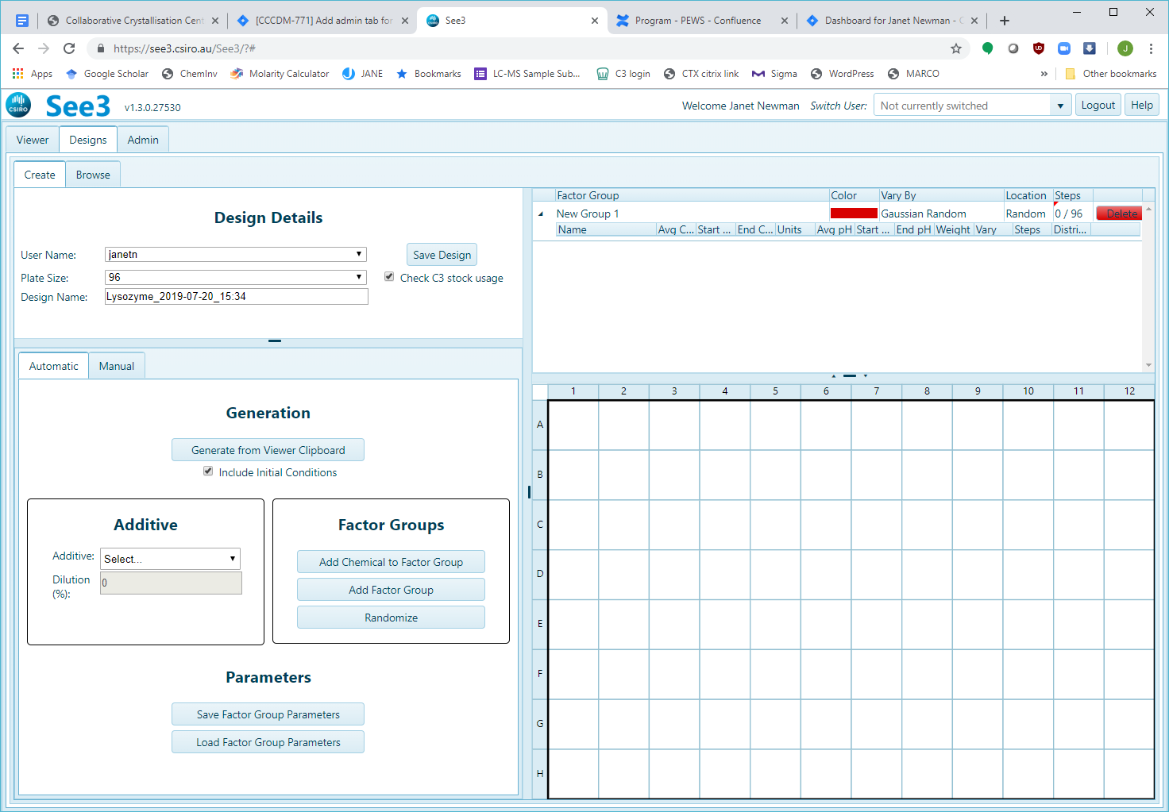

Click on ‘New Group 1’ and rename it to something else e.g. ‘Salt’ or ‘Factor 1’ or whatever makes sense.

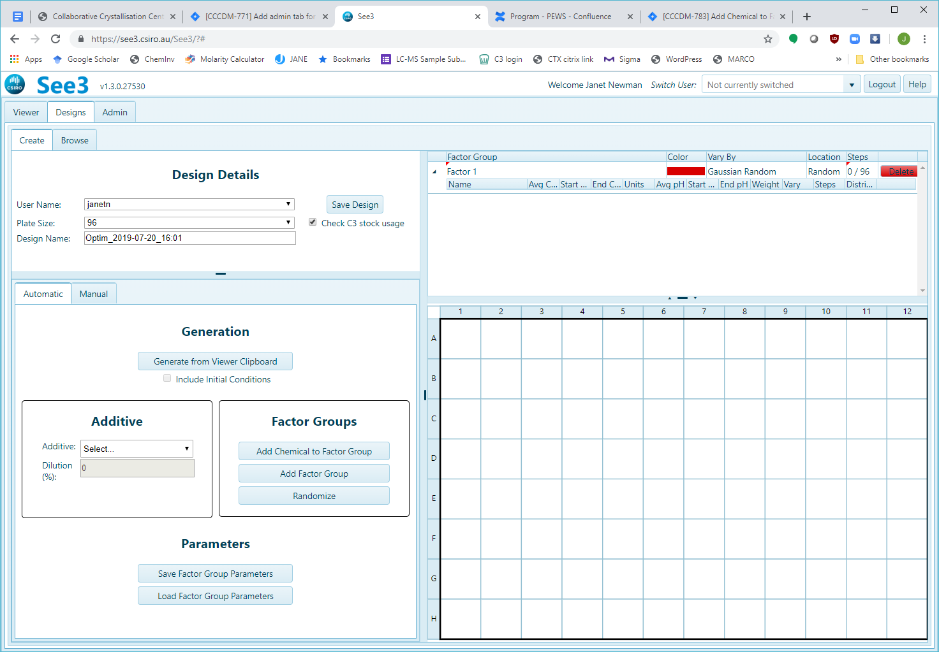

Once the Factor Grid is not empty (and the Factor Groups are not named ‘New Group 1’) then use the ‘Add Chemical to Factor Group’ button in the Generation Panel – circled below:



This will bring up the ‘Add Factor’ Dialogue – select the desired chemical by either using the pulldown menu or by typing part of the chemical name into the ‘Name’ field. In the example below the letters ‘ace’ were typed in to find all the chemicals in C3 containing ‘acetate’

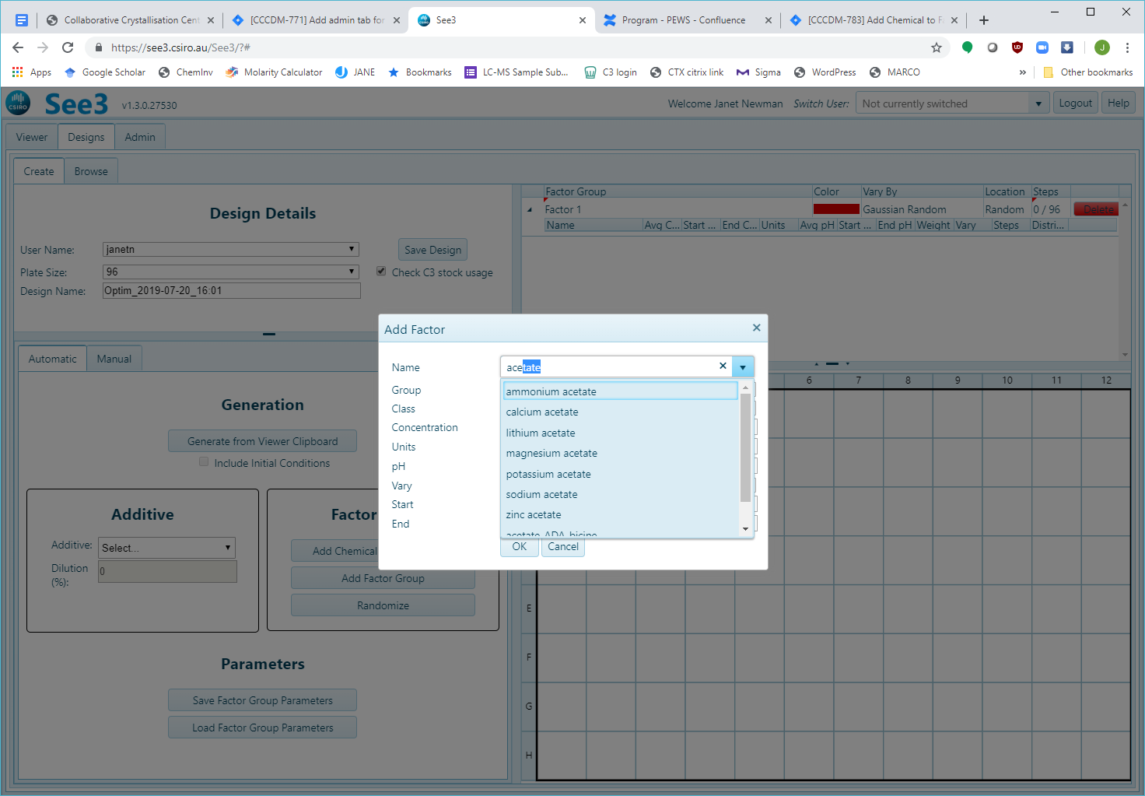

Once the correct chemical has been selected, use the pulldown menu to choose the desired Factor Group. You must fill in the ‘Concentration’ field, clicking on any other field will fill in the defaults for ‘Class’, ‘Units’, ‘Vary’, ‘Start’ and ‘End’. Change ‘Start’ and ‘End’ to the appropriate values if desired. Click ‘OK’

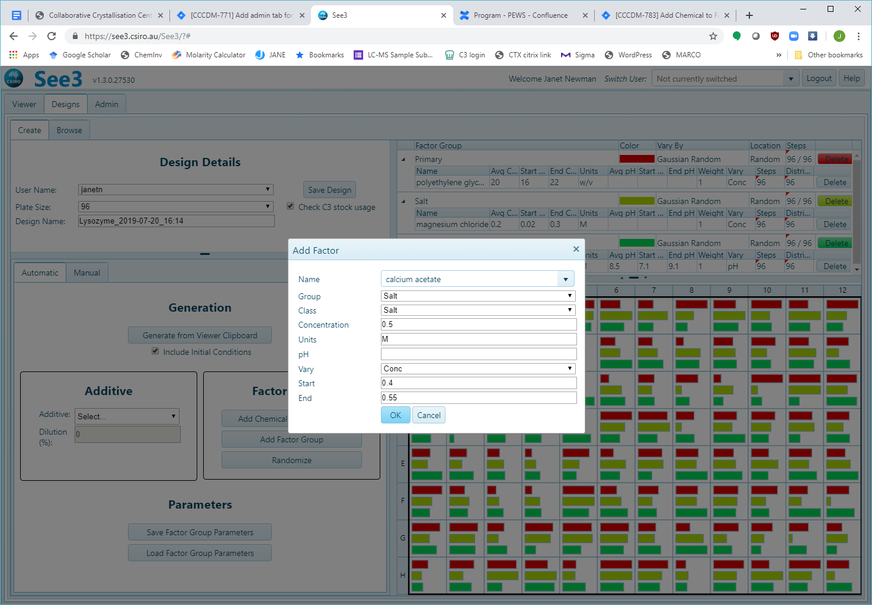

An optimisation is saved into the database by pressing the ‘Save Design’ button on the **Design Details** panel**.**

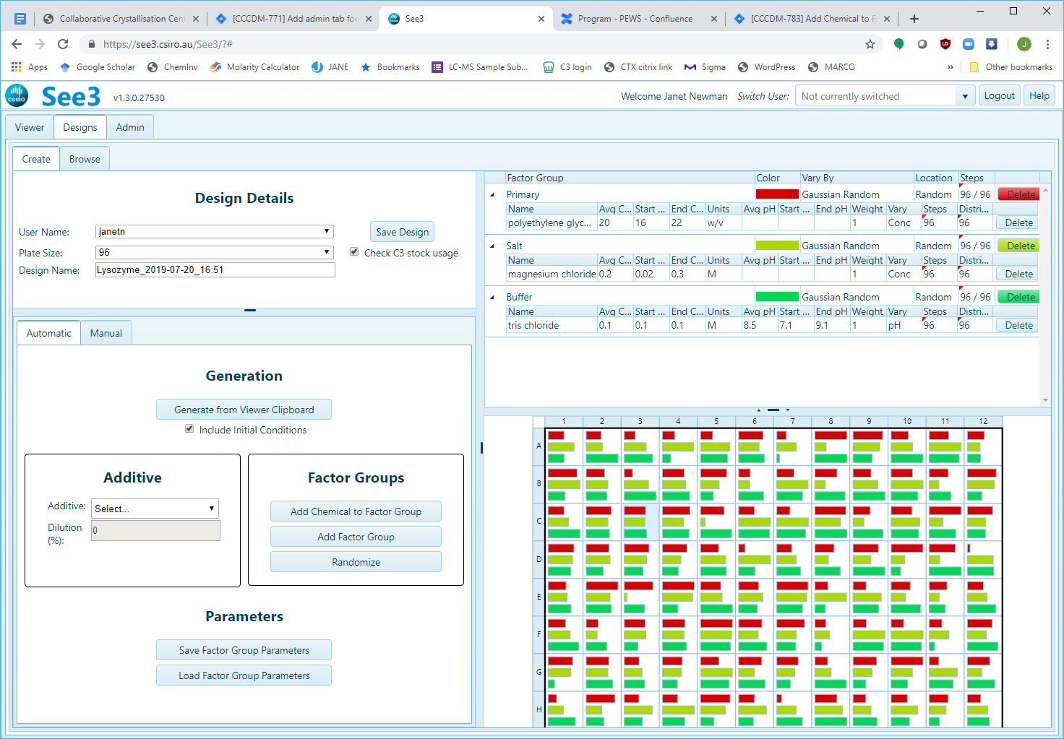

When ‘Save Design’ is clicked, a check is made to ensure that all the stocks are available in C3 to make the optimisation. This ensures that the optimisation can be ordered through the booking software. However, if you are not planning on using C3 to make up the optimisation for you, you can uncheck the ‘Check C3 stock usage’ box (indicated with the purple arrow, above). Do not uncheck this if you are intending to have C3 make up your optimisation for you. We will get upset.

By default, the software checks to see that the optimisation can be made up with the C3 stocks. There are two main reasons an optimisation may fail this check – firstly, there may be unit mismatch between a Chemical Factor in the optimisation, and the C3 stock. For example, if 20 w/v polyethylene glycol 200 has been used as a Chemical Factor, this will cause an error, as the stock in C3 is 80 v/v polyethylene glycol 200.

More commonly, there may be ‘overfill’ errors, where the stocks available in C3 are not concentrated enough to be able to make the requested combination of Chemical Factors. For example, an optimisation contains a with both 30 w/v polyethylene glycol 4000 and 2M ammonium sulfate. This well can’t be made with C3 stocks (50 w/v polyethylene glycol 4000; 3.5M ammonium sulfate (as 30/50+3/3.5 >1). If there are less than 20 overfill errors, the software will give the option of autofixing (Click ‘Autofix’), which it does by reducing the concentration of the primary factor until there is no error, if possible. Clicking ‘OK’ will return you to the Optimization VIEW to fix this manually.

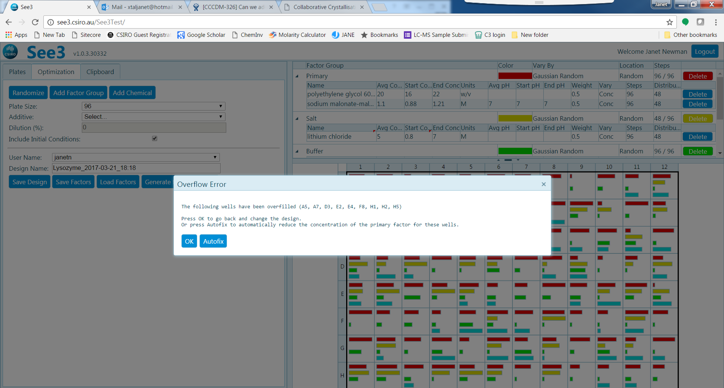

The software will warn, but not error, if incompatible chemicals are co-located in wells. Combinations that are incompatible include magnesium salts with phosphate salts and zinc salts with sodium HEPES buffer. Press ‘OK’ to go back into the Optimization VIEW, or ‘Ignore’ to continue writing the design into the database.

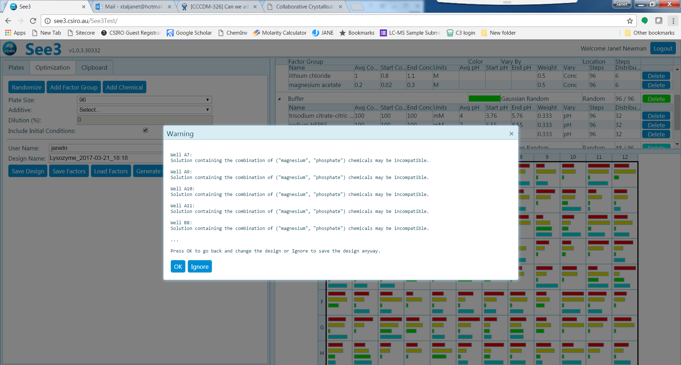

The **Factor Grid** can be saved by clicking the ‘Save Factors’ button on the **Generation** Panel.



The saved **Factor Grid** will have the ‘Design Name’ as shown in the **Design Details** at the time the button is clicked.

The other option in Designs is “Manual”

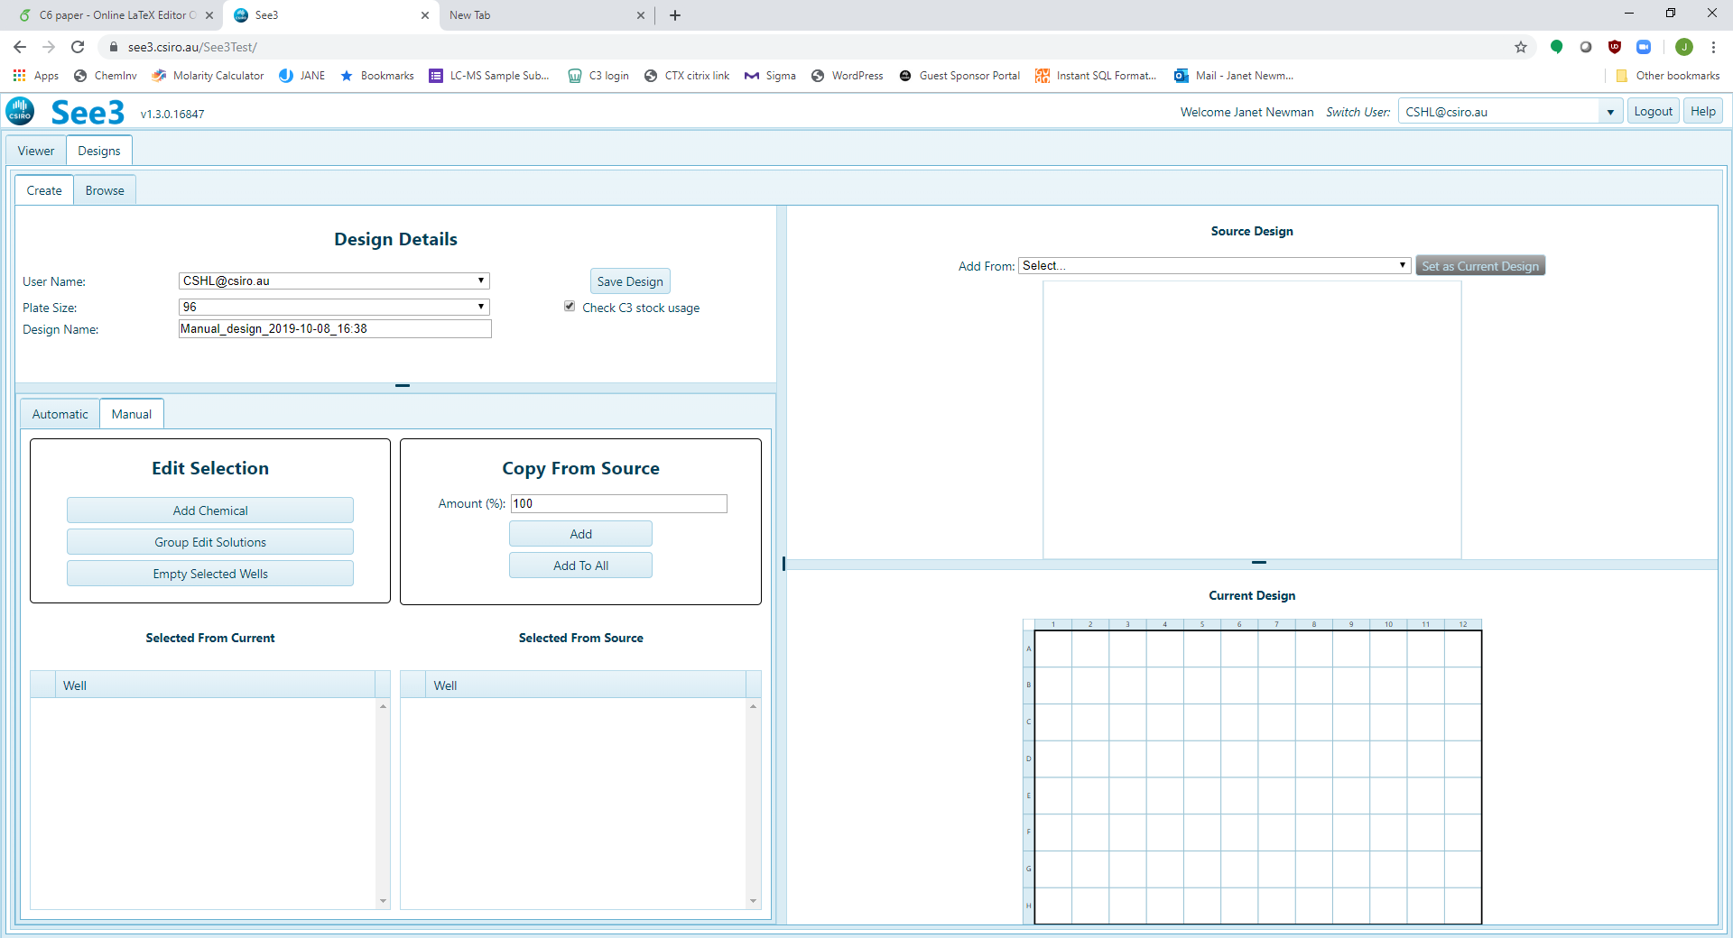

In this mode, a user can define a screen well by well, and create gradients across selections of wells. If you start a new manual design, the following pane will be displayed



**Current Design**

**Source Design**

**Generation**

**Design Details**

One can select a well or set of wells in the Current Design or the Source Design by clicking on them – left click will select a single well, left click and drag will select a continuous set of wells, Ctrl left click allows one to select individual wells. When a well is active it has a black background – in the image below wells A1-D6 are active. Clicking a second time on a selected well will unselect it. Right clicking will select (or unselect) the entire grid.

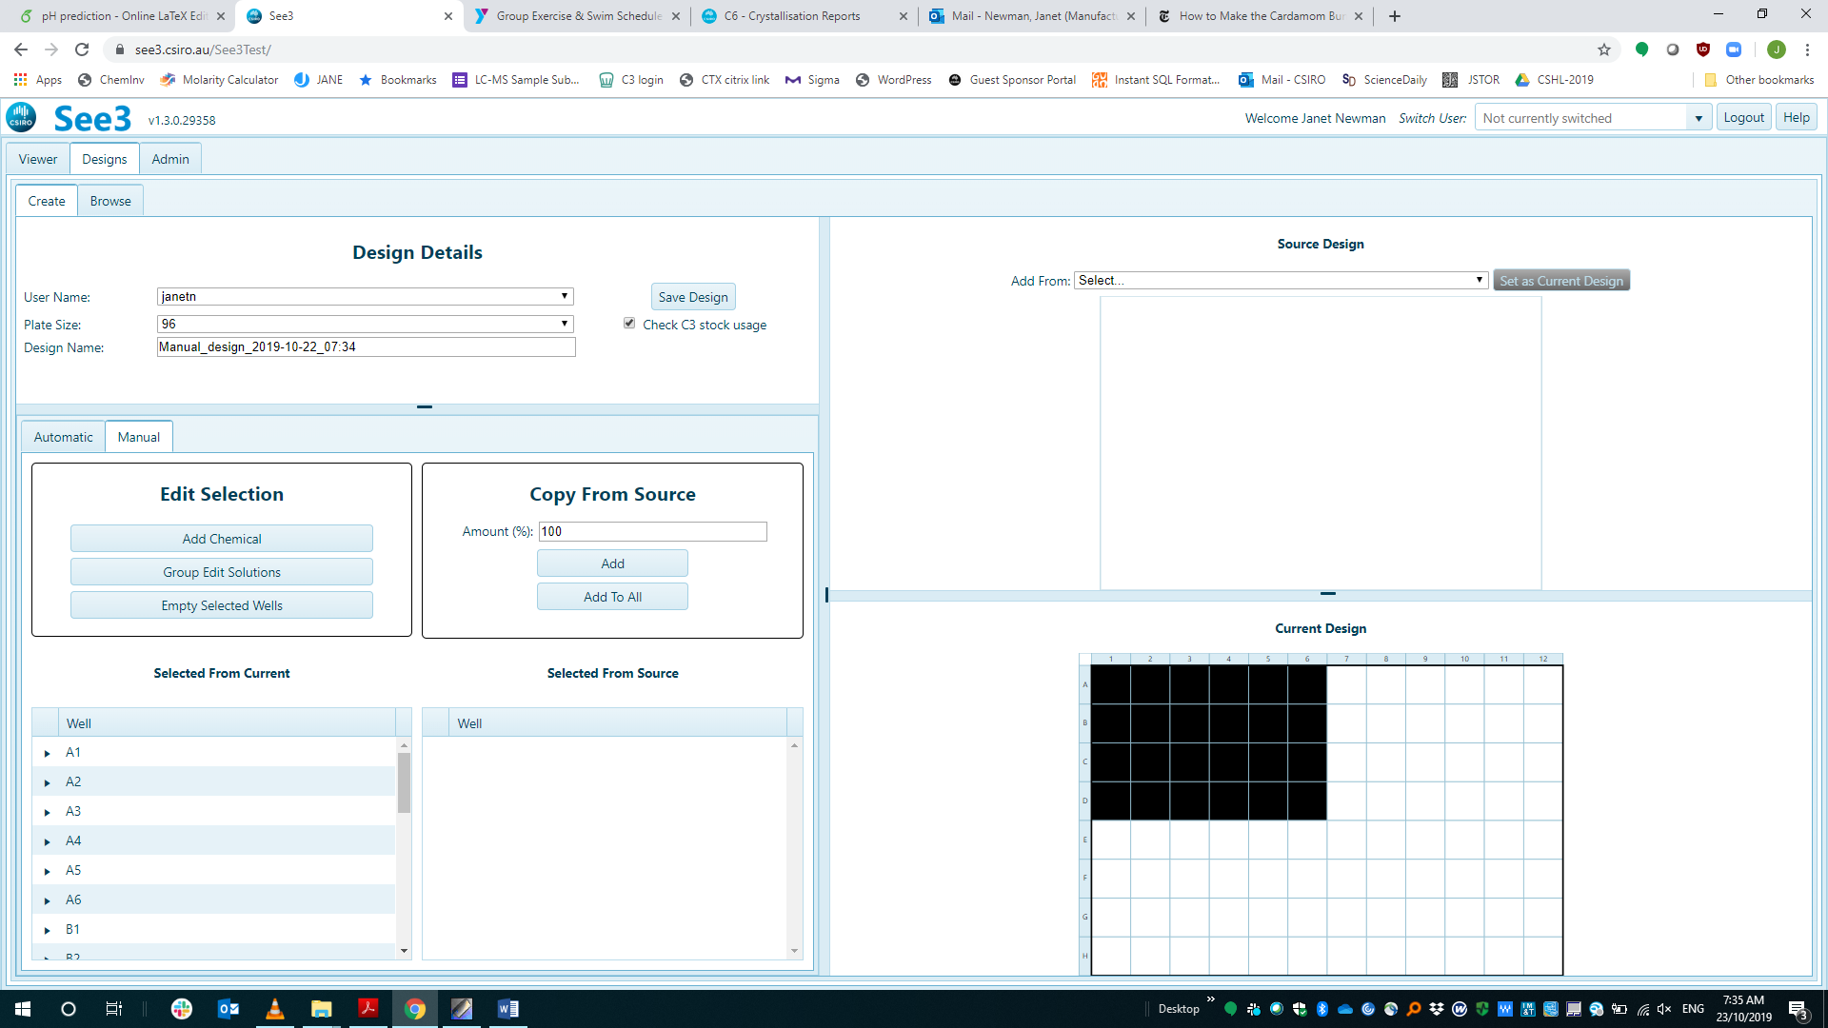

**All the actions that can be done in the manual mode are done only on wells which are active.** Actions include adding or editing chemical factors, deleting chemicals, or adding entire conditions from other wells.

## Adding chemicals

Once the appropriate wells have been selected in the “Current Design” pane, click on the “Add Chemical” button in the “Generation” pane. This will bring up a dialogue box, shown below (in the instance below, the chemical polyethylene glycol 3350 has been selected).

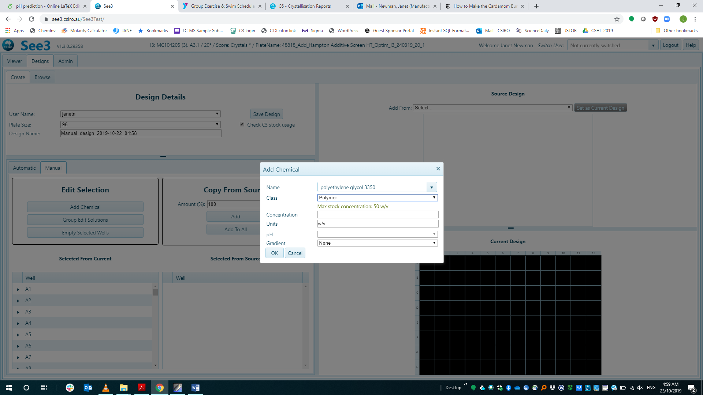

This name field can be searched by a substring search, so typing ‘3350’ will find return only one chemical - polyethylene glycol - whereas typing ‘polyethylene’ will return a list of all chemicals with ‘polyethylene’ in the name.

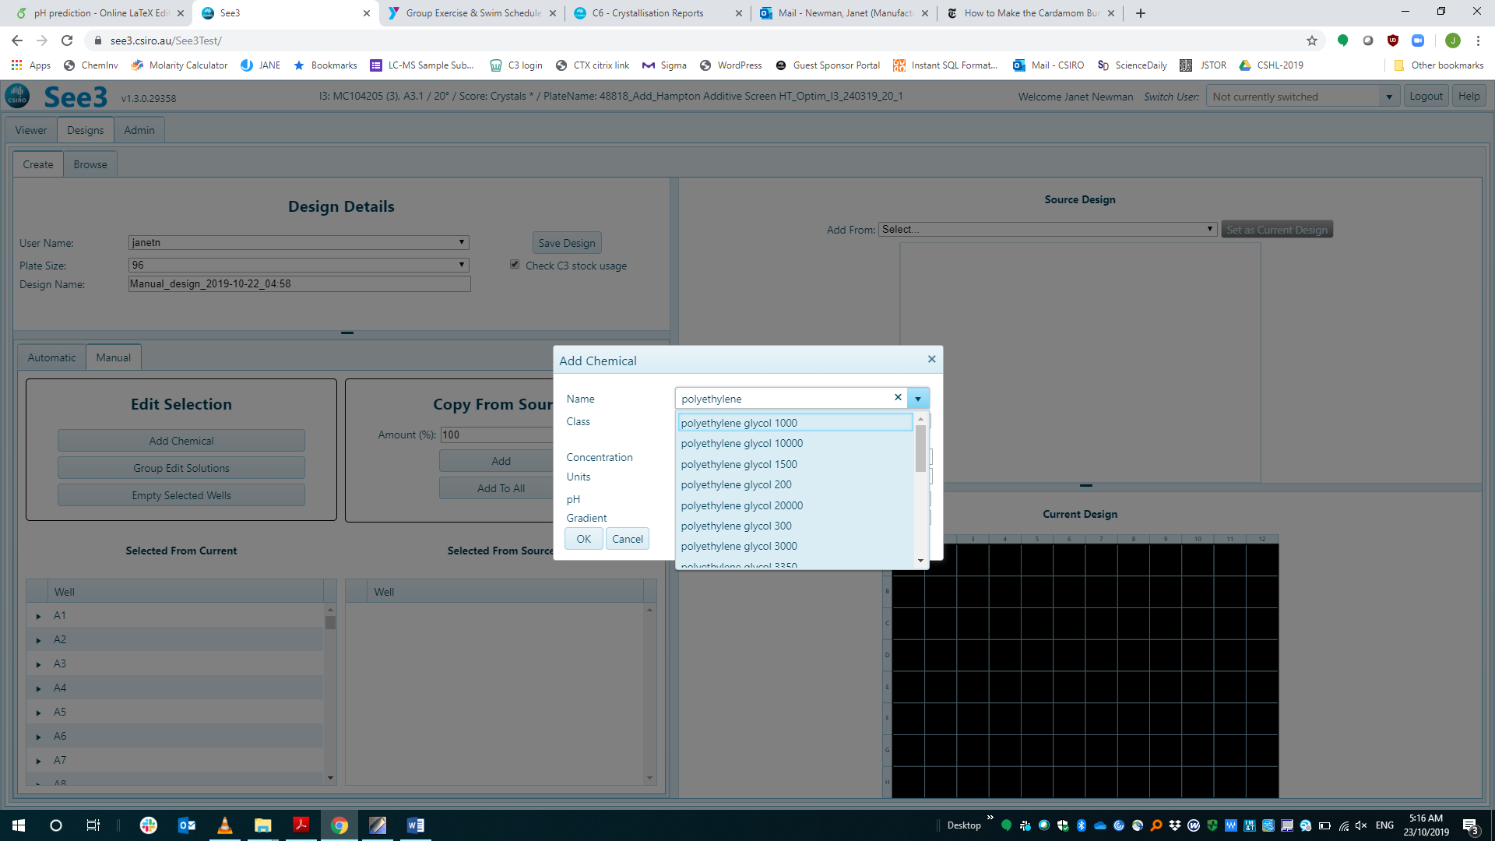

Once a chemical has been selected, one can use it to place a single concentration of that chemical in all the selected wells, or you can place a gradient of concentrations – either over wells, or over columns or rows. In all three cases below there is a PEG 3350 gradient from 0-50%, either over wells, rows, or columns

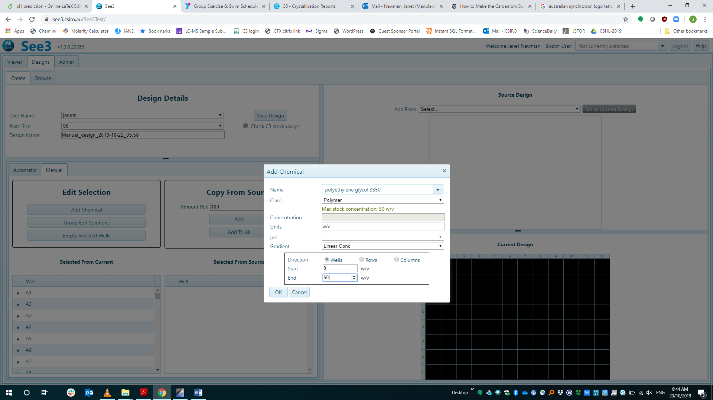 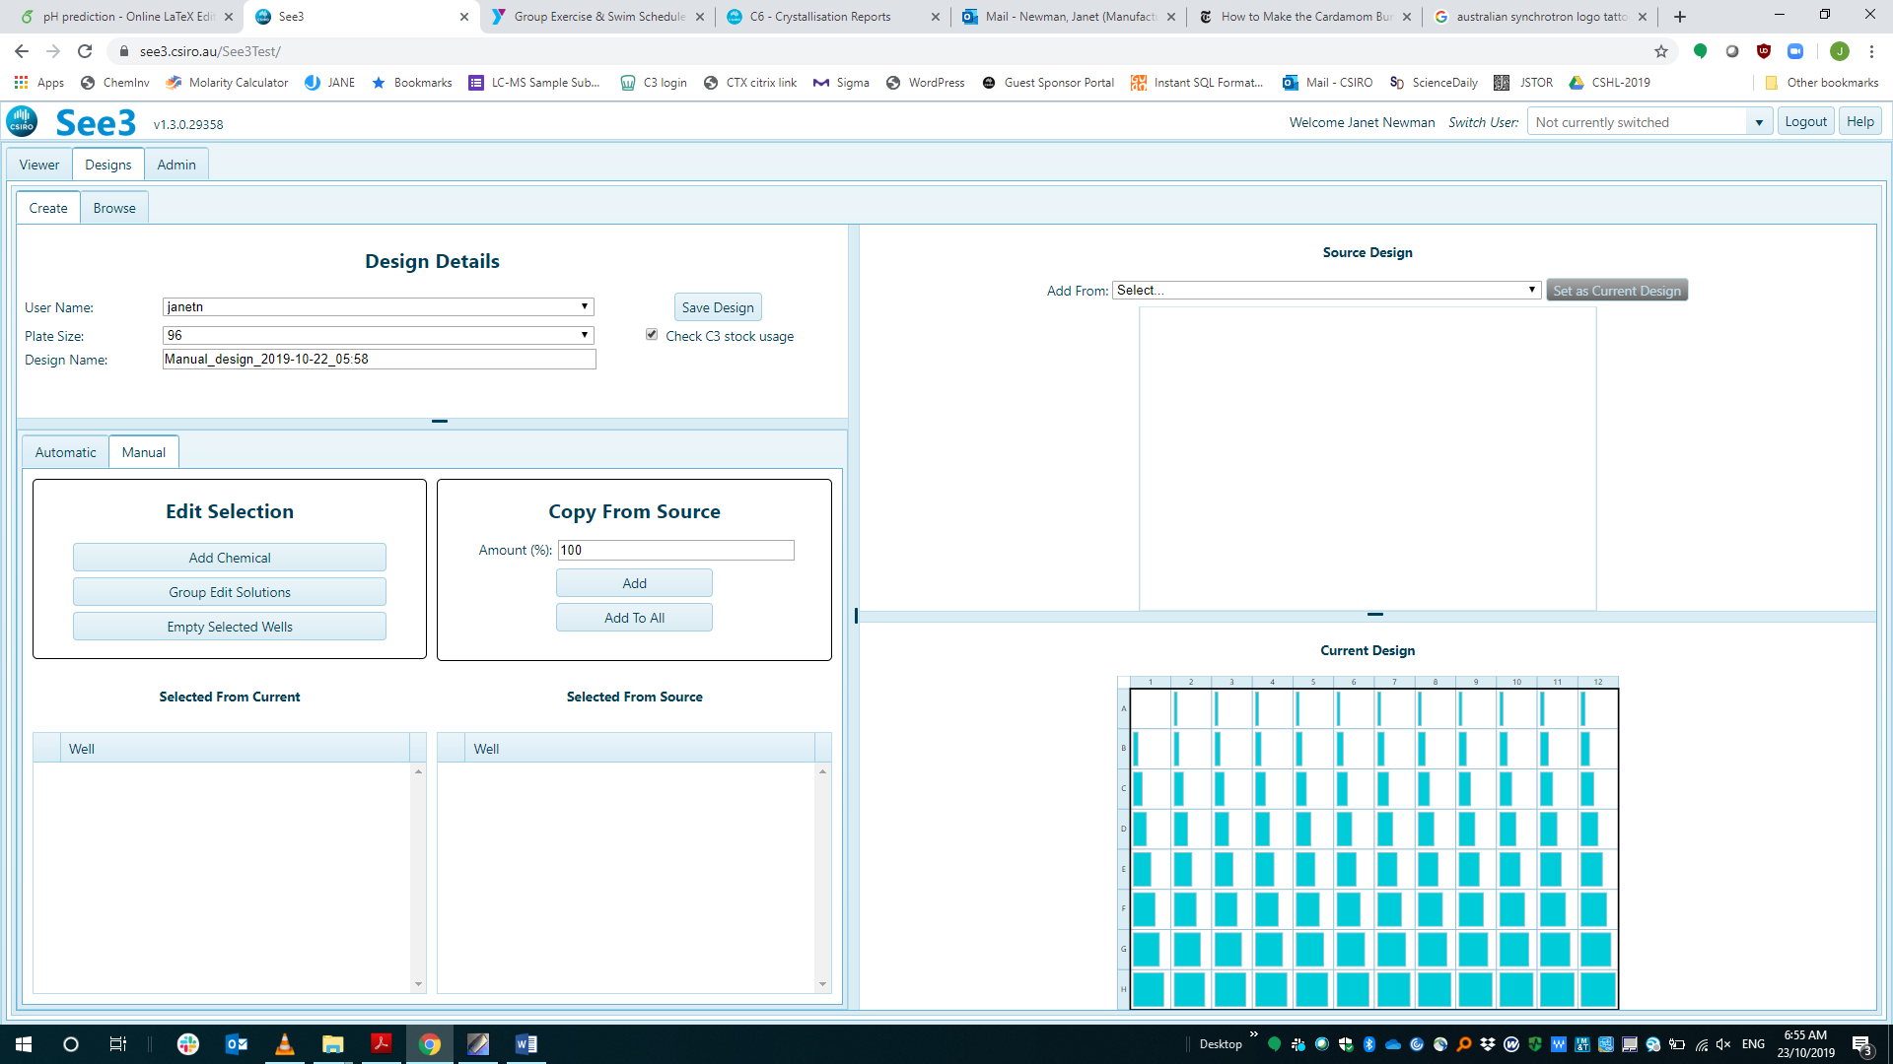

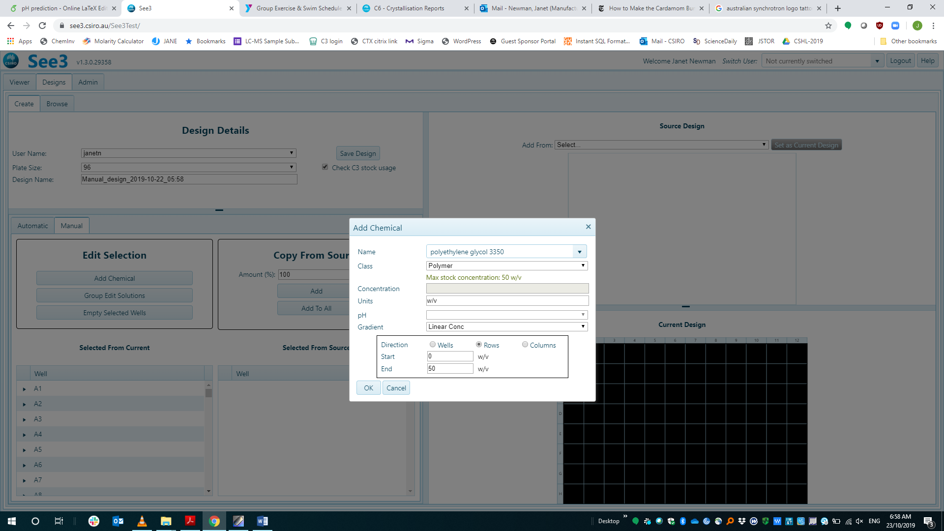 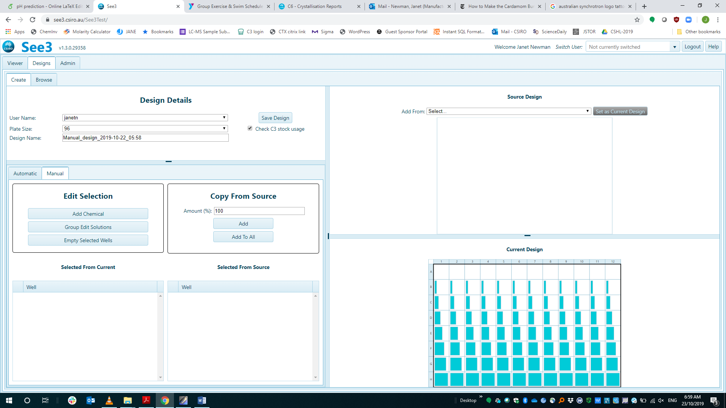

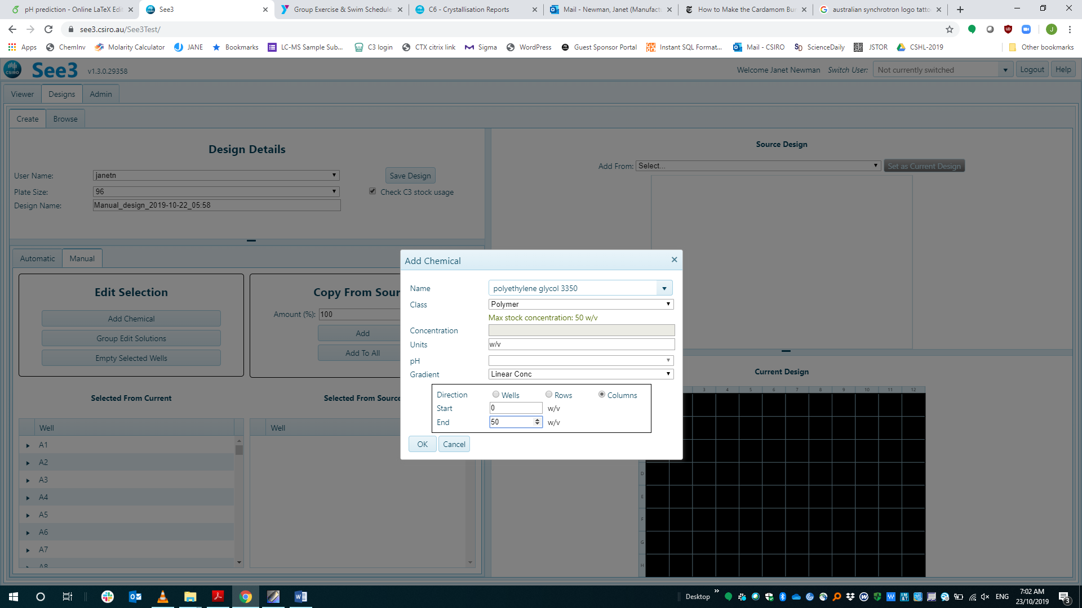 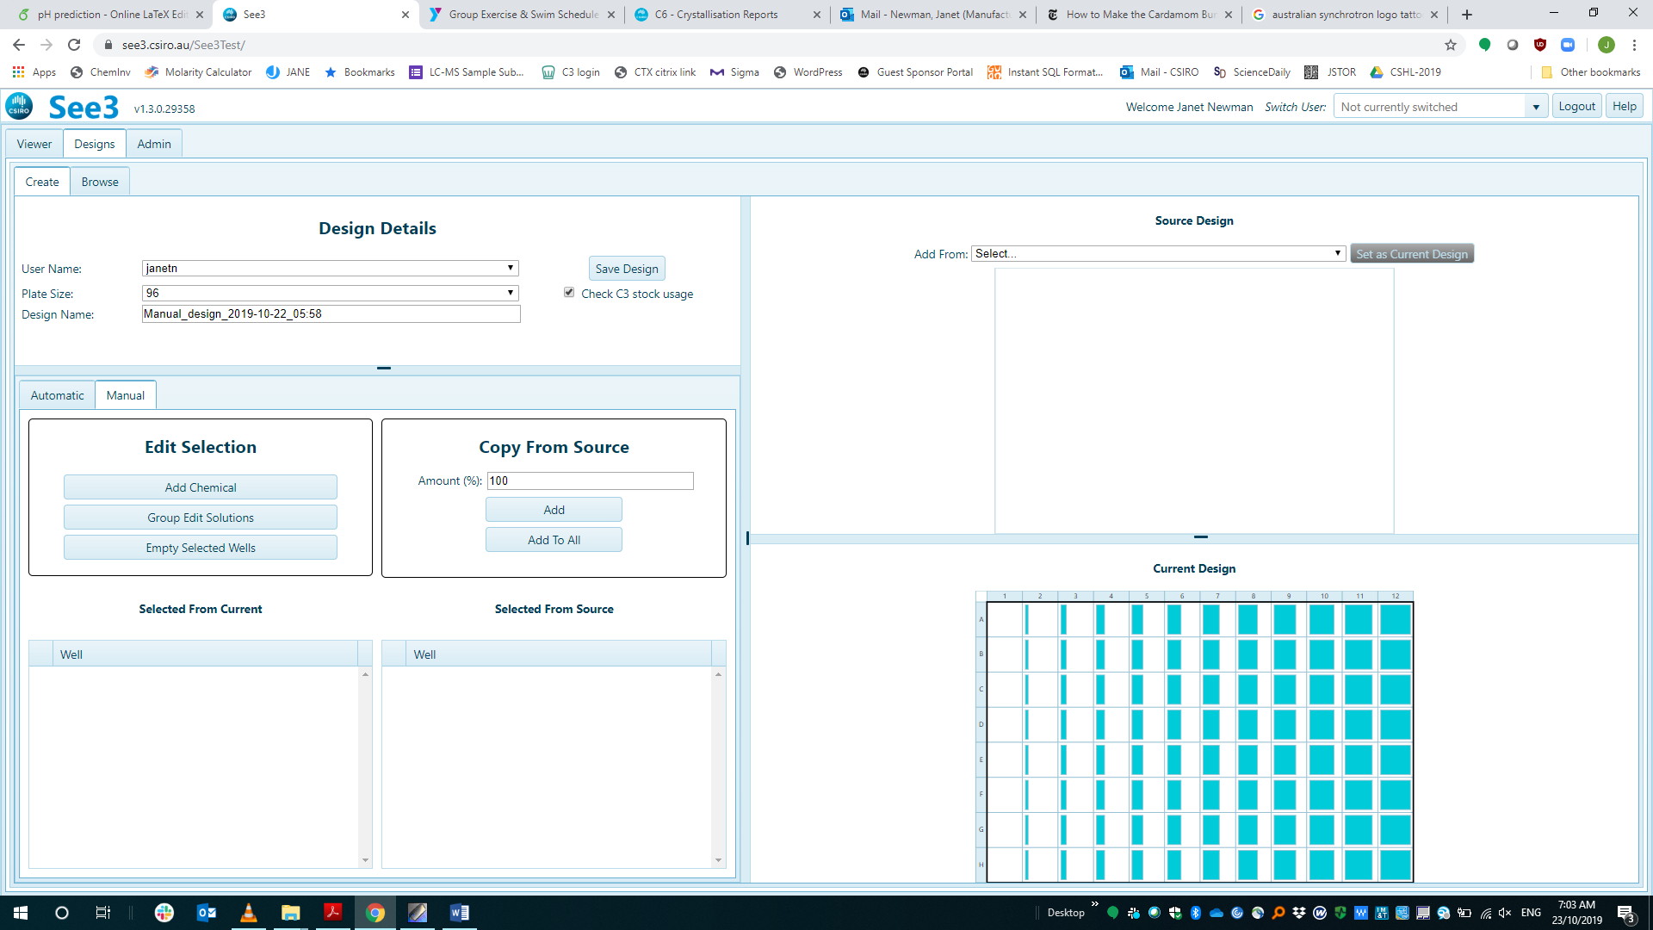

## Emptying wells

To remove the contents of a well or set of wells, select the appropriate wells (they will have a black background) then press the “Empty Selected Wells” button in the Generation pane.

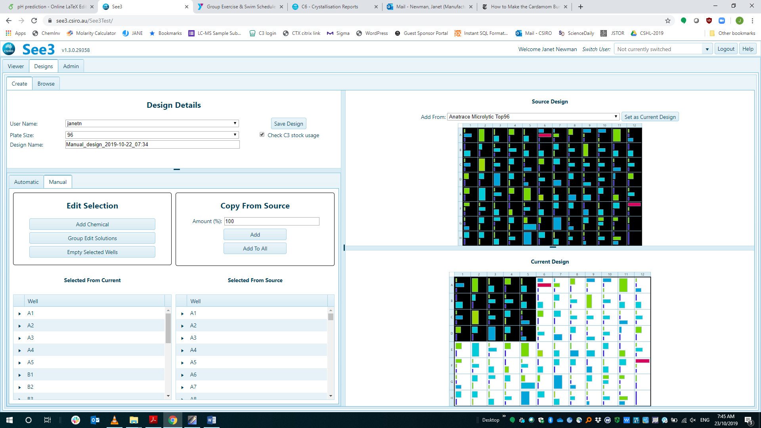  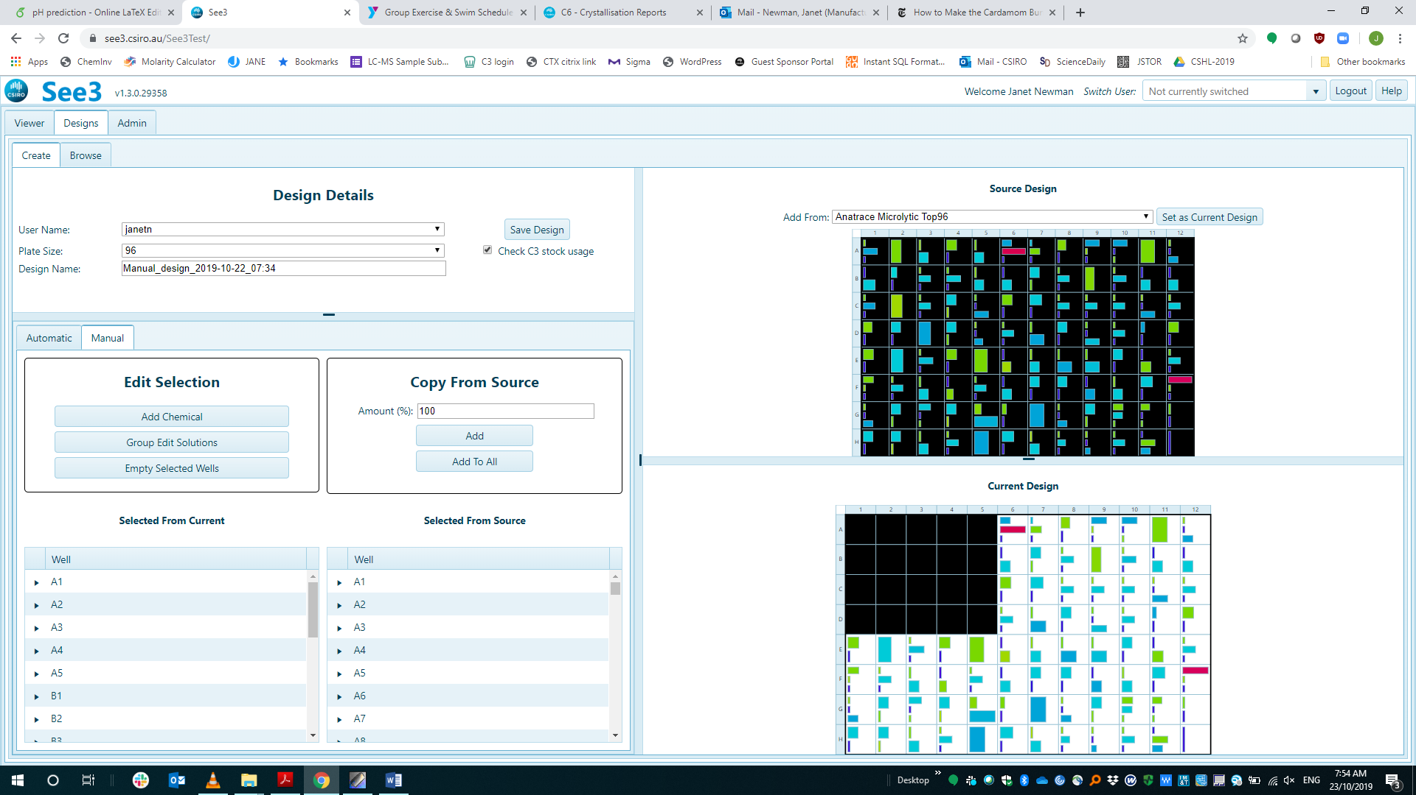

Editing well contents

Editing works both on a single well, or on multiple wells at the same time. Select the well(s) that you wish to modify, and click on the “Group Edit Solutions” button in the Generation panel

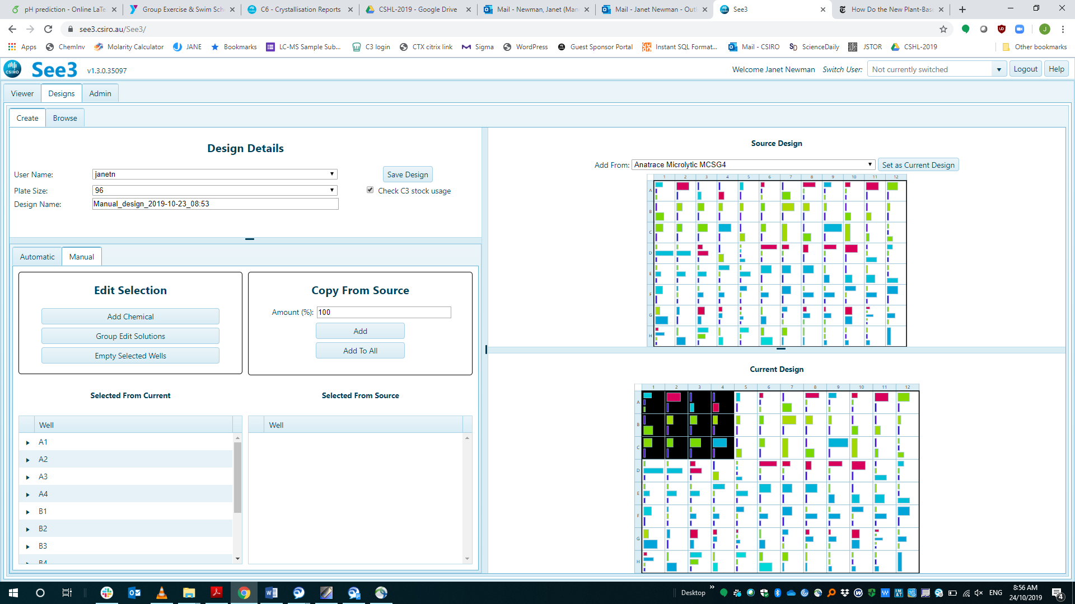  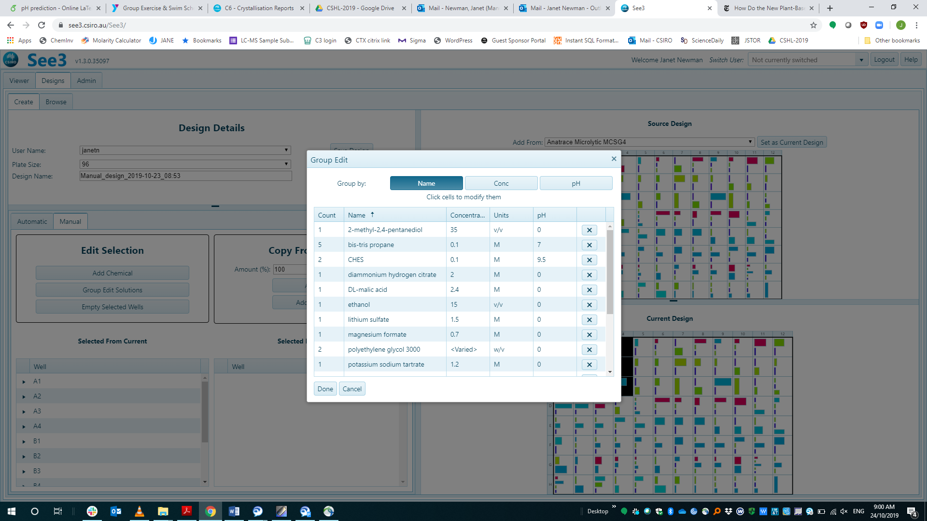

The “Group Edit” dialogue shows all the chemical factors from the conditions that have been selected – if the group by option ‘name’ is selected just the list of distinct chemicals is shown. If the ‘Conc’ option is also chosen, then chemicals which have more than one concentration within the selection are broken down into distinct chemical/concentrations – in the example below there are three conditions that contain ammonium acetate (circled in red), these can be individually edited when ‘Conc’ is pressed (circled in purple)

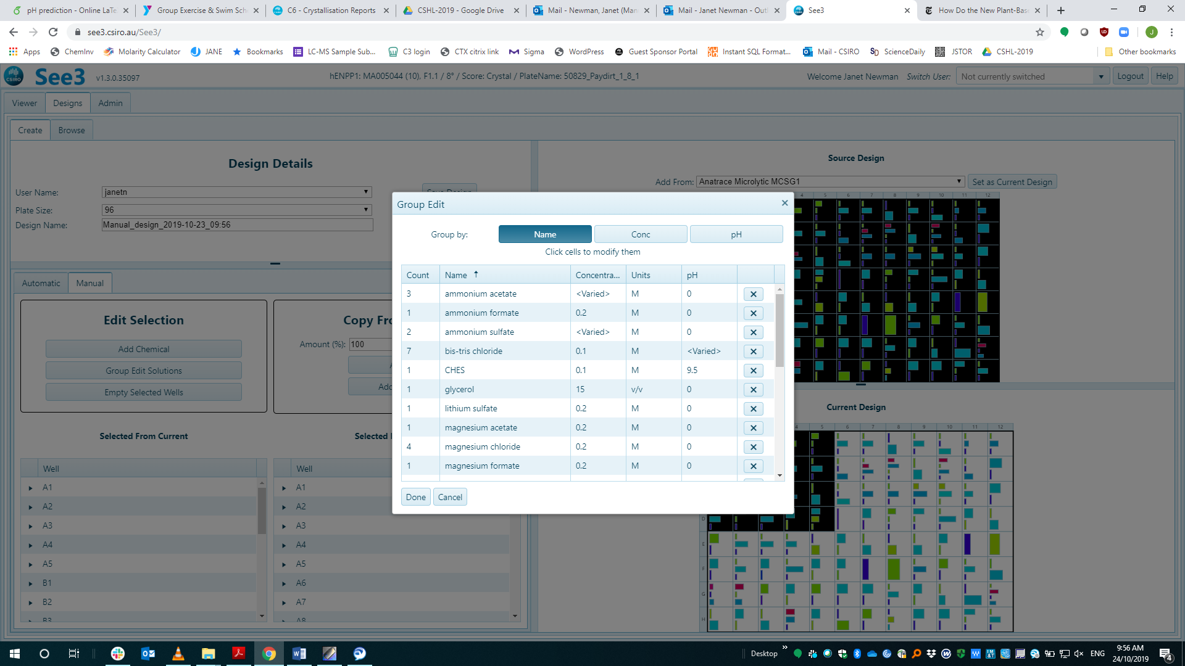 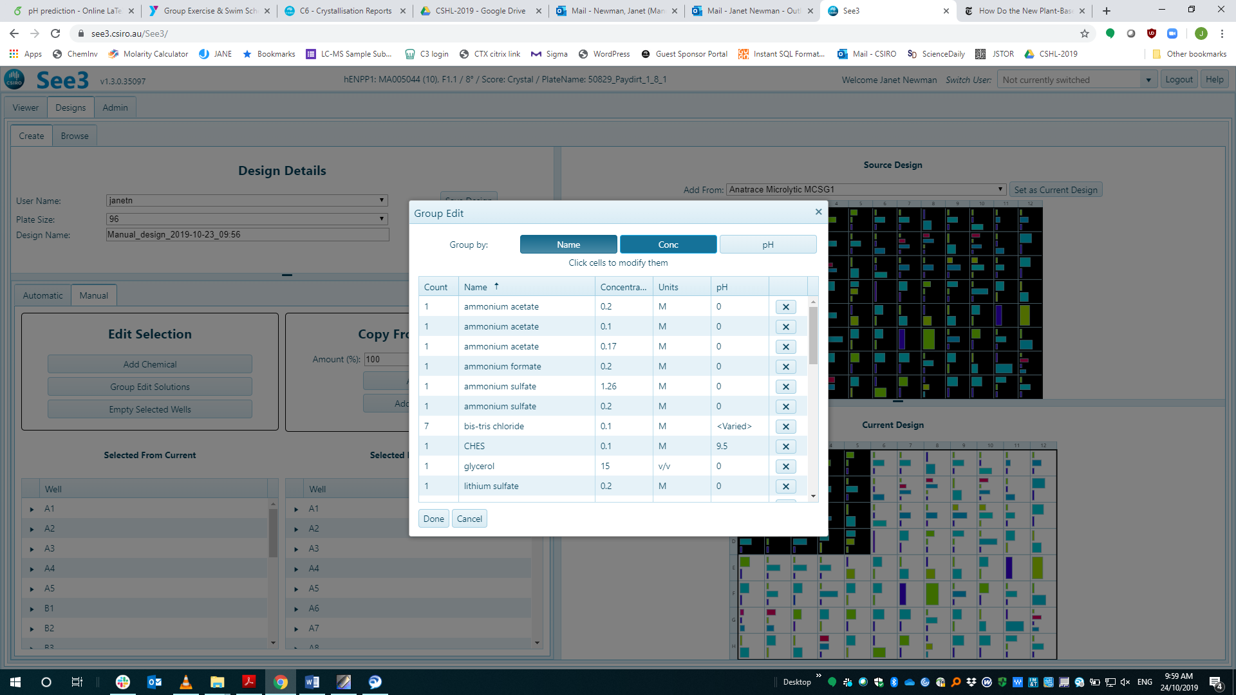

The same process works for pH – here if the ‘pH’ button is pressed, then the chemical factors with the same buffer but with different pH’s are itemised.

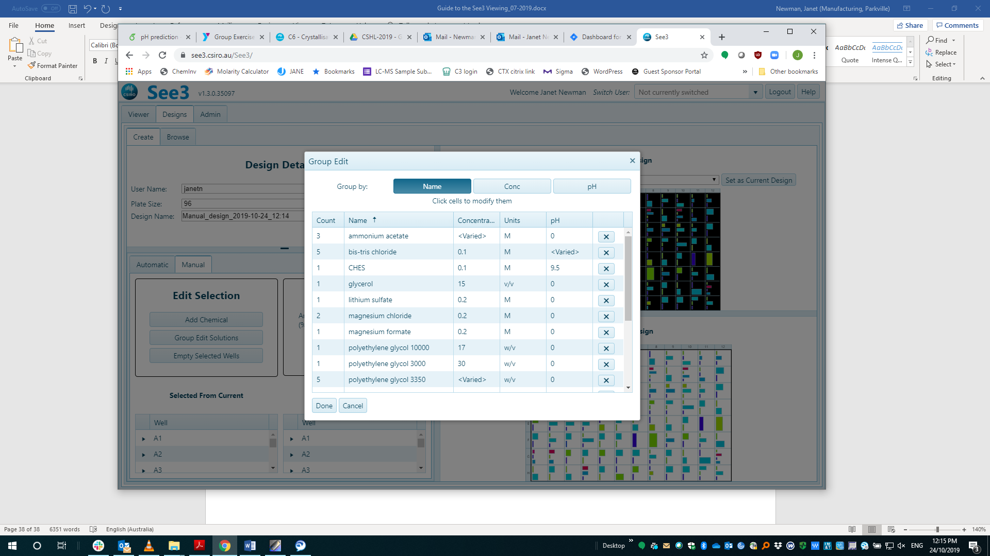 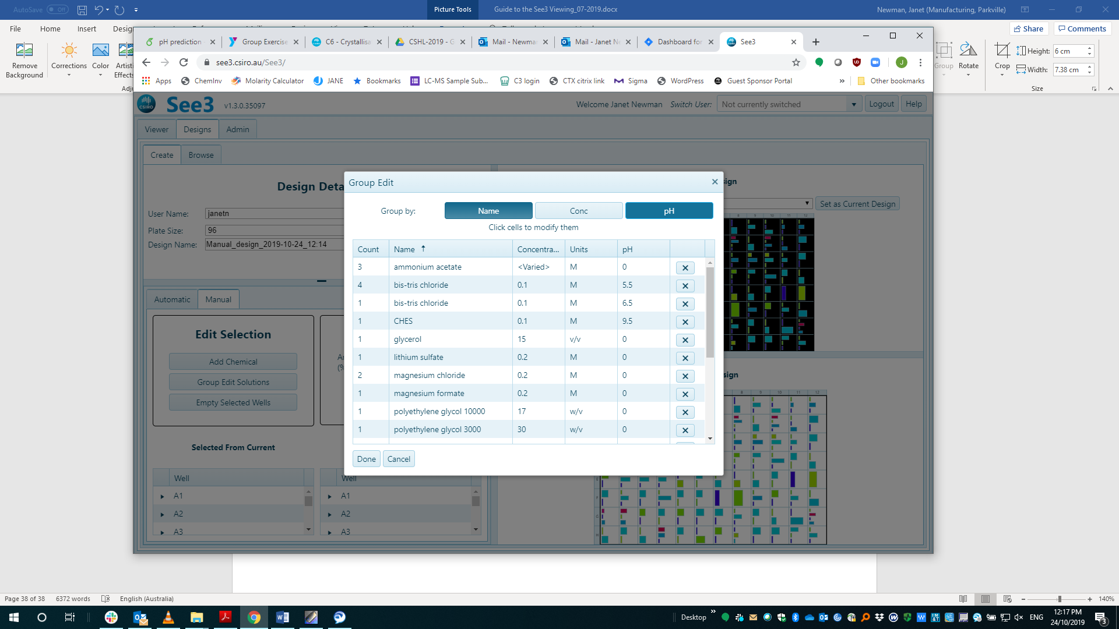

One can add one or more conditions from a known screen into the current design. Select the appropriate well(s) in the source design and current design (there must be the same number of wells selected from both grids), then use the “Add” button:

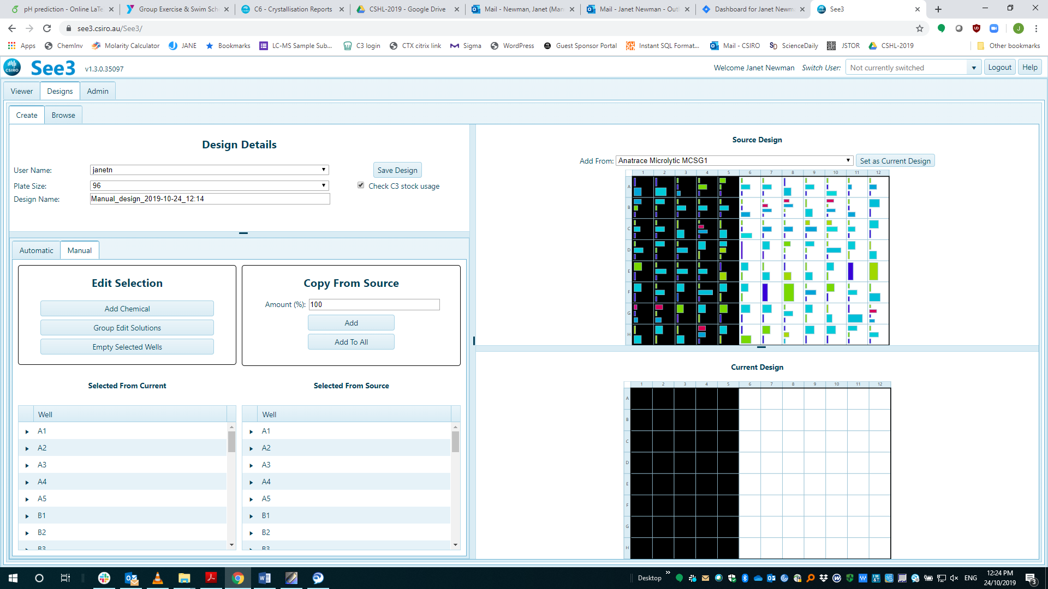

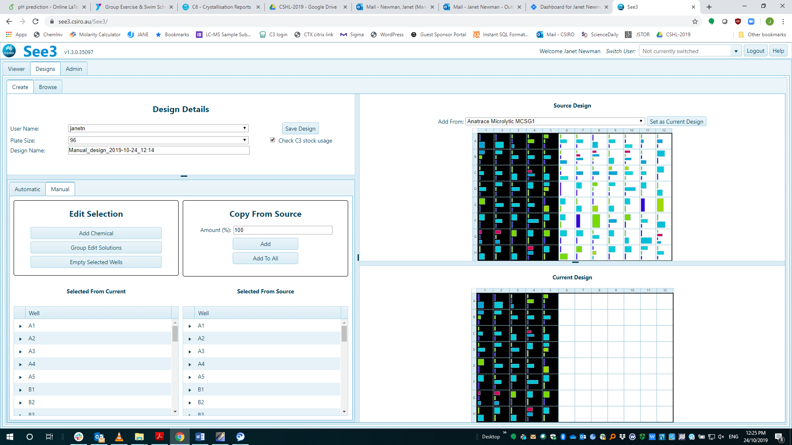

## Moving between Automatic and Manual design modes.

One can also start in Automatic mode, create a design then make changes to individual wells by moving from “Automatic” into “Manual” design mode. When a “Manual” is pressed after a design has been created in Automatic mode the user is asked if they would like to “Set the current Automatic design as your manual design” – if “yes” is selected, then the Automatic “Current design” is loaded into the manual “Current Design” pane. The colours of the well contents change from reflecting the colours of the factor groups to being generic class-based colours.

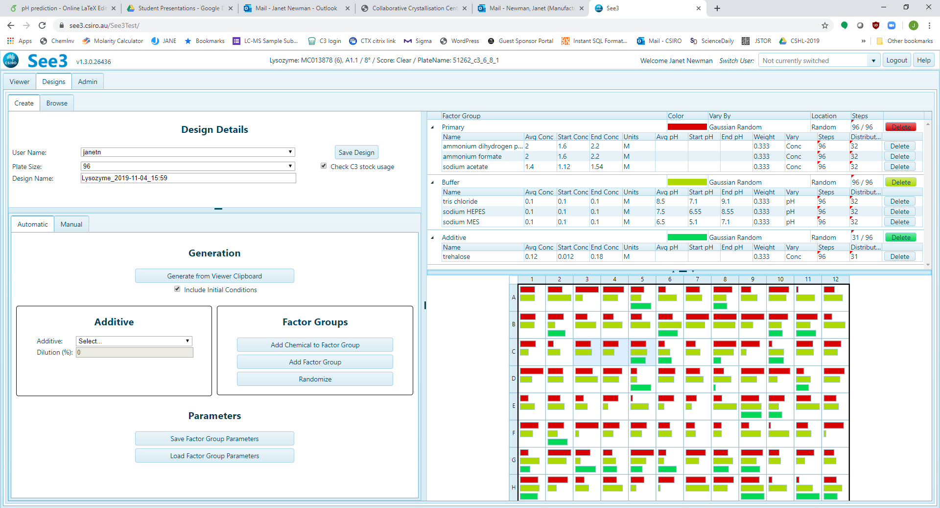

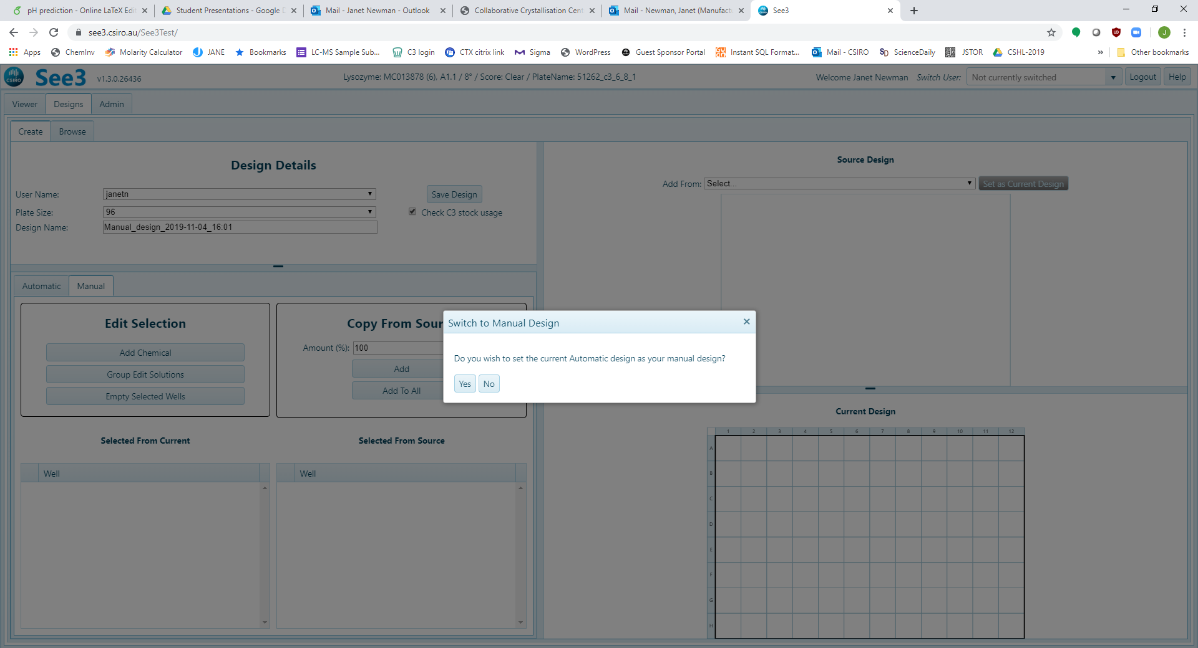

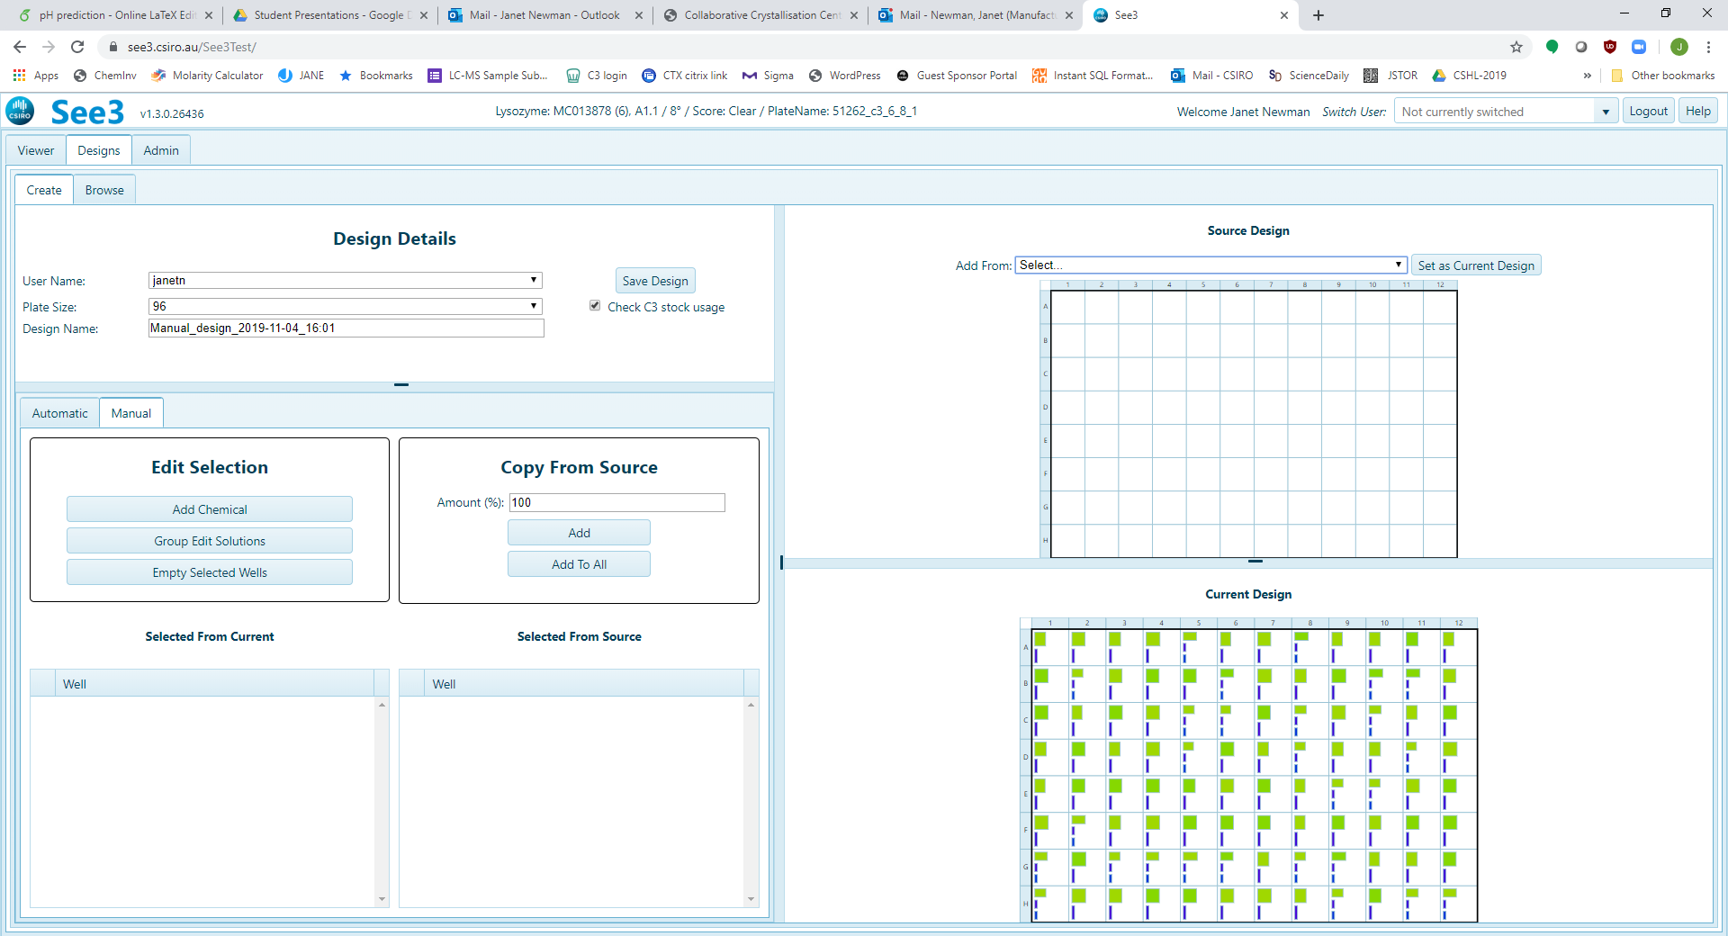

All the operations that can be done in manual mode are now available on the Automatic design. Notice that there are two special selections in the “Source Design” pane – clipboard and “Current Design”.

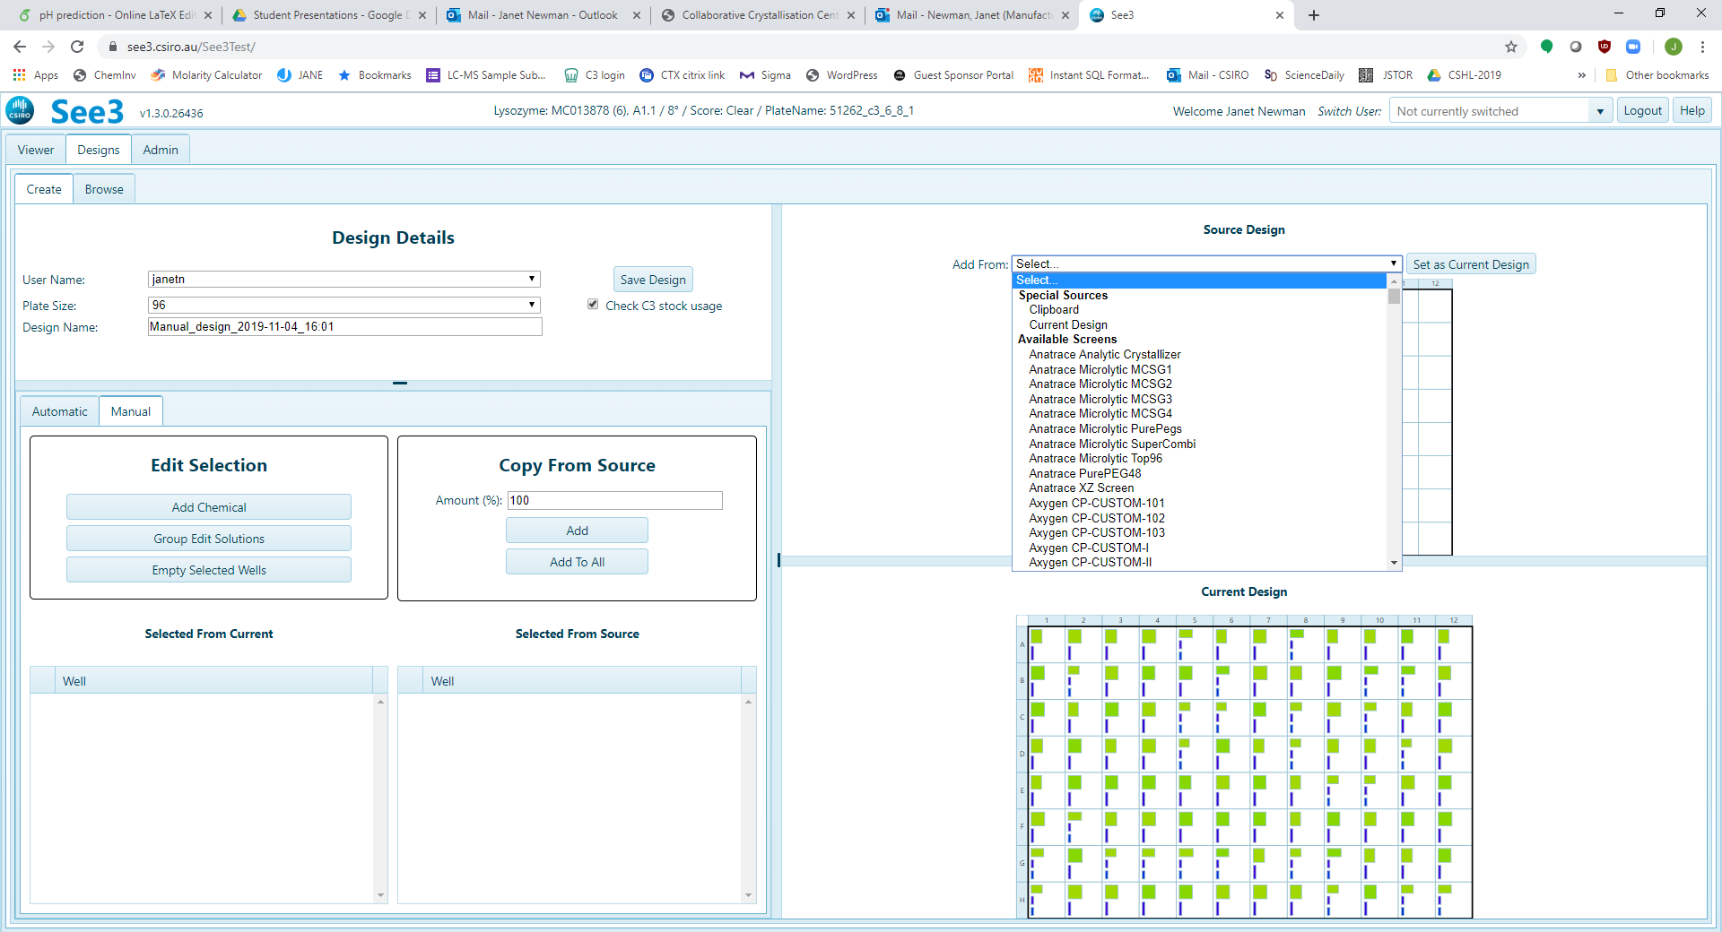

By setting the “Source Design” to the Current Design one can duplicate part of the current screen. In the example below we setting the last 6 columns of the current designed to be duplicated in the first 6 columns – All that is needed now is to press the “Add” button, circled in red.

